|  | | |  | | |
| --- | --- | --- | --- | --- | --- |
| **Extension Terminal à Conteneurs Port de Tanger Med** | | | | | |
| **Etude de manœuvrabilité - Extension Terminal à Conteneurs Port de Tanger Med** | | | | | |
| **Code**  **Document** | **Projet** | **Destinataire** | **Type du document** | **Numéro du document** | **Année** |
| TMD-2024-MAN-001 | Autorité Portuaire de Tanger Med | Rapport de manœuvrabilité | RM-TMD-001 | 2024 |

|  |  |  |  |  |  |
| --- | --- | --- | --- | --- | --- |
| **Révision** | **Date** | **Description** | **Préparé par** | **Révisé par** | **Approuvé par** |
| A | 2024-01-15 | Version initiale pour revue client | J. Benali | M. Alaoui | Dr. K. Mansouri |
| B | 2024-02-10 | Intégration des commentaires client | J. Benali | M. Alaoui | Dr. K. Mansouri |
| Ce document ne peut être reproduit sans autorisation préalable de TME  Zone franche, Ksar El Majaz, Commune El Anjra, B.P. 123 – Ksar Sghir – 94152 - Maroc  Tel : 00.212 (0)5 39 37 00 70/71 Fax : 00.212 (0)5 39 37 90 72 Site Web : www.tme.ma | | | | | |

# 

Table des matières

Table des figures 2

Table des tableaux 3

Introduction 4

1. Données d’entrée 4

1.1. Plan de masse 4

1.2. Plan de balisage 4

1.3. Bathymétrie 4

1.4. Conditions environnementales 4

1.4.1. Houle 4

1.4.2. Agitation 5

1.4.3. Vent 5

1.4.4. Courant 5

1.4.5. Marée 5

1.5. Synthèse des données environnementales 5

2. Navires 6

2.1. Navires à tester 6

2.2. Remorqueurs 6

3. Essais réalisés 6

3.1. Méthodologie des simulations 6

3.2. Résultats détaillés 7

4. Analyse 8

4.1. Statistiques générales 8

4.2. Analyse détaillée 8

4.3. Recommendations 8

5. Conclusion 8

6. Tableau des essais et commentaires des pilotes 9

# 

# Table des figures

Figure 1 Planche de plan de masse 4

Figure 2 Planche de plan de balisage 4

Figure 3 Planche de bathymétrie 4

# Table des tableaux

Table 1: Tableau détaillé des simulations entretenues 7

Table 2 Tableau global des essais avec commentaires des pilotes 9

# Introduction

L'Autorité Portuaire de Tanger Med a mandaté TME pour réaliser une étude de manœuvrabilité portuaire dans le cadre de l'extension du terminal à conteneurs, situé dans la zone franche de Tanger Med. Cette mission vise à évaluer les capacités de manœuvre du nouveau quai Q4, conçu pour accueillir des porte-conteneurs de nouvelle génération jusqu'à 24 000 EVP. Ce projet s'inscrit dans un contexte de croissance prévue du trafic conteneurisé et d'optimisation des flux maritimes trans-méditerranéens.  
  
Cette étude est essentielle pour garantir la sécurité et l'efficacité des opérations portuaires. Elle permet d'anticiper les défis liés à l'accueil de navires de plus grande taille et de préparer les infrastructures aux exigences futures du marché maritime.  
  
Les objectifs techniques de cette étude sont les suivants :  
• Évaluer la faisabilité des manœuvres d'accostage et d'appareillage pour les porte-conteneurs de 300 à 400 mètres  
• Analyser les interactions hydrodynamiques entre les navires et le nouveau quai Q4  
• Identifier les conditions météo-océaniques critiques et les zones à risque  
• Valider la compatibilité des dimensions du chenal d'accès avec les navires cibles  
• Proposer des recommandations pour l'optimisation des procédures de pilotage  
  
L'approche méthodologique repose sur des simulations numériques réalisées à l'aide de modèles hydrodynamiques avancés. Ces simulations ont été conduites en tenant compte des caractéristiques des navires types et des conditions environnementales représentatives. Au total, 44 simulations ont été réalisées pour trois navires types. Les sections suivantes détailleront les résultats obtenus et les analyses effectuées.

# Données d’entrée

La fiabilité d'une étude de manœuvrabilité dépend de la précision des données d'entrée. Cette étude intègre diverses catégories de données essentielles. Les informations disponibles concernent le plan de masse, le balisage, la bathymétrie, les conditions météorologiques telles que le vent et la houle, ainsi que les paramètres hydrodynamiques comme les courants, les marées et l'agitation. Les sections suivantes détaillent chaque jeu de données utilisé pour les simulations.

## Plan de masse

Le plan de masse de l'étude porte sur les infrastructures portuaires actuelles et futures du terminal. Les infrastructures concernées incluent les quais Q1, Q2 et Q3 existants, ainsi que le nouveau quai Q4 prévu dans la phase d'extension. Le chenal principal, actuellement à 16 mètres de tirant d'eau, sera élargi pour accueillir le nouveau quai Q4 de 450 mètres avec un tirant d'eau de 18 mètres. L'aire d'évitage sera également élargie pour faciliter les manœuvres des navires.  
  
La phase 1 du projet concerne la configuration actuelle des quais Q1, Q2 et Q3, avec le chenal principal à 16 mètres de tirant d'eau. La phase 2 prévoit l'extension du terminal avec la construction du quai Q4, qui s'étendra sur 450 mètres avec un tirant d'eau de 18 mètres. Cette phase inclut également l'élargissement de l'aire d'évitage pour améliorer les conditions de manœuvre des navires.  
  
Les éléments clés pour la manœuvre incluent les postes d'accostage des quais Q1, Q2, Q3 et Q4, le bassin d'évitage et le chenal principal. Ces infrastructures sont essentielles pour assurer la sécurité et l'efficacité des opérations portuaires. Les figures détaillées de ces infrastructures sont disponibles en annexe pour une meilleure compréhension des aménagements prévus.  
  
Ainsi, le plan de masse permet de visualiser les différentes phases du projet et les aménagements nécessaires pour optimiser les opérations portuaires.

## Plan de balisage

Le balisage maritime joue un rôle crucial dans la sécurité des opérations navales, en particulier pour les manœuvres d'approche et d'accostage. Il permet de guider les navires à travers des zones potentiellement dangereuses, telles que les chenaux étroits ou les zones de hauts-fonds. Les éléments de balisage pertinents pour cette étude incluent les bouées cardinales, qui indiquent la direction des dangers navigables, ainsi que les feux de secteur, qui fournissent des indications visuelles précises pour le guidage nocturne. Ces dispositifs sont essentiels pour éviter les collisions et les échouements. La figure en annexe illustre le plan de balisage détaillé, montrant la disposition des différentes marques et feux. L'impact sur les procédures de manœuvre est significatif, car un balisage bien conçu réduit les risques opérationnels et améliore l'efficacité des mouvements des navires dans le port.

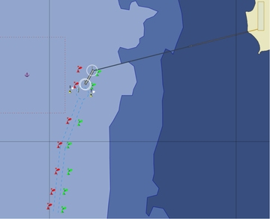

Figure 2 Planche de plan de balisage

## Bathymétrie

Les données bathymétriques utilisées pour cette étude proviennent des relevés réalisés par le Service Hydrographique et Océanographique de la Marine en octobre 2023. Ces données récentes assurent une représentation précise des fonds marins dans la zone d'étude, garantissant ainsi la fiabilité des informations utilisées. Les profondeurs dans le chenal principal varient de 16 à 18 mètres, offrant des conditions favorables pour l'accueil de navires avec un tirant d'eau maximal de 14,5 mètres, en tenant compte du pied de pilote réglementaire. Le fond est stable, composé de sable fin et de vase, ce qui facilite les manœuvres et réduit les risques d'ensablement. Une zone d'évitage a été approfondie à 18 mètres pour accueillir les plus gros navires, renforçant ainsi la capacité d'accueil du port. Ces caractéristiques bathymétriques sont essentielles pour assurer des conditions de manœuvre sécurisées et efficaces. Elles ont été intégrées dans le modèle de simulation pour garantir la représentativité des essais et des opérations portuaires.

La bathymétrie est illustrée par 1 carte(s) détaillant la topographie sous-marine.

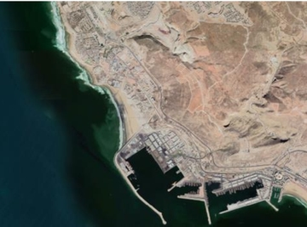

Figure 3 Planche de bathymétrie

## Conditions environnementales

Les conditions environnementales jouent un rôle crucial dans la manœuvrabilité des navires au sein des infrastructures portuaires. La houle, le vent, le courant, la marée et l'agitation influencent directement les opérations de navigation et les exigences en matière de remorquage. Ces paramètres environnementaux déterminent les marges de sécurité nécessaires pour garantir des manœuvres efficaces et sûres. Cette section examine les conditions environnementales spécifiques à notre étude. Les sous-sections suivantes analysent chaque paramètre en détail, en tenant compte des valeurs pertinentes pour les simulations.

### Houle

Les conditions de houle considérées dans cette étude sont basées sur cinq années de mesures houlographe au large, obtenues à partir de la station X du SHOM et du modèle WAVEWATCH III. Les valeurs retenues pour la houle critique sont une hauteur significative de 3 mètres, une période de pic de 10 secondes, et une direction provenant du nord-ouest. Ces paramètres permettent de simuler des scénarios extrêmes pour évaluer la robustesse des infrastructures portuaires. La houle a un impact significatif sur les manœuvres des navires, notamment en augmentant le roulis et en rendant les opérations d'amarrage plus complexes. Les figures 1 et 2 illustrent les distributions des hauteurs et des périodes de houle enregistrées, fournissant une base solide pour l'analyse des conditions environnementales.

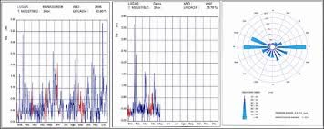

Figure 4 Rose de houle - Directions et hauteurs dominantes

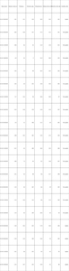

Figure 5 Tableau des houles

### Agitation

Les conditions d'agitation résiduelle dans le bassin portuaire ont été déterminées par une modélisation numérique validée par des mesures in-situ. La hauteur maximale admissible d'agitation au poste d'amarrage est fixée à 0,5 mètre. Cette valeur est cruciale pour assurer la sécurité et l'efficacité des opérations portuaires, notamment lors des manœuvres d'amarrage et de désamarrage. L'agitation résiduelle affecte directement la stabilité des navires à quai, influençant ainsi les opérations de manutention et de chargement/déchargement. Une agitation excessive peut entraîner des difficultés de manœuvre et des risques accrus pour les infrastructures portuaires. Par conséquent, il est essentiel de maintenir des niveaux d'agitation conformes aux valeurs retenues pour garantir des conditions opérationnelles optimales.

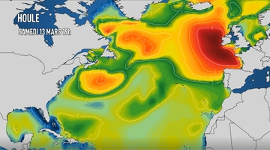

Figure 6 Carte d'agitation dans le bassin portuaire

### Vent

Les conditions de vent analysées dans cette étude se basent sur une rose des vents établie à partir de dix années de données météo-marine fournies par la station météorologique de Tanger Med et Météo-France. Les valeurs retenues pour les simulations sont un vent critique de 30 nœuds provenant du secteur ouest, avec des rafales atteignant 40 nœuds. Ces conditions sont considérées comme les plus contraignantes pour les manœuvres portuaires, notamment lors des phases d'approche et d'accostage. Le vent exerce une influence significative sur les opérations portuaires, générant des efforts latéraux importants qui peuvent affecter la stabilité et la manœuvrabilité des navires. La figure 1 illustre la distribution des vents sur la période étudiée, mettant en évidence la prépondérance du secteur ouest.

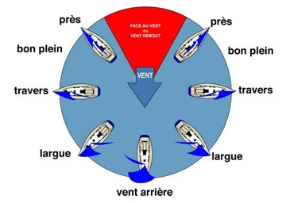

Figure 7 Rose des vents - Station Tanger Med 2014-2024

### Courant

Les courants de marée jouent un rôle crucial dans les opérations portuaires, influençant directement les manœuvres des navires. Les valeurs retenues pour cette étude sont basées sur des mesures ADCP effectuées sur une année complète, complétées par des observations terrain et un modèle hydrodynamique TELEMAC. La vitesse maximale du courant atteint 1,2 nœud, avec une direction variable selon la marée. Cette variabilité est essentielle à considérer pour les manœuvres d'approche et d'accostage. Le courant de flot, orienté vers le nord-est, et le courant de jusant, orienté vers le sud-ouest, doivent être pris en compte pour optimiser la sécurité et l'efficacité des opérations portuaires.

### Marée

Les conditions de marée considérées dans l'étude sont basées sur les données marégraphiques du port Tanger Med, fournies par le SHOM. Les niveaux d'eau retenus pour les simulations couvrent les conditions extrêmes, avec une pleine mer (PM) à +2,4 mètres et une basse mer (BM) à -0,7 mètres, pour des coefficients de marée compris entre 95 et 120. Ces valeurs permettent d'évaluer l'impact des variations de tirant d'eau disponible sur les manœuvres des navires. La distinction entre vive-eau et morte-eau est cruciale, car elle influence directement les créneaux d'accès et les opérations portuaires. Par exemple, en vive-eau, le tirant d'eau est maximal, facilitant l'entrée et la sortie des navires de fort tonnage, tandis qu'en morte-eau, les restrictions opérationnelles peuvent être plus sévères.

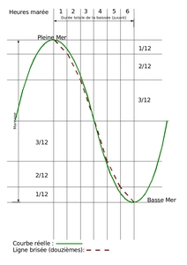

Figure 8 Courbes de marée type - VE et ME

## Synthèse des données environnementales

Les données d'infrastructure incluent trois quais existants Q1, Q2 et Q3 avec un chenal principal de 16 mètres de tirant d'eau. La phase d'extension prévoit un nouveau quai Q4 de 450 mètres avec un tirant d'eau de 18 mètres et une aire d'évitage élargie. Le balisage est actif et conforme aux normes, tandis que la bathymétrie, mise à jour en octobre 2023, montre des profondeurs suffisantes dans le chenal principal, avec un fond stable composé de sable fin et de vase. La zone d'évitage est approfondie à 18 mètres pour accueillir les plus gros navires.  
  
Les conditions environnementales incluent une houle dominante du Nord-Ouest avec des hauteurs significatives de 1 à 3 mètres selon les saisons, et une houle critique de 3 mètres avec une période de 10 secondes. Les vents critiques proviennent du secteur Ouest avec des rafales atteignant 40 nœuds. Les courants de marée sont faibles, inférieurs à 1 nœud, avec un courant maximal de 1,2 nœud. Les marées présentent un marnage semi-diurne de 1,8 mètres en vive-eau et 0,4 mètres en morte-eau, avec des conditions extrêmes de plus haute mer à 2,4 mètres et de basse mer à -0,7 mètres. L'agitation résiduelle dans le bassin portuaire est faible, avec une agitation maximale admissible de 0,5 mètre au poste d'amarrage.  
  
L'ensemble des données présente une cohérence satisfaisante, permettant une évaluation précise des manœuvres portuaires. Les interactions entre les infrastructures et les conditions environnementales sont bien définies, facilitant l'analyse des scénarios de manœuvre. Les simulations des navires pourront ainsi être réalisées en tenant compte de ces paramètres.  
  
Les prochaines étapes consistent à intégrer ces données dans les simulations de manœuvre des navires.

# Navires

## Navires à tester

La flotte de navires types retenue pour l'étude comprend trois catégories de porte-conteneurs représentatives du trafic actuel et futur. Les porte-conteneurs ULCV, de 400 mètres de longueur et 220 000 tonnes de déplacement, constituent le défi principal en raison de leurs dimensions imposantes et de leur tirant d'eau de 16,5 mètres à l'arrière. Ces navires sont équipés de moteurs diesel basse vitesse et d'hélices à pas variable, développant une puissance de 75 000 kW. Les porte-conteneurs de type Large, mesurant 350 mètres de longueur et 165 000 tonnes de déplacement, complètent le panel pour couvrir la diversité des escales. La sélection de ces navires permet d'évaluer les conditions de manœuvre pour l'ensemble des configurations opérationnelles. Les porte-conteneurs ULCV sont identifiés comme le cas dimensionnant en raison de leurs caractéristiques exceptionnelles.

* **Porte-conteneurs Type ULCV:** Le navire est de type Ultra Large Container Vessel

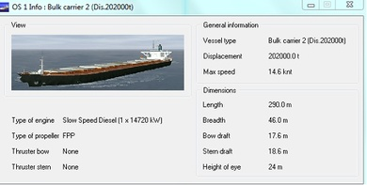

Figure 8 Fiche détaille du Porte-conteneurs Type ULCV

* + Longueur: 400.0 m
  + Tirant d'eau: 16.0/16.5 m
* **Porte-conteneurs Type Large:** Le navire est de type Large Container Vessel

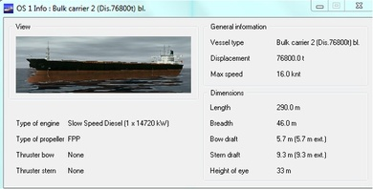

Figure 8 Fiche détaille du Porte-conteneurs Type Large

* + Longueur: 350.0 m
  + Tirant d'eau: 14.5/15.0 m
* **Porte-conteneurs Standard:** Le navire est de type Container Vessel

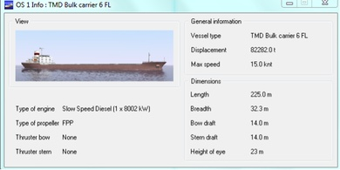

Figure 8 Fiche détaille du Porte-conteneurs Standard

* + Longueur: 300.0 m
  + Tirant d'eau: 8.5/9.0 m

## Remorqueurs

La flotte de remorqueurs utilisée pour cette étude se compose de trois types principaux : des remorqueurs ASD 70T, ASD 50T et des remorqueurs conventionnels 40T. Ces remorqueurs présentent des caractéristiques variées, avec des longueurs allant de 26 à 32 mètres, des largeurs de 10,5 à 12,8 mètres et des tirants d'eau de 4,5 à 5,2 mètres. La sélection de ces remorqueurs est représentative du trafic maritime courant, permettant d'adapter les opérations aux différentes conditions de vent et de courant. Les remorqueurs ASD, équipés de propulseurs azimutaux, offrent une grande manoeuvrabilité et une traction élevée, tandis que les remorqueurs conventionnels assurent une traction fiable pour des opérations plus standardisées. La répartition des remorqueurs avant et arrière est ajustée en fonction des conditions environnementales pour optimiser l'efficacité des opérations de remorquage. Ces remorqueurs sont choisis pour leur capacité à gérer une variété de situations, y compris les manœuvres complexes et les conditions météorologiques défavorables.

* **Remorqueur ASD 70T:** Le remorqueur est de type Azimuth Stern Drive

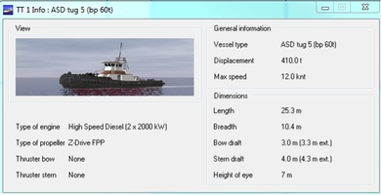

Figure 9 Fiche détaillée du Remorqueur ASD 70T

* + Longueur: 32.0 m
  + Largeur: 12.8 m
* **Remorqueur ASD 50T:** Le remorqueur est de type Azimuth Stern Drive

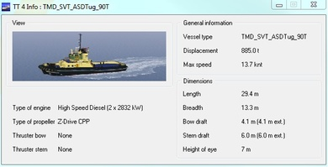

Figure 9 Fiche détaillée du Remorqueur ASD 50T

* + Longueur: 28.0 m
  + Largeur: 11.0 m
* **Remorqueur Conventionnel 40T:** Le remorqueur est de type Tracteur conventionnel
  + Longueur: 26.0 m
  + Largeur: 10.5 m

# Essais réalisés

## Méthodologie des simulations

Les simulations et essais réalisés dans le cadre de ce projet ont été conçus pour évaluer la manœuvrabilité des navires dans diverses conditions environnementales et opérationnelles au port de Tanger Med. La méthodologie de simulation employée repose sur une approche de modélisation numérique en temps réel, utilisant des simulateurs de navigation professionnels. Ces simulateurs intègrent des données bathymétriques précises ainsi que des informations météo-océaniques pour garantir une représentation fidèle des conditions réelles. La validation des simulations a été effectuée par des pilotes expérimentés, assurant ainsi la représentativité et la fiabilité des résultats obtenus.  
  
Les paramètres de simulation ont été définis en fonction des conditions environnementales critiques identifiées pour le port de Tanger Med. Les vents critiques ont été établis à 30 nœuds secteur Ouest avec des rafales atteignant 40 nœuds, basés sur une analyse de 10 ans de données météo-marine. La houle critique a été définie avec une hauteur significative de 3 mètres et une période de pic de 10 secondes, provenant de données houlographiques sur 5 ans. Les courants maximaux mesurés par ADCP sur une année complète ont atteint 1,2 nœud avec une direction variable selon la marée. Les conditions extrêmes de marée ont été établies à PM +2,4 mètres et BM -0,7 mètres, en référence au référentiel Cote Marine de Tanger Med. Enfin, l'agitation maximale admissible au poste d'amarrage a été fixée à 0,5 mètre, validée par des mesures in-situ.  
  
Les scénarios testés ont couvert une variété de conditions et de configurations pour évaluer la manœuvrabilité des navires. Pour le scénario E1, trois simulations ont été réalisées avec des porte-conteneurs standard et de type large, accostant au poste P2 tribord dans des conditions de vent de nord-est à 25 nœuds et de houle de nord-est à 2,5 mètres avec une période de 12 secondes. L'assistance de quatre remorqueurs a été nécessaire, avec des résultats globalement réussis, bien que certaines ajustements aient été nécessaires pour les navires de type large. Le scénario E2 a inclus des simulations avec des conditions de vent d'est à 25 nœuds, montrant des résultats mitigés, notamment des échecs lors de l'accostage en raison de la difficulté à contrôler la dérive des navires. Le scénario E3 a testé des conditions de vent de nord-ouest à 25 nœuds, avec des résultats conditionnels, nécessitant une gestion précise de la dérive et de la vitesse des navires. Le scénario E4 a évalué des conditions de vent d'ouest à 30 nœuds, avec des résultats généralement réussis mais nécessitant une assistance accrue des remorqueurs. Enfin, le scénario E5 a testé des conditions de vent de sud-est à 25 nœuds, avec des résultats variés, notamment des échecs lors de l'accostage en raison de la difficulté à contrôler la dérive des navires.  
  
Les statistiques globales des simulations montrent que sur un total de 44 simulations réalisées, 29 ont été réussies, soit 65,9%, tandis que 14 ont échoué, représentant 31,8%. Les types de manœuvres simulées incluent l'accostage par conditions météorologiques variables, l'appareillage en configurations d'assistance différentes, les manœuvres d'urgence et procédures exceptionnelles, ainsi que des tests de robustesse en conditions limites.  
  
La validation et la calibration des simulations ont été effectuées en comparant les résultats avec des données de manœuvres réelles, en validant les modèles par l'expertise des pilotes et en calibrant les modèles hydrodynamiques. Une analyse de sensibilité des paramètres critiques a également été réalisée pour identifier les facteurs influençant le plus les résultats des simulations. Cette approche méthodologique rigoureuse permet de garantir la fiabilité et la représentativité des résultats obtenus, tout en identifiant les limites et les améliorations possibles pour les futures simulations.

## Résultats détaillés

|  |  |  |  |  |  |  |  |  |  |  |  |
| --- | --- | --- | --- | --- | --- | --- | --- | --- | --- | --- | --- |
| **N°** | **Navire** | **Etat de charge** | **Condition** | **Vent** | **Houle** | **Courant** | **Marée** | **Poste** | **Remorqueurs** | **Entrée** | **Manoeuvre** |
| 1 | Porte-conteneurs Standard | Chargé | E1 | NE 25knt | NE 2,5m 12s | 3knt 60°/N | 0,6 m | P2 | 4 Remorqueurs | TM3 | Accostage P2 tribord |
| 2 | Porte-conteneurs Standard | Chargé | E2 | E 25 knt | NE 2,5m 12s | 1 knt 240°/N | 0,6 m | P2 | 4 Remorqueurs | TM3 | Accostage P2 tribord |
| 3* (near miss) | Porte-conteneurs Type Large | Sur lest | E3 | NW 25 knt | NW 3m 14s | 3 knt 60°/N | 0,6 m | P2 | 4 Remorqueurs | TM3 | Accostage P2 tribord |
| 3(bis) | Porte-conteneurs Type Large | Chargé | E3 | NW 25 knt | NW 3m 14s | 3 knt 60°/N | 0,6 m | P2 | 4 Remorqueurs | TM3 | Accostage P2 tribord |
| 4 | Porte-conteneurs Type ULCV | Sur lest | E4 | W 30 knt | W 3m 14s | 3 knt 60°/N | 0,6 m | P2 | 4 Remorqueurs | TM3 | Accostage P2 tribord |
| 5 | Porte-conteneurs Type Large | Sur lest | E5 | SE 25 knt | NE 3m 14s | Null | 0,6 m | P2 | 5 Remorqueurs | TM3 | Accostage P2 bâbord |
| 6 | Porte-conteneurs Type Large | Sur lest | E1 | NE 25 knt | NE 2,5m 12s | 3 knt 60°/N | 0,6 m | P2 | 4 Remorqueurs | TM3 | Accostage P2 tribord |
| 6(bis) | Porte-conteneurs Standard | Sur lest | E1 | NE 25 knt | NE 2,5m 12s | 3 knt 60°/N | 0,6 m | P2 | 4 Remorqueurs | TM3 | Accostage P2 tribord |
| 7 | Porte-conteneurs Type Large | Chargé | E2 | E 25 knt | NE 2,5m 12s | 1 knt 240°/N | 0,6 m | P2 | 3 Remorqueurs | TM3 | Appareillage P2 tribord |
| 8 | Porte-conteneurs Type ULCV | Chargé | E3 | NW 20 knt | NW 3m 14s | 3 knt 60°/N | 0,6 m | P2 | 4 Remorqueurs | TM3 | Appareillage P2 tribord |
| 9 | Porte-conteneurs Type Large | Sur lest | E4 | W 30 knt | W 3m 14s | 3 knt 60°/N | 0,6 m | P2 | 4 Remorqueurs | TM3 | Appareillage P2 tribord |
| 10 | Porte-conteneurs Standard | Sur lest | E1 | NE 25 knt | NE 2,5m 12s | 3 knt 60°/N | 0,6 m | P3 | 4 Remorqueurs | TM2 | Accostage P3 tribord |
| 11 | Porte-conteneurs Type ULCV | Sur lest | E3 | SW 25 knt | NW 3m 14s | 3 knt 60°/N | 0,6 m | P2 | 4 Remorqueurs | TM3 | Accostage P2 tribord |
| 12 | Porte-conteneurs Type Large | Sur lest | E2 | E 25 knt | NE 2,5m 12s | 1 knt 240°/N | 0,6 m | P3 | 4 Remorqueurs | TM3 | Accostage P3 tribord |
| 12 BIS | Porte-conteneurs Standard | Chargé | E2 | E 25 knt | NE 2,5m 12s | 1 knt 240°/N | 0,6 m | P3 | 4 Remorqueurs | TM3 | Accostage P3 tribord |
| 13 | Porte-conteneurs Type Large | Chargé | E4 | W 30 knt | W 3m 14s | 3 knt 60°/N | 0,6 m | P1 | 4 Remorqueurs | TM3 | Accostage P1 tribord |
| 13 Bis | Porte-conteneurs Type ULCV | Chargé | E4 | W 30 knt | W 3m 14s | 3 knt 60°/N | 0,6 m | P1 | 4 Remorqueurs | TM3 | Accostage P1 tribord |
| 13 Ter | Porte-conteneurs Type ULCV | Chargé | E4 | W 25 knt | W 3m 14s | 3 knt 60°/N | 0,6 m | P1 | 4 Remorqueurs | TM3 | Accostage P1 tribord |
| 14 | Porte-conteneurs Standard | Sur lest | E2 | E 25 knt | NE 2,5m 12s | 1 knt 240°/N | 0,6 m | P1 | 4 Remorqueurs | TM3 | Accostage P1 tribord |
| 15* | Porte-conteneurs Standard | Chargé | E1 | NE 25 knt | NE 2,5m 12s | 3 knt 60°/N | 0,6 m | P1 | 3 Remorqueurs | TM3 | Appareillage P1 tribord |
| 16 | Porte-conteneurs Type ULCV | Chargé | E5 | SE 25 knt | NE 3m 14s | 3 knt 60°/N | 0,6 m | P3 | 4 Remorqueurs | TM3 | Appareillage P3 bâbord |
| 17 | Porte-conteneurs Type Large | Sur lest | E2 | E 25 knt | NE 2,5m 12s | 1 knt 240°/N | 0,6 m | P3 | 3 Remorqueurs | TM3 | Appareillage P3 tribord |
| 18 | Porte-conteneurs Type Large | Chargé | E5 | SE 25 knt | NE 3m 14s | 3 knt 60°/N | 0,6 m | P1 | 4 Remorqueurs | TM3 | Appareillage P1 bâbord |
| 19 | Porte-conteneurs Type ULCV | Sur lest | E1 | NE 25 knt | NE 2,5m 12s | 3 knt 60°/N | 0,6 m | P1 | 5 Remorqueurs | TM3 | Appareillage P1 bâbord |
| 20 | Porte-conteneurs Type ULCV | Sur lest | E1 | NE 25 knt | NE 2,5m 12s | 3 knt 60°/N | 0,6 m | P1 | 5 Remorqueurs | TM3 | Accostage P1 bâbord |
| 21 | Porte-conteneurs Type ULCV | Sur lest | E5 | SE 25 knt | NE 3m 14s | 3 knt 60°/N | 0,6 m | P1 | 5 Remorqueurs | TM3 | Appareillage P1 bâbord |
| 22 | Porte-conteneurs Standard | Chargé | E4 | SW 25 knt | W 3m 14s | 3 knt 60°/N | 0,6 m | P1 | 5 Remorqueurs | TM3 | Accostage P1 tribord |
| 23 | Porte-conteneurs Type ULCV | Sur lest | E5 | SE 25 knt | NE 3m 14s | 3 knt 60°/N | 0,6 m | P1 | 5 Remorqueurs | TM3 | Accostage P1 tribord |
| 23 BIS | Porte-conteneurs Type Large | Chargé | E5 | SE 25 knt | NE 3m 14s | 3 knt 60°/N | 0,6 m | P1 | 5 Remorqueurs | TM3 | Accostage P1 tribord |
| 24 | Porte-conteneurs Type Large | Chargé | E4 | W 30 knt | W 3m 14s | 3 knt 60°/N | 0,6 m | P1 | 5 Remorqueurs | TM3 | Appareillage P1 tribord |
| 25 | Porte-conteneurs Standard | Chargé | E4 | SW 30 knt | W 3m 14s | 3 knt 60°/N | 0,6 m | P3 | 5 Remorqueurs | TM3 | Appareillage P3 bâbord |
| 26 | Porte-conteneurs Type Large | Sur lest | E4 | SW 30 knt | W 3m 14s | 3 knt 60°/N | 0,6 m | P1 | 5 Remorqueurs | TM3 | Accostage P1 tribord |
| 26 BIS | Porte-conteneurs Standard | Chargé | E4 | SW 30 knt | W 3m 14s | 3 knt 60°/N | 0,6 m | P1 | 5 Remorqueurs | TM3 | Accostage P1 tribord |
| 26 TER | Porte-conteneurs Standard | Chargé | E4 | SW 30 knt | W 3m 14s | 3 knt 60°/N | 0,6 m | P1 | 4 Remorqueurs | TM3 | Accostage P1 tribord |
| 27 | Porte-conteneurs Type ULCV | Chargé | E3 | NW 25 knt | NW 3m 14s | 3 knt 60°/N | 0,6 m | P1 | 5 Remorqueurs | TM3 | Accostage P1 tribord |
| 27 BIS | Porte-conteneurs Type Large | Chargé | E3 | NW 25 knt | NW 3m 14s | 3 knt 60°/N | 0,6 m | P1 | 5 Remorqueurs | TM3 | Accostage P1 tribord |
| 28 | Porte-conteneurs Type Large | Chargé | E5 | NW 25 knt | NW 3m 14s | 3 knt 60°/N | 0,6 m | P3 | 5 Remorqueurs | TM3 | Accostage P3 tribord |
| 29 | Porte-conteneurs Type Large | Chargé | E2 | NW 25 knt | NW 3m 14s | 3 knt 60°/N | 0,6 m | P1 | 5 Remorqueurs | TM3 | Appareillage P1 tribord |
| 30 | Porte-conteneurs Type Large | Chargé | E2 | E 25 knt | NE 2,5m 12s | 1 knt 240°/N | 0,6 m | P3 | 5 Remorqueurs | TM3 | Accostage P3 tribord |
| 31 | Porte-conteneurs Type Large | Chargé | E3 | NW 25 knt | NW 3m 14s | 3 knt 60°/N | 0,6 m | P3 | 5 Remorqueurs | TM3 | Accostage P3 tribord |
| 33 | Porte-conteneurs Standard | Chargé | E5 | SE 25 knt | NE 3m 14s | 3 knt 60°/N | 0,6 m | P1 | 5 Remorqueurs | TM2 | Appareillage P1 tribord |
| 33 (bis) | Porte-conteneurs Type ULCV | Chargé | E5 | SE 25 knt | NE 3m 14s | 3 knt 60°/N | 0,6 m | P1 | 5 Remorqueurs | TM2 | Appareillage P1 tribord |
| 34 | Porte-conteneurs Standard | Chargé | E1 | NE 25 knt | NE 2,5m 12s | 3 knt 60°/N | 0,6 m | P3 | 5 Remorqueurs | TM3 | Appareillage P3 tribord |
| 35 | Porte-conteneurs Type ULCV | Chargé | E3 | NW 25 knt | NW 3m 14s | 3 knt 60°/N | 0,6 m | P3 | 5 Remorqueurs | TM3 | Appareillage P3 bâbord |

Table 1: Tableau détaillé des simulations entretenues

# Analyse

## Statistiques générales

La campagne de simulations de manœuvrabilité a permis d'évaluer 44 scénarios dans diverses conditions. Sur l'ensemble des simulations réalisées, 29 ont abouti à une réussite, tandis que 14 ont échoué, résultant en un taux de réussite de 65.9 pour cent. Ces résultats reflètent une performance globale acceptable, bien que des améliorations soient nécessaires pour augmenter la fiabilité des manœuvres. Les distances parcourues en moyenne s'élèvent à 2.8 milles entre le pilotage et l'accostage, avec un temps moyen de manœuvre de 45 minutes. Les essais ont révélé des variations significatives dans les performances, notamment en fonction des conditions environnementales et des configurations de manœuvre. L'analyse détaillée des facteurs influençant ces résultats est présentée ci-après.

## Analyse détaillée

L'analyse des 44 simulations de manœuvrabilité démontre une faisabilité opérationnelle pour les porte-conteneurs de nouvelle génération au terminal Q4 de Tanger Med, avec un taux de réussite de 66 pour cent. Ce taux reflète une bonne adéquation des dimensions du chenal et de la zone d'évitage aux navires cibles, sous réserve d'une assistance adéquate des remorqueurs. Les conditions météo-océaniques critiques identifiées nécessitent des procédures spécifiques et une utilisation optimale des remorqueurs haute performance pour garantir la sécurité des manœuvres.  
  
Les réussites observées sont principalement attribuables à des conditions environnementales modérées et à une assistance appropriée des remorqueurs. Les configurations performantes incluent des approches avec des vents inférieurs à 20 nœuds et des courants modérés, permettant un contrôle précis du navire. La distance parcourue moyenne de 2.8 milles du pilotage à l'accostage et un temps moyen de manœuvre de 45 minutes confirment la viabilité opérationnelle dans ces conditions.  
  
Les échecs identifiés mettent en lumière des conditions critiques où les efforts latéraux et la dérive deviennent incontrôlables. Par exemple, des vents supérieurs à 25 nœuds combinés à des courants forts ou des situations d'urgence comme l'indisponibilité du propulseur d'étrave ont conduit à des manœuvres échouées. Les essais 2, 3(bis), 5, 12 et 13 bis illustrent ces limites opérationnelles, soulignant l'importance de maintenir un contrôle continu du taux de virage et de la vitesse. Les seuils critiques identifiés incluent des vents de 30 nœuds et des courants de 3 nœuds, au-delà desquels les manœuvres deviennent impraticables sans ajustements significatifs.  
  
Ces résultats confirment la faisabilité des manœuvres dans l'enveloppe opérationnelle nominale tout en identifiant des seuils critiques à respecter. Les recommandations détaillées pour améliorer les procédures et les équipements sont présentées dans la section suivante.

## Recommendations

Sur la base de l'analyse des simulations, les recommandations suivantes sont formulées pour améliorer la sécurité et l'efficacité des manœuvres portuaires.  
  
- Adapter les procédures d'accostage pour les navires de 300 à 400 mètres en fonction des conditions de vent et de courant.  
- Limiter la vitesse d'approche à moins de 20 nœuds en cas de vent de secteur nord-ouest supérieur à 20 nœuds et de courant est supérieur à 2 nœuds.  
- Prévoir l'utilisation de quatre remorqueurs pour les manœuvres d'accostage dans des conditions de vent supérieur à 25 nœuds et de courant est supérieur à 2 nœuds.  
- Renforcer la coordination entre les remorqueurs et les pilotes pour maintenir une présentation correcte du navire à l'entrée du port.  
- Utiliser le propulseur d'étrave et les moteurs pour maintenir un taux de rotation positif en cas de vent fort.  
- Prévoir l'utilisation de deux ancres pour arrêter le navire en cas de vitesse excessive à l'entrée du port.  
- Adapter les manœuvres d'accostage en fonction de la disponibilité des équipements de bord, notamment le propulseur d'étrave.  
- Prévoir l'utilisation de cinq remorqueurs et du propulseur de poupe pour les manœuvres d'accostage côté bâbord en cas de vent de secteur sud-est supérieur à 25 nœuds.  
- Limiter la distance parcourue entre le pilotage et l'accostage à moins de 2,8 milles pour réduire les risques de dérive.  
- Adapter le temps de manœuvre à environ 45 minutes pour optimiser la sécurité et l'efficacité des opérations.  
  
Ces recommandations permettent de définir une enveloppe opérationnelle sécurisée tout en maintenant une exploitation efficiente du terminal.

# Conclusion

L'étude de manœuvrabilité réalisée pour le terminal Q4 a permis d'évaluer les conditions d'accès et de manœuvre des porte-conteneurs de nouvelle génération. Sur les 44 simulations effectuées, 29 ont abouti à une réussite, soit un taux de réussite global de 65.9 pour cent. Ces résultats, bien que satisfaisants, révèlent des marges d'amélioration pour garantir une sécurité optimale.  
  
Les objectifs initiaux de l'étude ont été atteints. La faisabilité des manœuvres d'accostage et d'appareillage est validée pour les navires cibles dans les conditions environnementales définies. Les conditions météo-océaniques critiques ont été identifiées, permettant ainsi d'adapter les procédures opérationnelles.  
  
Sur la base de ces résultats, les recommandations suivantes sont formulées :  
• Mettre en place des procédures spécifiques pour les conditions météo-océaniques critiques identifiées  
• Utiliser des remorqueurs haute performance pour assister les manœuvres dans des conditions dégradées  
• Optimiser l'utilisation des remorqueurs en fonction des dimensions des navires et des conditions environnementales  
• Renforcer la coordination entre les pilotes et les équipes portuaires pour assurer une communication fluide  
• Prévoir des créneaux horaires adaptés pour les manœuvres en fonction des conditions de marée et de vent  
• Former régulièrement les pilotes et les équipes portuaires aux nouvelles procédures et aux conditions critiques  
  
Cette étude présente certaines limitations inhérentes à l'approche par simulation. Des essais en conditions réelles lors de la mise en service permettront de valider les conclusions et d'affiner les seuils opérationnels. Des études complémentaires pourraient également être menées pour explorer des scénarios plus extrêmes et affiner les procédures opérationnelles.

# Tableau des essais et commentaires des pilotes

**Tableau récapitulatif de tous les essais (44 essais)**

|  |  |  |  |  |  |  |  |  |  |  |  |  |
| --- | --- | --- | --- | --- | --- | --- | --- | --- | --- | --- | --- | --- |
| **Test n°** | **Condition** | **Wind** | **Wave** | **Current** | **Tide** | **Berth** | **Maneuver** | **Pilote** | **Side** | **Tugs** | **Entrance** | **Commentaire** |
| 1 | E1 | NE 25knt | NE 2,5m 12s | 3knt 60°/N | 0,6 m | P2 | Accostage P2 tribord | RAF/ Berjal | Tribord | 4 Remorqueurs | TM3 | 1st run with 25-knot wind speed and an opposing current of 3 knots: The presentation was satisfactory, and speed control was sufficient to stop the vessel inside the breakwater with the assistance of the tugs. At dead slow ahead or astern, there was almost no reaction when the vessel was dead in the water inside the port. The port-side swing was maintained with the bow facing the wind. Four tugs were sufficient to bring the vessel alongside, starboard side to the pier; no stern tug (ST) was used. |
| 2 | E2 | E 25 knt | NE 2,5m 12s | 1 knt 240°/N | 0,6 m | P2 | Accostage P2 tribord | RAC/ Naoufel | Tribord | 4 Remorqueurs | TM3 | Under such conditions, it was necessary to keep the helm constantly to starboard with the engine at half to full ahead, as the ship was easily shearing into the wind. This resulted in excessive speed at the entrance. To stop the vessel, two tugs were used astern and two ahead (starboard and port), with both engines at full astern and two anchors dropped. The vessel was then turned to port and brought alongside with the assistance of tugs, engines, and primarily the bow thruster (BT). |
| 3* (near miss) | E3 | NW 25 knt | NW 3m 14s | 3 knt 60°/N | 0,6 m | P2 | Accostage P2 tribord | Dourasse/ Berjal | Tribord | 4 Remorqueurs | TM3 | With wind and current pushing in the same direction, the vessel had to be kept as close as possible to the main breakwater to allow enough time and space to control the drift. The crossbeam distance to the green light was less than 10 meters — very tight. Four tugs were used to stop the vessel, with the engine at half astern. A 20-knot wind from the northwest was identified as the threshold limit. The vessel was swung to starboard and brought parallel to the berth, with the wind pushing it alongside. Note: The distance to the green light can be improved to one vessel breadth (50 meters) for increased safety. |
| 3(bis) | E3 | NW 25 knt | NW 3m 14s | 3 knt 60°/N | 0,6 m | P2 | Accostage P2 tribord | RAF/ Berjal | Tribord | 4 Remorqueurs | TM3 | Northwest wind conditions at 25 knots with an easterly current of 3 knots. The vessel showed a normal tendency to sheer to starboard during the approach. It was necessary to maintain both course over ground (COG) and speed overground (SOG) to ensure a proper presentation at the correct angle, while avoiding overspeed to allow for a safe stop inside the port. Speed decreased significantly when approaching the port, making steering difficult. Additional engine power and assistance from the center lead tug were required to pass the entrance. Such conditions represent operational limits. For a vessel of this size, safe feasibility is clearly below 20 knots NW wind and 2 knots easterly current. Four tugs were necessary to perform the swing and bring the vessel starboard side alongside. |
| 4 | E4 | W 30 knt | W 3m 14s | 3 knt 60°/N | 0,6 m | P2 | Accostage P2 tribord | AndelAziz/ Naoufel | Tribord | 4 Remorqueurs | TM3 | Sheering during approach. It was necessary to use the engine for steering, which further increased the vessel’s speed, while the aft tugs could not be used effectively under westerly wind conditions. Once sheltered, using the engine astern produced a significant thrust effect. Three aft tugs were required to perform a starboard swing. |
| 5 | E5 | SE 25 knt | NE 3m 14s | Null | 0,6 m | P2 | Accostage P2 bâbord | Rafouk/ Berjal | Bâbord | 5 Remorqueurs | TM3 | 25 knots of southeast wind with no current. Emergency situation: the bow thruster (BT) was unavailable when engaged inside the port. The presentation was acceptable, although the bow was challenging to control as it sought the wind. It was necessary to use the engine to maintain a positive rate of turn (ROT). Speed was kept under control to pass the entrance. Once inside, it was difficult to stop the vessel’s inertia with only one tug reducing speed. It was essential to maintain two tugs aft for braking, in order to avoid using the engine full astern. To bring the vessel port side alongside, five tugs and the stern thruster were required. |
| 6 | E1 | NE 25 knt | NE 2,5m 12s | 3 knt 60°/N | 0,6 m | P2 | Accostage P2 tribord | Reda Mariky | Tribord | 4 Remorqueurs | TM3 | It is preferable to hook the forward starboard tug to reduce speed and ensure a reasonable speed when passing through the channel. |
| 6(bis) | E1 | NE 25 knt | NE 2,5m 12s | 3 knt 60°/N | 0,6 m | P2 | Accostage P2 tribord | mefsioui | Tribord | 4 Remorqueurs | TM3 | Assisted by 4 tugboats, the presentation and turning maneuver were well controlled. During berthing, all 4 tugboats were engaged at full power. |
| 7 | E2 | E 25 knt | NE 2,5m 12s | 1 knt 240°/N | 0,6 m | P2 | Appareillage P2 tribord | Dourasse/ Berjal | Tribord | 3 Remorqueurs | TM3 | Departure with onshore wind: Three tugs were used to pull and center the vessel in the turning area, with the bow aligned to initiate the approach to the entrance. Speed gradually built up with the wind on the forward quarter, using engine power and the centerline bow tug pulling from the 6 o’clock position. Crossing speed was maintained at 5 knots. Starboard side alongside is the preferred option for departure. |
| 8 | E3 | NW 20 knt | NW 3m 14s | 3 knt 60°/N | 0,6 m | P2 | Appareillage P2 tribord | Abdelaziz/Dourasse | Tribord | 4 Remorqueurs | TM3 | Unberthing starboard side with 4 tugs: Tug positions: center forward, port bow, center aft, and port quarter. The strategy is to bring the stern as much as possible into the wind, using the bow thruster to starboard if necessary. Once the vessel is in a good position, the bow is gradually brought to port. |
| 9 | E4 | W 30 knt | W 3m 14s | 3 knt 60°/N | 0,6 m | P2 | Appareillage P2 tribord | Reda/Rachdi | Tribord | 4 Remorqueurs | TM3 | Use of 4 tugboats. The vessel was slow to get underway but quickly gained forward speed. The engine was set to slow astern to support the action of the aft tugs. It is recommended not to give too much advantage to the bow when approaching the channel, as the vessel tends to luff significantly. The channel was crossed at 6 knots, with the engine at full ahead at times. |
| 10 | E1 | NE 25 knt | NE 2,5m 12s | 3 knt 60°/N | 0,6 m | P3 | Accostage P3 tribord | RAF/ Berjal | Tribord | 4 Remorqueurs | TM2 | Northeast wind conditions at 25 knots with an easterly current of 3 knots. The vessel's presentation was south of the planned passage for the TM2 entrance, requiring a full turn to port to align the vessel at the correct course over ground (COG). The entrance from TM2 was approached at a speed of 7 knots, passing all vessels alongside at a safe distance. Speed was reduced using the aft tug and the forward tug positioned at the center lead. After passing the TM3 red light, the berth vessel was close to port-side vessels. Swinging to starboard was not safe due to insufficient room at the port quarter. Safe berthing was achieved port side alongside. Four tugs were used. |
| 11 | E3 | SW 25 knt | NW 3m 14s | 3 knt 60°/N | 0,6 m | P2 | Accostage P2 tribord | Soerensen / Dourasse | Tribord | 4 Remorqueurs | TM3 | The initial turn was too wide, resulting in an unfavorable position during the approach. It was difficult to initiate a port turn at the breakwater, even with four tugs, due to the wind conditions. Once inside, the vessel turned to port using three aft tugs to bring the stern up into the wind. |
| 12 | E2 | E 25 knt | NE 2,5m 12s | 1 knt 240°/N | 0,6 m | P3 | Accostage P3 tribord | REDA/ BERJAL | Tribord | 4 Remorqueurs | TM3 | Berthing with an easterly wind of 25 knots. The maneuver failed: the vessel was unable to turn to starboard and continued drifting toward the TM2 breakwater. Due to the vessel’s large windage and inertia, it is essential to maintain continuous control of the rate of turn. The rate of turning to port must not be allowed to increase excessively, as the vessel may no longer be able to regain a positive rate of turn — even with the engine at full ahead. |
| 12 BIS | E2 | E 25 knt | NE 2,5m 12s | 1 knt 240°/N | 0,6 m | P3 | Accostage P3 tribord | RAF/ REDA | Tribord | 4 Remorqueurs | TM3 | Failed maneuver. It is essential to keep the helm hard to starboard and maintain a positive rate of turn, as the vessel luffs significantly and it becomes difficult to recover a positive ROT. |
| 13 | E4 | W 30 knt | W 3m 14s | 3 knt 60°/N | 0,6 m | P1 | Accostage P1 tribord | Rahoui/ BERJAL | Tribord | 4 Remorqueurs | TM3 | Strong drift to port due to a strong westerly wind and a 3-knot easterly current. Even with the engine at full ahead to increase speed and steer out of the entrance, it was difficult to control the port-side drift. The vessel entered too close to the secondary pier. |
| 13 Bis | E4 | W 30 knt | W 3m 14s | 3 knt 60°/N | 0,6 m | P1 | Accostage P1 tribord | Dourasse/ Berjal | Tribord | 4 Remorqueurs | TM3 | Proceed to the entrance with adequate speed and a clear strategy to manage the drift caused by the combined effect of westerly wind and current. The impact of a 30-knot wind on the beam near the green light is too strong and represents a limitation for vessels of this class. Even if the jetties are avoided, the challenge of swinging the vessel under such conditions remains a critical limitation. A 30-knot westerly wind has been identified as the operational limit, as two trial attempts failed under these conditions. Next step: attempt the maneuver with 25 knots. |
| 13 Ter | E4 | W 25 knt | W 3m 14s | 3 knt 60°/N | 0,6 m | P1 | Accostage P1 tribord | Rahoui | Tribord | 4 Remorqueurs | TM3 | Presentation was satisfactory, with adjustments to heading and speed effectively counteracting the drift to starboard. Passage speed was manageable. The vessel was brought to a stop at the turning circle using the engine and three tugs. Starboard swing was successfully executed. |
| 14 | E2 | E 25 knt | NE 2,5m 12s | 1 knt 240°/N | 0,6 m | P1 | Accostage P1 tribord | RAF/MEFSIOUI | Tribord | 4 Remorqueurs | TM3 | Successful maneuver. The rate of turn (ROT) did not exceed 12 degrees. The passage plan must be followed to ensure the success of the maneuver. Tugboats were engaged at the port entrance, and berthing was well controlled. The bollard pull of the tugboats at TM3 must exceed 100 tons. |
| 15* | E1 | NE 25 knt | NE 2,5m 12s | 3 knt 60°/N | 0,6 m | P1 | Appareillage P1 tribord | Dourasse/ Berjal | Tribord | 3 Remorqueurs | TM3 | Departure from the berth using two aft tugs and one forward tug. With the support of the onshore wind, efforts were made to control the vessel’s drift in order to reach the turning area in a good position to approach the entrance. It was important to anticipate the port turn to proceed to open sea while maintaining a safe distance from the TM2 main jetty. Special precautions are essential under easterly wind conditions. |
| 16 | E5 | SE 25 knt | NE 3m 14s | 3 knt 60°/N | 0,6 m | P3 | Appareillage P3 bâbord | Dourasse/ Berjal | Bâbord | 4 Remorqueurs | TM3 | Once the vessel is clear of the berth, begin the starboard swing while keeping the wind head-on. Control the astern speed and stop the vessel in the turning area. Use four tugs to perform the swing and proceed toward the entrance, initiating the port turn early to prevent the vessel from sharing into the wind. This is a very important precaution under southeast (SE) wind conditions, even more so than under northeast (NE) conditions. |
| 17 | E2 | E 25 knt | NE 2,5m 12s | 1 knt 240°/N | 0,6 m | P3 | Appareillage P3 tribord | Rafouq/ Rachdi | Tribord | 3 Remorqueurs | TM3 | Departure starboard side alongside at P1. Wind: 25 knots from the east. Current: 3 knots easterly. The vessel’s bow was oriented toward the port entrance. Three tugs were used to control lateral drift and align the vessel with the entrance. It was necessary to quickly build up longitudinal speed to maintain control of the vessel’s trajectory toward the entrance. Maneuver successful. |
| 18 | E5 | SE 25 knt | NE 3m 14s | 3 knt 60°/N | 0,6 m | P1 | Appareillage P1 bâbord | mefsioui | Bâbord | 4 Remorqueurs | TM3 | Departure with onshore wind. Two tugs pulling, with the bow positioned toward the center of the turning area. The vessel approaches the entrance by building speed with the engine half ahead. Crossing speed: 6 knots. |
| 19 | E1 | NE 25 knt | NE 2,5m 12s | 3 knt 60°/N | 0,6 m | P1 | Appareillage P1 bâbord | Reda/ Rachdi | Bâbord | 5 Remorqueurs | TM3 | Four tugs are required for departure. Drift was controlled throughout the entire maneuver. The rate of turn (ROT) was low while passing the main breakwater. It is preferable to keep the tug secured at the aft center and/or continue navigating until there is more space before turning to port. |
| 20 | E1 | NE 25 knt | NE 2,5m 12s | 3 knt 60°/N | 0,6 m | P1 | Accostage P1 bâbord | BERJAL | Bâbord | 5 Remorqueurs | TM3 | During the approach, maintain control of the rate of turn and avoid excessive values. Use the engine half ahead to correct the vessel’s heading. Adjust the heading so that the current-induced drift brings the vessel to the center of the port entrance. The wind, coming almost from astern, has minimal effect on drift or steering. Keep the vessel’s speed under control to ensure it can be stopped safely. Berthing is carried out with four tugs. |
| 21 | E5 | SE 25 knt | NE 3m 14s | 3 knt 60°/N | 0,6 m | P1 | Appareillage P1 bâbord | Reda / BERJAL | Bâbord | 5 Remorqueurs | TM3 | The channel was entered without issue. However, with a 3-knot current setting to the east, the vessel was unable to develop a rate of turn to port and continued on a straight course despite all actions taken to initiate a turn to port. |
| 22 | E4 | SW 25 knt | W 3m 14s | 3 knt 60°/N | 0,6 m | P1 | Accostage P1 tribord | RAFOUK/ MEFSIOUI | Tribord | 5 Remorqueurs | TM3 | Wind from the southwest at 25 knots, gusting up to 30 knots. Current at 3 knots. Four tugs in assistance. The Vessel presentation was satisfactory despite wind gusts and current limiting speed buildup. The port entrance was crossed at 4 knots with speed decreasing. Swinging in the basin to starboard using three tugs plus the ship’s thruster. Berthing at position P1 with four tugs, starboard thruster, and bow thruster. The wind consider for SW winds is 25 knots. |
| 23 | E5 | SE 25 knt | NE 3m 14s | 3 knt 60°/N | 0,6 m | P1 | Accostage P1 tribord | Rafouk | Tribord | 5 Remorqueurs | TM3 | Tug assistance was insufficient. Wind from the southeast at 25 knots. Current at 3 knots. Four tugs in use. Vessel presentation remained under control, balancing wind and current. Speed and course over ground were managed to cross the entrance at 7 knots, decreasing. Swinging in the basin was performed using four tugs, bow thruster (BT), and starboard thruster (ST). The issue arose when approaching berth P1: two tugs and full starboard bow thruster were not enough to hold the bow against the 25-knot beam wind. Recommended limit for safe operation in SE wind is 20 knots, with five tugs required to maintain a safety margin. |
| 23 BIS | E5 | SE 25 knt | NE 3m 14s | 3 knt 60°/N | 0,6 m | P1 | Accostage P1 tribord | Rahoui | Tribord | 5 Remorqueurs | TM3 | The vessel presentation to the port was satisfactory. Drift was controlled through appropriate heading and speed adjustments. The port entrance was crossed at a controlled speed. Once the current effect subsided, the vessel began drifting to starboard toward the main jetty. Swinging to port was initiated to bring the vessel head-on into the wind, which was successfully achieved. During the final approach to the berth, under the influence of crosswind, the use of four tugs operating at maximum pushing power was insufficient to fully counteract the wind effect. A fifth tug was called in to overcome the crosswind. Note: The bow thruster was out of service. |
| 24 | E4 | W 30 knt | W 3m 14s | 3 knt 60°/N | 0,6 m | P1 | Appareillage P1 tribord | Soerensen/ Rafouq | Tribord | 5 Remorqueurs | TM3 | Four tugs were used; no thrusters were available. Departure from the berth proceeded smoothly. The vessel came close to the opposite side but remained safe and under full control at all times.   While going astern, the maneuver was well executed with a controlled turn and effective use of centerline tugs. Minimum safe distance of 130 meters was maintained from the breakwater when passing the green light. |
| 25 | E4 | SW 30 knt | W 3m 14s | 3 knt 60°/N | 0,6 m | P3 | Appareillage P3 bâbord | Rafouq/ Berjal | Bâbord | 5 Remorqueurs | TM3 | Departure from P1, port side alongside. Bow thruster not available. Wind from the southwest at 25 knots, current at 3 knots. The vessel’s bow was positioned in the enclosed corner of the berth. Four tugs were used to bring the vessel to the turning circle.   Heavy drift toward the main jetty was experienced, with a minimum distance of less than 30 meters between the bow and the breakwater. The maneuver required an extended duration. It was necessary to build up longitudinal speed quickly to maintain control of the vessel’s trajectory toward the entrance.   For improved safety and operational efficiency, the vessel should be berthed starboard side alongside P1. |
| 26 | E4 | SW 30 knt | W 3m 14s | 3 knt 60°/N | 0,6 m | P1 | Accostage P1 tribord | nan | Tribord | 5 Remorqueurs | TM3 | Emergency scenario: engine failure.   The engine failed while the vessel was crossing the port entrance at a speed of 6.2 knots. The vessel was brought to a stop using four tugs operating at full power, without the use of anchors.   The vessel swung, and an attempt was made to berth. However, it was unsuccessful, as part of the available tug power—both forward and aft—was used to control longitudinal movement (ahead and astern), leaving insufficient force to bring the vessel alongside. |
| 26 BIS | E4 | SW 30 knt | W 3m 14s | 3 knt 60°/N | 0,6 m | P1 | Accostage P1 tribord | nan | Tribord | 5 Remorqueurs | TM3 | Engine failure occurred at the port entrance while the vessel was making 7.5 knots. The vessel was brought to a stop using tug assistance and emergency anchoring on both sides. An attempt was made to berth, but it was unsuccessful. |
| 26 TER | E4 | SW 30 knt | W 3m 14s | 3 knt 60°/N | 0,6 m | P1 | Accostage P1 tribord | nan | Tribord | 4 Remorqueurs | TM3 | Engine failure occurred at the port entrance while the vessel was making 6.2 knots. The vessel was quickly stopped using tugs and anchors. It then swung and successfully berthed with the assistance of a fifth tug. |
| 27 | E3 | NW 25 knt | NW 3m 14s | 3 knt 60°/N | 0,6 m | P1 | Accostage P1 tribord | Rafouk/ Mefsioui | Tribord | 5 Remorqueurs | TM3 | The vessel presentation to the port was under control, and the entrance was crossed at a safe speed. The vessel stopped with the assistance of the tugs and began swinging clear. However, it was not possible to hold position with four tugs, and the vessel began drifting due to the wind. |
| 27 BIS | E3 | NW 25 knt | NW 3m 14s | 3 knt 60°/N | 0,6 m | P1 | Accostage P1 tribord | Rahoui/ Mefsioui | Tribord | 5 Remorqueurs | TM3 | The presentation to the port was satisfactory. Drift was controlled through heading and speed adjustments. The vessel crossed the entrance at a controlled speed, but continued drifting to port due to wind effect. Drift was managed using the stern tug, forward tug, and rudder.   Swinging to starboard was initiated to bring the vessel head-on into the wind, and the swing was completed successfully. However, during the approach to the berth, four tugs were insufficient to counteract the crosswind effect. |
| 28 | E5 | NW 25 knt | NW 3m 14s | 3 knt 60°/N | 0,6 m | P3 | Accostage P3 tribord | nan | Tribord | 5 Remorqueurs | TM3 | Berthing was carried out in southwesterly winds of 25 knots. The vessel should not be allowed to develop excessive port rate of turn due to its strong weather helm; otherwise, it may become difficult to bring it back to starboard.   The port entrance was crossed at just over 8 knots. The vessel swung to port, into the wind, and engine power was used to prevent drifting astern due to wind pressure.   Berthing was completed slowly, with four tugs pushing toward the quay and the bow thruster operating at full power. |
| 29 | E2 | NW 25 knt | NW 3m 14s | 3 knt 60°/N | 0,6 m | P1 | Appareillage P1 tribord | mefsioui | Tribord | 5 Remorqueurs | TM3 | Departure maneuver assisted by four tugboats from berth P1 to exit the TM2 channel. The unberthing phase was well executed.   An emergency scenario involving an engine failure was simulated at the turning circle, with the vessel making 6 knots. The forward and aft centerline tugs were able to maintain control and steer the vessel, allowing it to safely exit the port. Once outside, the engine was successfully restarted. |
| 30 | E2 | E 25 knt | NE 2,5m 12s | 1 knt 240°/N | 0,6 m | P3 | Accostage P3 tribord | Soerensen/ Rafouk | Tribord | 5 Remorqueurs | TM3 | The vessel came too close to the breakwater from Med 2. Only the aft tug was able to turn the vessel sufficiently. The vessel passed the green light at 7.7 knots but was successfully stopped using four tugs and the stern thruster, allowing for a controlled turn inside the basin.   After the turn, the maneuver proceeded smoothly, and the vessel was successfully docked using only three tugs, the bow thruster, and the main engine. |
| 31 | E3 | NW 25 knt | NW 3m 14s | 3 knt 60°/N | 0,6 m | P3 | Accostage P3 tribord | Dourasse | Tribord | 5 Remorqueurs | TM3 | Northwesterly wind at 25 knots with an easterly current of 3 knots. Attempting to line up earlier appears to be a more suitable and safer strategy, even in wind conditions exceeding 20 knots from the northwest.   This remains a very tricky and challenging situation, and should be avoided in real-life operations whenever possible. |
| 33 | E5 | SE 25 knt | NE 3m 14s | 3 knt 60°/N | 0,6 m | P1 | Appareillage P1 tribord | Rachdi/ Berjal | Tribord | 5 Remorqueurs | TM2 | Unberthing maneuver carried out with four tugs: center lead forward and aft, port bow, and port quarter. The maneuver began with the intention to exit via TM2, initially moving the vessel sideways using the tugs while keeping the stern aligned with the wind.   A change of plan redirected the exit to TM3. The vessel was brought astern and began to slow down at 2 knots. However, the exit was then changed back to TM2, which resulted in excessive port drift.   Tugs were used at full power to counter the drift, while the main engine was brought to full ahead speed to quickly build up longitudinal speed. The vessel exited outbound through the channel.   It began to veer to port earlier than expected due to the 3-knot easterly current, which tends to push the vessel toward Pax Port. |
| 33 (bis) | E5 | SE 25 knt | NE 3m 14s | 3 knt 60°/N | 0,6 m | P1 | Appareillage P1 tribord | Rachdi/ Mefsioui | Tribord | 5 Remorqueurs | TM2 | Unberthing was carried out with four tugs, keeping the vessel close to the quay to counteract drift. The engine was kicked ahead while opening the bow and maintaining the stern into the wind. Speed was built up as quickly as possible to reach 7 to 8 knots, ensuring acceptable vessel behavior under the prevailing conditions. A port turn was initiated early to counter the effect of the current. |
| 34 | E1 | NE 25 knt | NE 2,5m 12s | 3 knt 60°/N | 0,6 m | P3 | Appareillage P3 tribord | nan | Tribord | 5 Remorqueurs | TM3 | For departure from P3 with strong northwesterly wind: - Push For departure from berth P3 in strong northwesterly wind conditions:   Push off while favoring the bow alignment with the departure heading, approximately 020°. Use engine power to build up speed as quickly as possible to prevent drifting toward the main jetty. Avoid staying too close to the red light; otherwise, the vessel may end up pressed against the TM2 jetty once outside, due to the effect of the current. Ensure a port side rate of turn when passing through the channel. favoring bow to align, with departure heading, approximately 020. - Use engine power to build up speed as quickly as possible to avoid drifting towards the main jetty - Do not stay too close to the red light , otherwise will end up pressed against TM2 jetty once outside, due to the effect of the current. - Ensure a port side rate of turn when passing the channel |
| 35 | E3 | NW 25 knt | NW 3m 14s | 3 knt 60°/N | 0,6 m | P3 | Appareillage P3 bâbord | nan | Bâbord | 5 Remorqueurs | TM3 | Departure was carried out in northwesterly winds of 25 knots. An initial attempt to sail with three tugs and the bow thruster proved insufficient, and a fourth tug was called in.   The vessel turned to starboard, and engine power was applied ahead to prevent wind-induced drift and avoid being pushed backward toward the quay.   The vessel exited with a heading close to the green light to compensate for wind drift and gained sufficient speed at the entrance to avoid being blown toward the TM2 breakwater. |

Table 2 Tableau global des essais avec commentaires des pilotes

**Essai n° 1**

|  |  |  |  |  |  |  |  |  |  |  |  |  |
| --- | --- | --- | --- | --- | --- | --- | --- | --- | --- | --- | --- | --- |
| **Test n°** | **Condition** | **Wind** | **Wave** | **Current** | **Tide** | **Berth** | **Maneuver** | **Pilote** | **Side** | **Tugs** | **Entrance** | **Commentaire** |
| 1 | E1 | NE 25knt | NE 2,5m 12s | 3knt 60°/N | 0,6 m | P2 | Accostage P2 tribord | RAF/ Berjal | Tribord | 4 Remorqueurs | TM3 | 1st run with 25-knot wind speed and an opposing current of 3 knots: The presentation was satisfactory, and speed control was sufficient to stop the vessel inside the breakwater with the assistance of the tugs. At dead slow ahead or astern, there was almost no reaction when the vessel was dead in the water inside the port. The port-side swing was maintained with the bow facing the wind. Four tugs were sufficient to bring the vessel alongside, starboard side to the pier; no stern tug (ST) was used. |

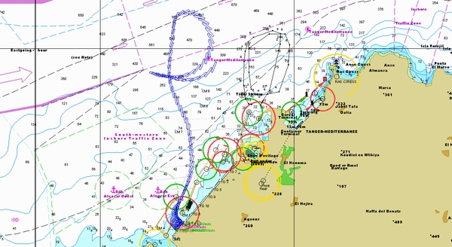

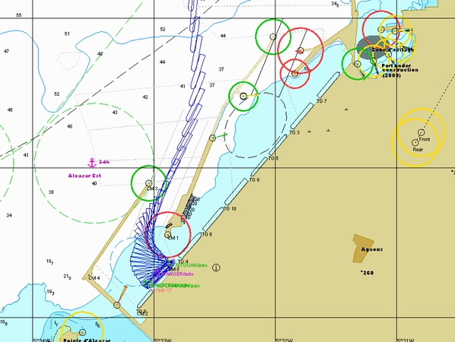

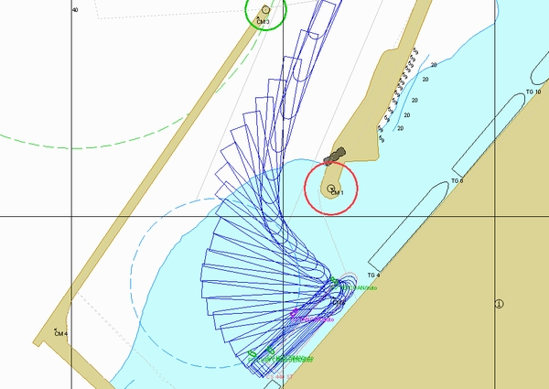

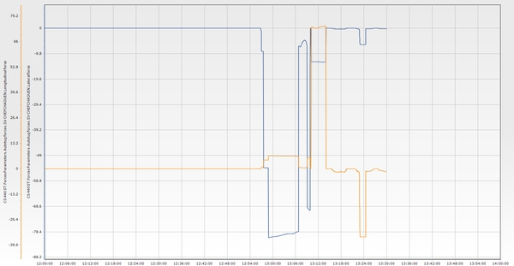

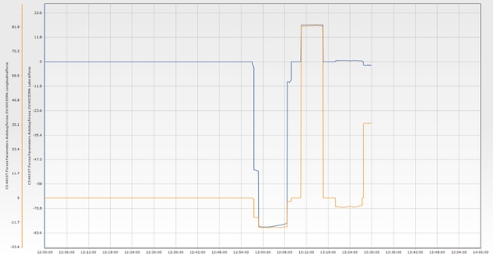

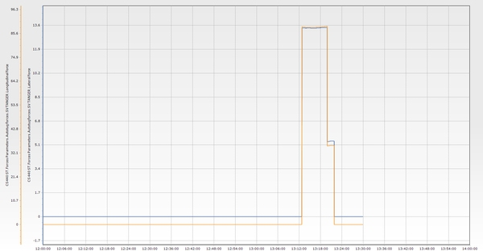

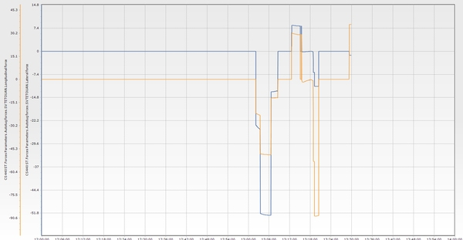

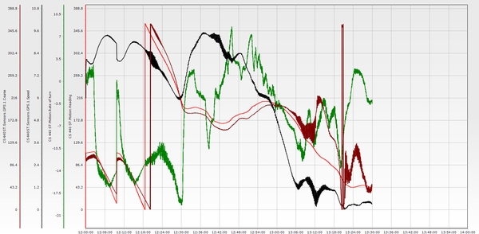

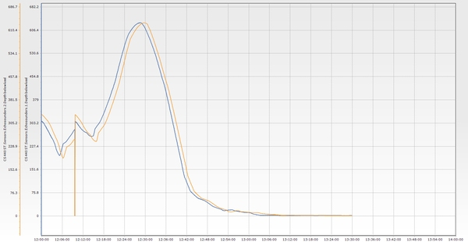

**Essai n° 2**

|  |  |  |  |  |  |  |  |  |  |  |  |  |
| --- | --- | --- | --- | --- | --- | --- | --- | --- | --- | --- | --- | --- |
| **Test n°** | **Condition** | **Wind** | **Wave** | **Current** | **Tide** | **Berth** | **Maneuver** | **Pilote** | **Side** | **Tugs** | **Entrance** | **Commentaire** |
| 2 | E2 | E 25 knt | NE 2,5m 12s | 1 knt 240°/N | 0,6 m | P2 | Accostage P2 tribord | RAC/ Naoufel | Tribord | 4 Remorqueurs | TM3 | Under such conditions, it was necessary to keep the helm constantly to starboard with the engine at half to full ahead, as the ship was easily shearing into the wind. This resulted in excessive speed at the entrance. To stop the vessel, two tugs were used astern and two ahead (starboard and port), with both engines at full astern and two anchors dropped. The vessel was then turned to port and brought alongside with the assistance of tugs, engines, and primarily the bow thruster (BT). |

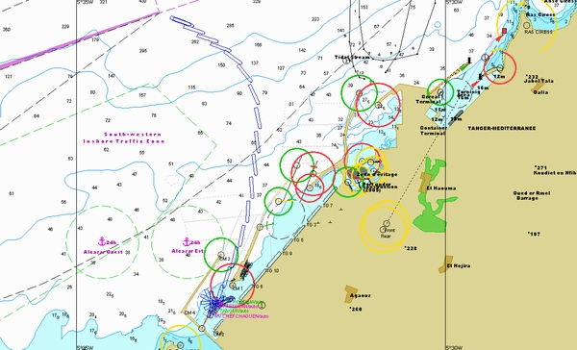

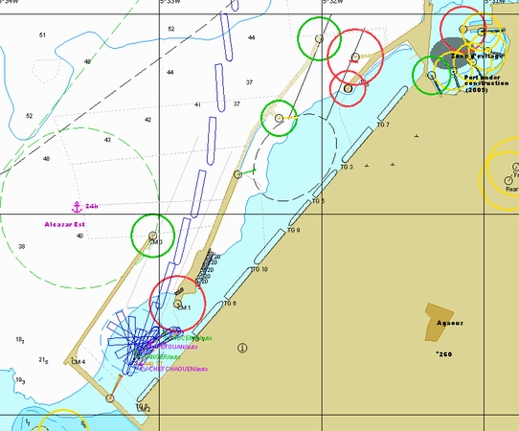

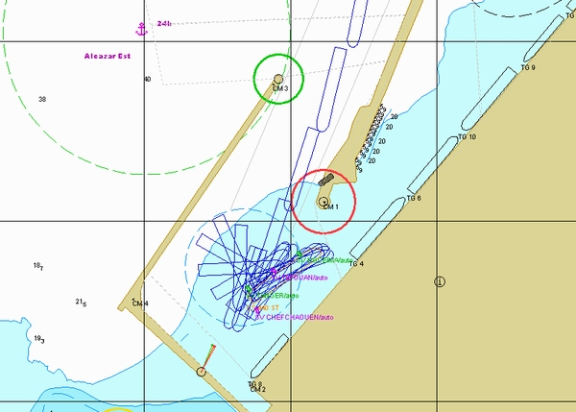

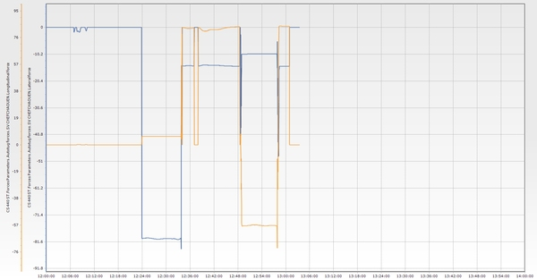

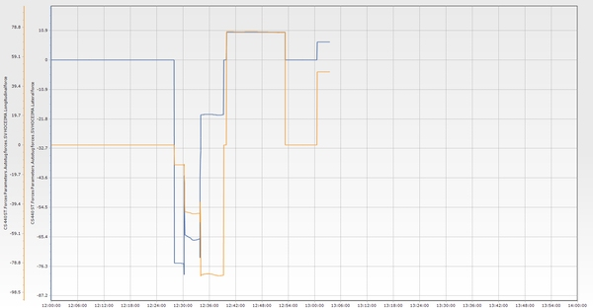

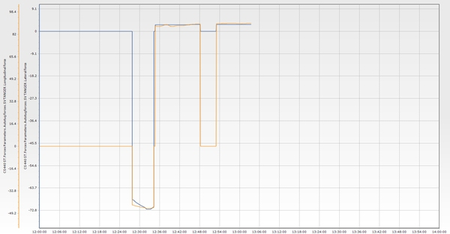

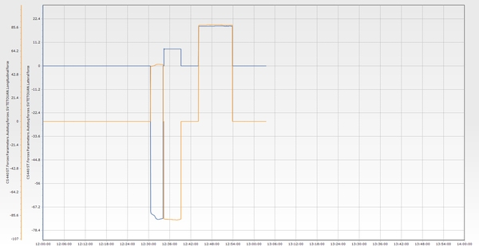

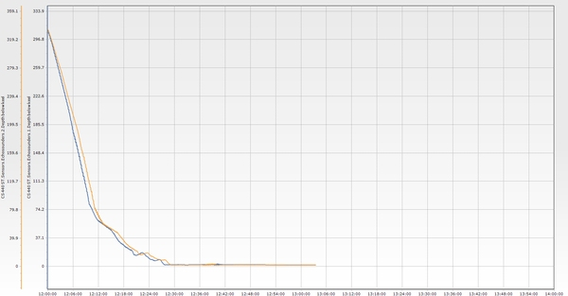

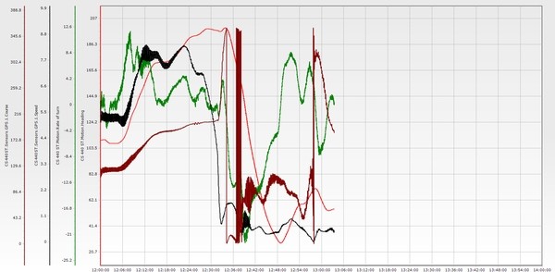

**Essai n° 3* (near miss)**

|  |  |  |  |  |  |  |  |  |  |  |  |  |
| --- | --- | --- | --- | --- | --- | --- | --- | --- | --- | --- | --- | --- |
| **Test n°** | **Condition** | **Wind** | **Wave** | **Current** | **Tide** | **Berth** | **Maneuver** | **Pilote** | **Side** | **Tugs** | **Entrance** | **Commentaire** |
| 3* (near miss) | E3 | NW 25 knt | NW 3m 14s | 3 knt 60°/N | 0,6 m | P2 | Accostage P2 tribord | Dourasse/ Berjal | Tribord | 4 Remorqueurs | TM3 | With wind and current pushing in the same direction, the vessel had to be kept as close as possible to the main breakwater to allow enough time and space to control the drift. The crossbeam distance to the green light was less than 10 meters — very tight. Four tugs were used to stop the vessel, with the engine at half astern. A 20-knot wind from the northwest was identified as the threshold limit. The vessel was swung to starboard and brought parallel to the berth, with the wind pushing it alongside. Note: The distance to the green light can be improved to one vessel breadth (50 meters) for increased safety. |

**Essai n° 3(bis)**

|  |  |  |  |  |  |  |  |  |  |  |  |  |
| --- | --- | --- | --- | --- | --- | --- | --- | --- | --- | --- | --- | --- |
| **Test n°** | **Condition** | **Wind** | **Wave** | **Current** | **Tide** | **Berth** | **Maneuver** | **Pilote** | **Side** | **Tugs** | **Entrance** | **Commentaire** |
| 3(bis) | E3 | NW 25 knt | NW 3m 14s | 3 knt 60°/N | 0,6 m | P2 | Accostage P2 tribord | RAF/ Berjal | Tribord | 4 Remorqueurs | TM3 | Northwest wind conditions at 25 knots with an easterly current of 3 knots. The vessel showed a normal tendency to sheer to starboard during the approach. It was necessary to maintain both course over ground (COG) and speed overground (SOG) to ensure a proper presentation at the correct angle, while avoiding overspeed to allow for a safe stop inside the port. Speed decreased significantly when approaching the port, making steering difficult. Additional engine power and assistance from the center lead tug were required to pass the entrance. Such conditions represent operational limits. For a vessel of this size, safe feasibility is clearly below 20 knots NW wind and 2 knots easterly current. Four tugs were necessary to perform the swing and bring the vessel starboard side alongside. |

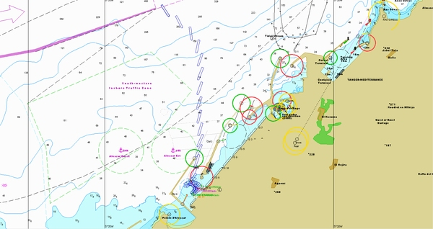

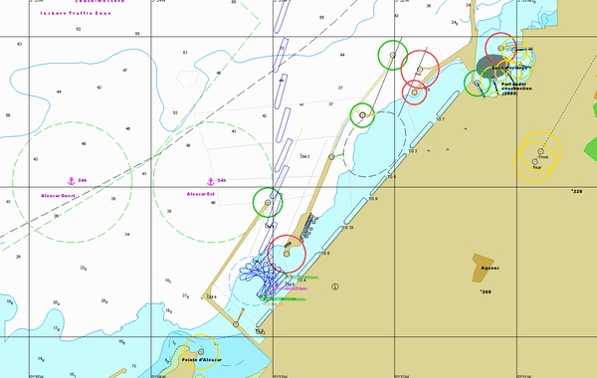

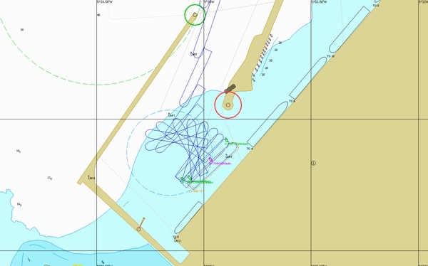

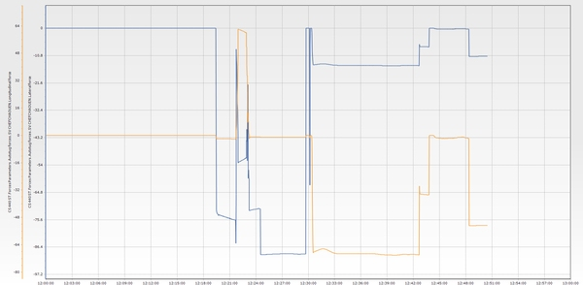

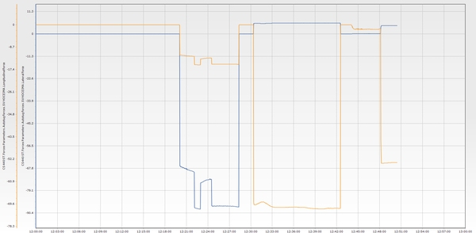

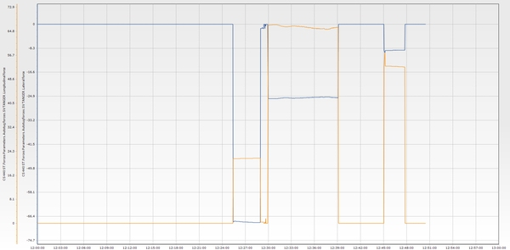

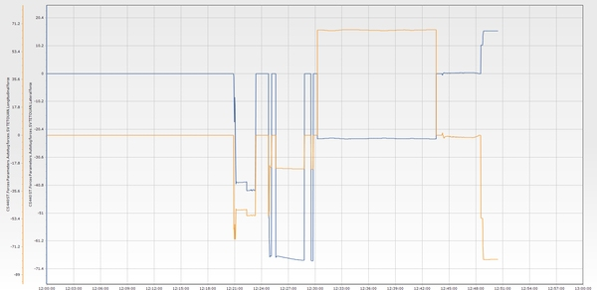

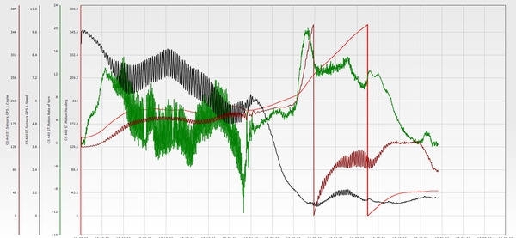

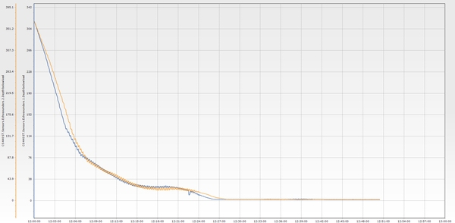

**Essai n° 4**

|  |  |  |  |  |  |  |  |  |  |  |  |  |
| --- | --- | --- | --- | --- | --- | --- | --- | --- | --- | --- | --- | --- |
| **Test n°** | **Condition** | **Wind** | **Wave** | **Current** | **Tide** | **Berth** | **Maneuver** | **Pilote** | **Side** | **Tugs** | **Entrance** | **Commentaire** |
| 4 | E4 | W 30 knt | W 3m 14s | 3 knt 60°/N | 0,6 m | P2 | Accostage P2 tribord | AndelAziz/ Naoufel | Tribord | 4 Remorqueurs | TM3 | Sheering during approach. It was necessary to use the engine for steering, which further increased the vessel’s speed, while the aft tugs could not be used effectively under westerly wind conditions. Once sheltered, using the engine astern produced a significant thrust effect. Three aft tugs were required to perform a starboard swing. |

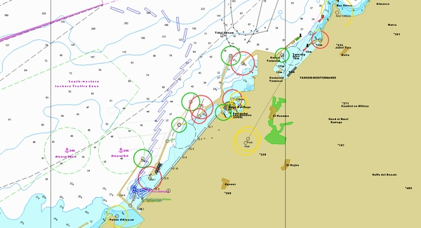

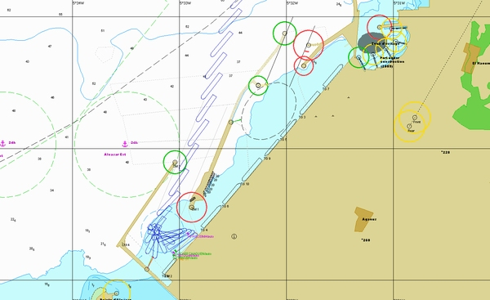

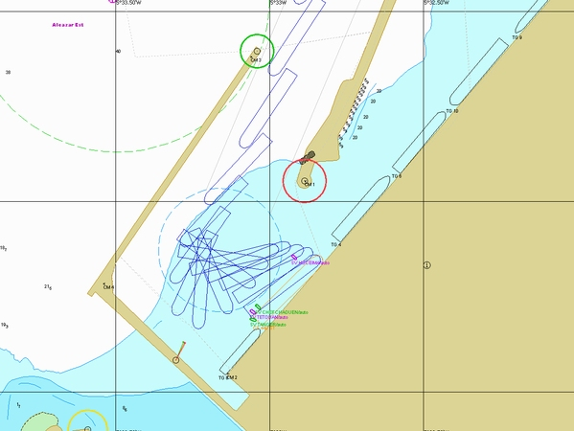

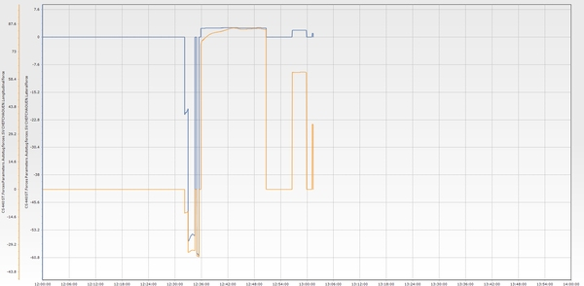

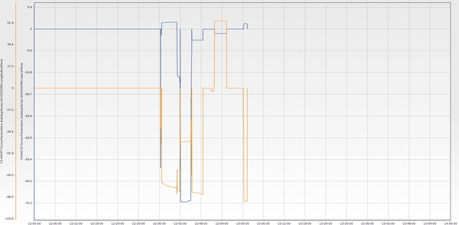

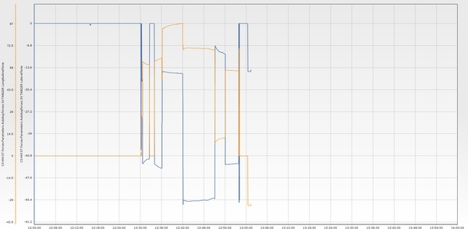

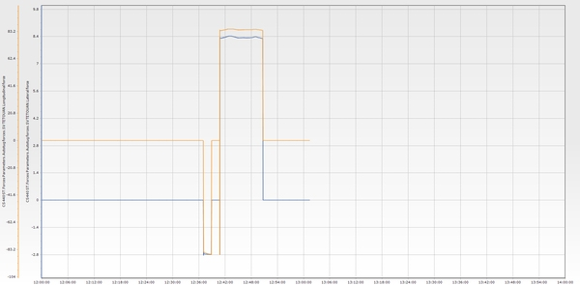

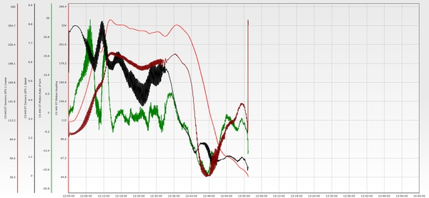

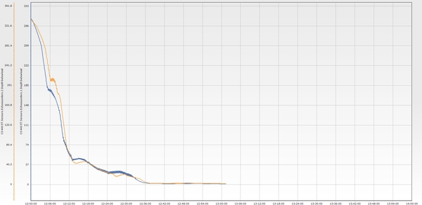

**Essai n° 5**

|  |  |  |  |  |  |  |  |  |  |  |  |  |
| --- | --- | --- | --- | --- | --- | --- | --- | --- | --- | --- | --- | --- |
| **Test n°** | **Condition** | **Wind** | **Wave** | **Current** | **Tide** | **Berth** | **Maneuver** | **Pilote** | **Side** | **Tugs** | **Entrance** | **Commentaire** |
| 5 | E5 | SE 25 knt | NE 3m 14s | Null | 0,6 m | P2 | Accostage P2 bâbord | Rafouk/ Berjal | Bâbord | 5 Remorqueurs | TM3 | 25 knots of southeast wind with no current. Emergency situation: the bow thruster (BT) was unavailable when engaged inside the port. The presentation was acceptable, although the bow was challenging to control as it sought the wind. It was necessary to use the engine to maintain a positive rate of turn (ROT). Speed was kept under control to pass the entrance. Once inside, it was difficult to stop the vessel’s inertia with only one tug reducing speed. It was essential to maintain two tugs aft for braking, in order to avoid using the engine full astern. To bring the vessel port side alongside, five tugs and the stern thruster were required. |

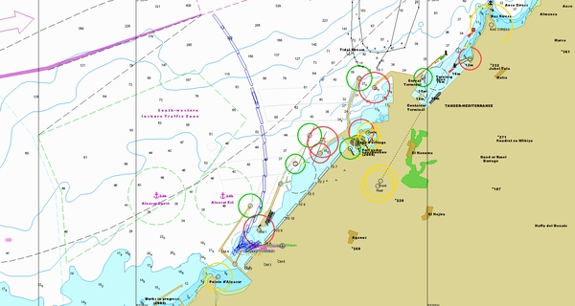

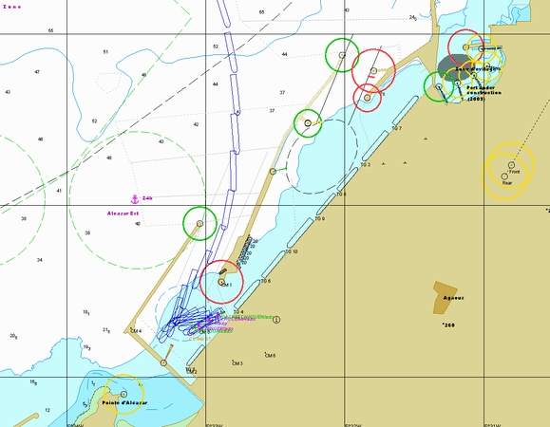

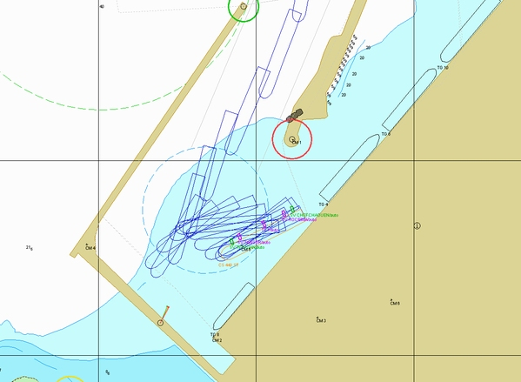

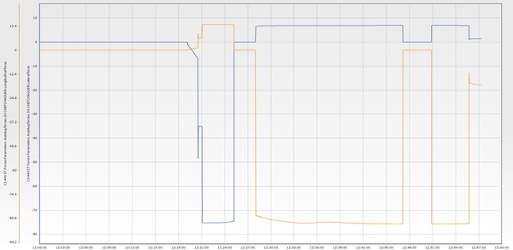

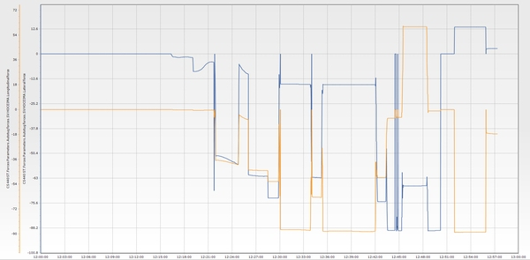

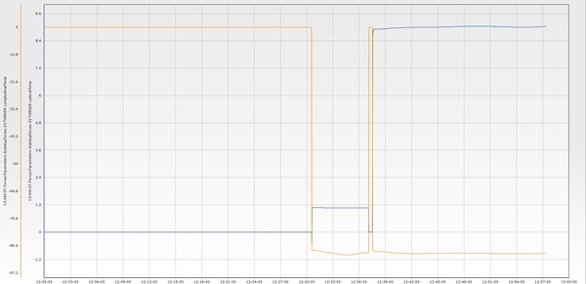

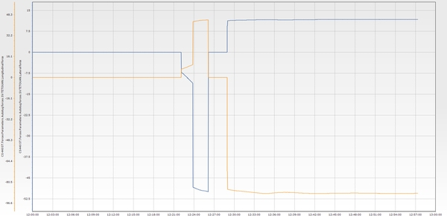

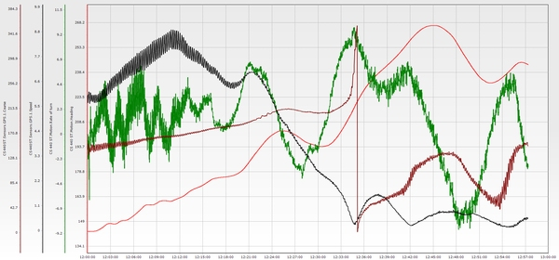

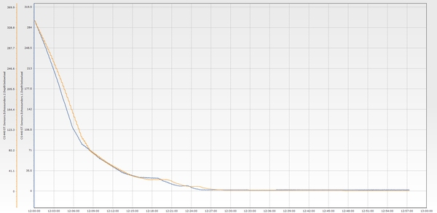

**Essai n° 6**

|  |  |  |  |  |  |  |  |  |  |  |  |  |
| --- | --- | --- | --- | --- | --- | --- | --- | --- | --- | --- | --- | --- |
| **Test n°** | **Condition** | **Wind** | **Wave** | **Current** | **Tide** | **Berth** | **Maneuver** | **Pilote** | **Side** | **Tugs** | **Entrance** | **Commentaire** |
| 6 | E1 | NE 25 knt | NE 2,5m 12s | 3 knt 60°/N | 0,6 m | P2 | Accostage P2 tribord | Reda Mariky | Tribord | 4 Remorqueurs | TM3 | It is preferable to hook the forward starboard tug to reduce speed and ensure a reasonable speed when passing through the channel. |

**Essai n° 6(bis)**

|  |  |  |  |  |  |  |  |  |  |  |  |  |
| --- | --- | --- | --- | --- | --- | --- | --- | --- | --- | --- | --- | --- |
| **Test n°** | **Condition** | **Wind** | **Wave** | **Current** | **Tide** | **Berth** | **Maneuver** | **Pilote** | **Side** | **Tugs** | **Entrance** | **Commentaire** |
| 6(bis) | E1 | NE 25 knt | NE 2,5m 12s | 3 knt 60°/N | 0,6 m | P2 | Accostage P2 tribord | mefsioui | Tribord | 4 Remorqueurs | TM3 | Assisted by 4 tugboats, the presentation and turning maneuver were well controlled. During berthing, all 4 tugboats were engaged at full power. |

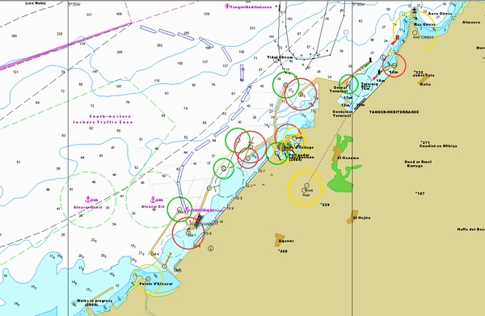

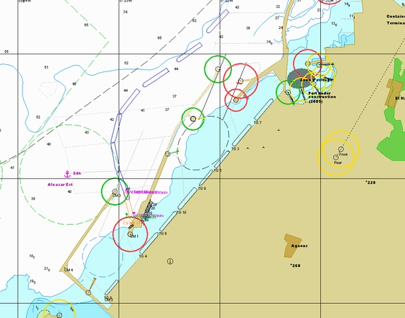

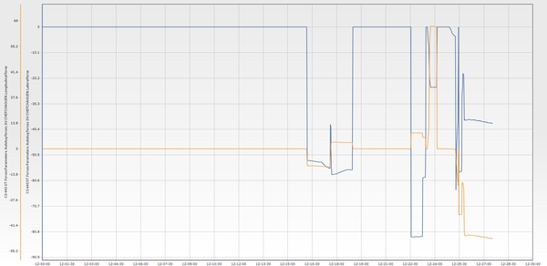

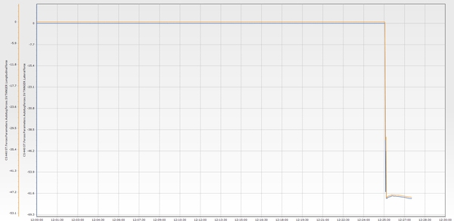

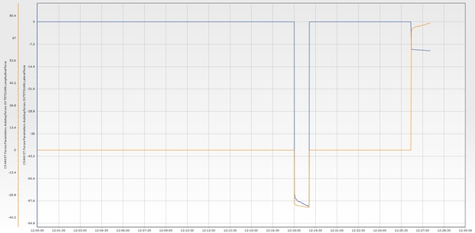

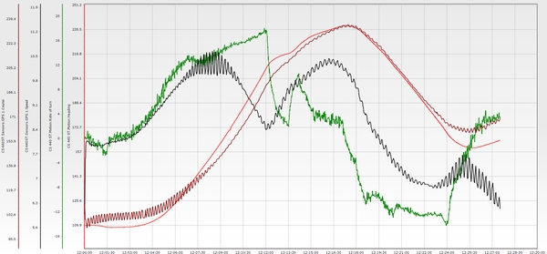

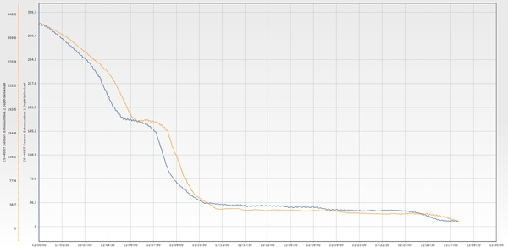

**Essai n° 7**

|  |  |  |  |  |  |  |  |  |  |  |  |  |
| --- | --- | --- | --- | --- | --- | --- | --- | --- | --- | --- | --- | --- |
| **Test n°** | **Condition** | **Wind** | **Wave** | **Current** | **Tide** | **Berth** | **Maneuver** | **Pilote** | **Side** | **Tugs** | **Entrance** | **Commentaire** |
| 7 | E2 | E 25 knt | NE 2,5m 12s | 1 knt 240°/N | 0,6 m | P2 | Appareillage P2 tribord | Dourasse/ Berjal | Tribord | 3 Remorqueurs | TM3 | Departure with onshore wind: Three tugs were used to pull and center the vessel in the turning area, with the bow aligned to initiate the approach to the entrance. Speed gradually built up with the wind on the forward quarter, using engine power and the centerline bow tug pulling from the 6 o’clock position. Crossing speed was maintained at 5 knots. Starboard side alongside is the preferred option for departure. |

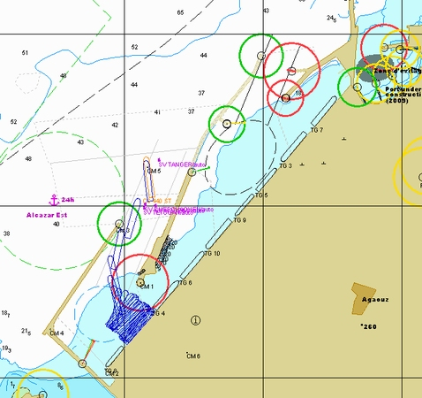

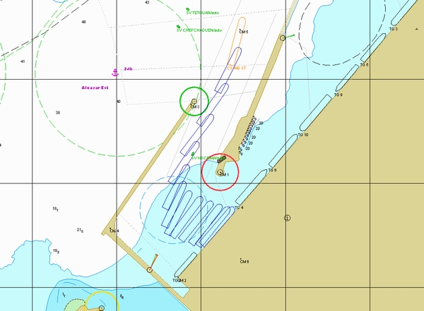

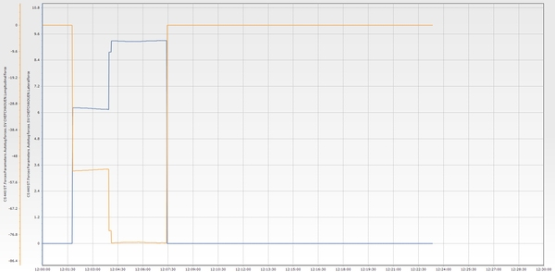

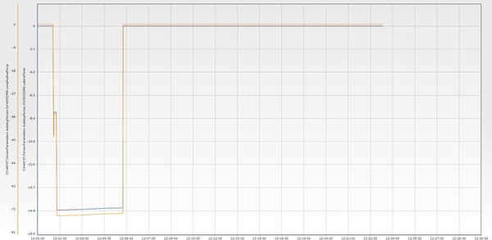

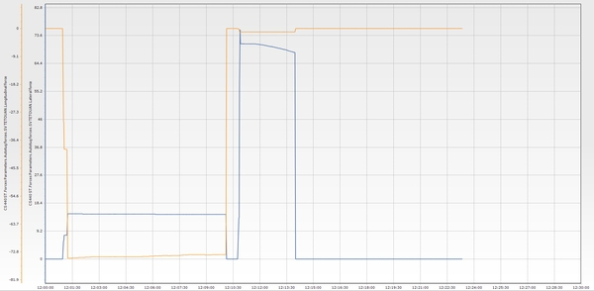

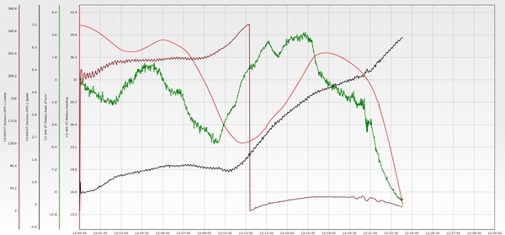

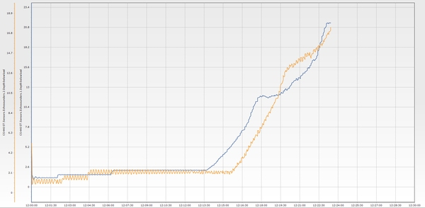

**Essai n° 8**

|  |  |  |  |  |  |  |  |  |  |  |  |  |
| --- | --- | --- | --- | --- | --- | --- | --- | --- | --- | --- | --- | --- |
| **Test n°** | **Condition** | **Wind** | **Wave** | **Current** | **Tide** | **Berth** | **Maneuver** | **Pilote** | **Side** | **Tugs** | **Entrance** | **Commentaire** |
| 8 | E3 | NW 20 knt | NW 3m 14s | 3 knt 60°/N | 0,6 m | P2 | Appareillage P2 tribord | Abdelaziz/Dourasse | Tribord | 4 Remorqueurs | TM3 | Unberthing starboard side with 4 tugs: Tug positions: center forward, port bow, center aft, and port quarter. The strategy is to bring the stern as much as possible into the wind, using the bow thruster to starboard if necessary. Once the vessel is in a good position, the bow is gradually brought to port. |

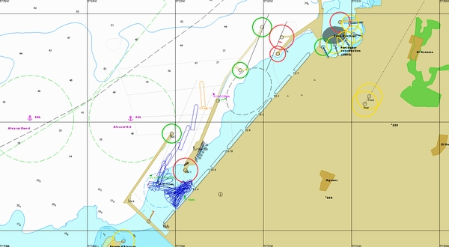

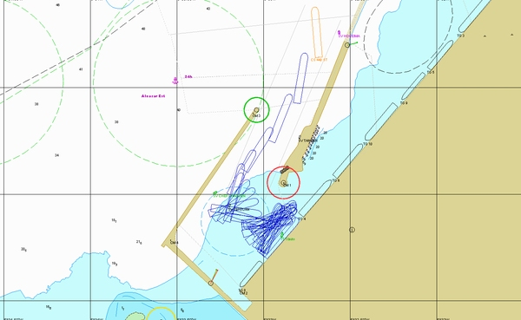

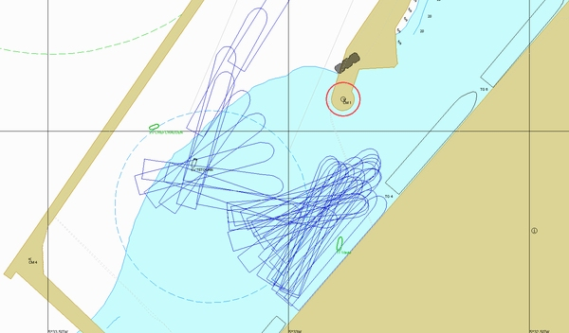

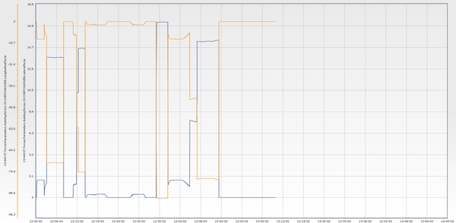

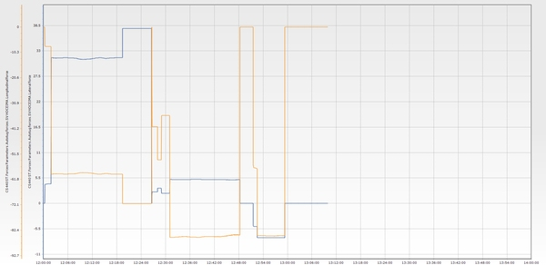

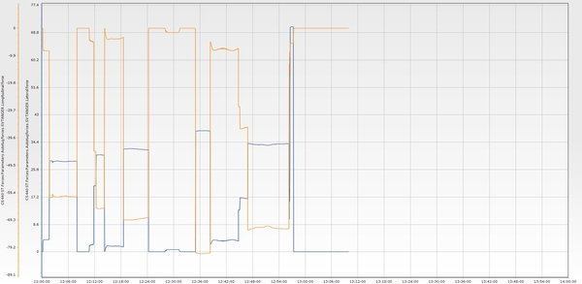

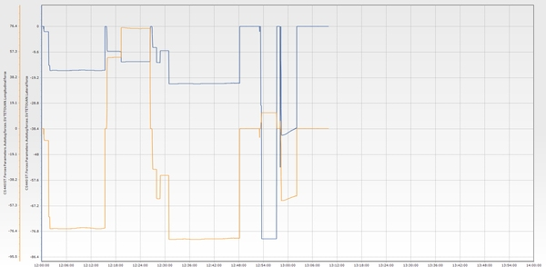

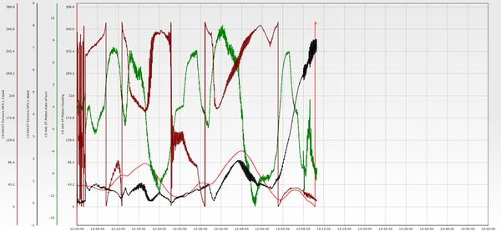

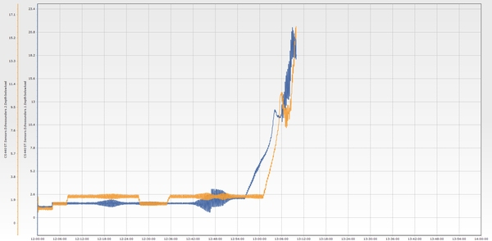

**Essai n° 9**

|  |  |  |  |  |  |  |  |  |  |  |  |  |
| --- | --- | --- | --- | --- | --- | --- | --- | --- | --- | --- | --- | --- |
| **Test n°** | **Condition** | **Wind** | **Wave** | **Current** | **Tide** | **Berth** | **Maneuver** | **Pilote** | **Side** | **Tugs** | **Entrance** | **Commentaire** |
| 9 | E4 | W 30 knt | W 3m 14s | 3 knt 60°/N | 0,6 m | P2 | Appareillage P2 tribord | Reda/Rachdi | Tribord | 4 Remorqueurs | TM3 | Use of 4 tugboats. The vessel was slow to get underway but quickly gained forward speed. The engine was set to slow astern to support the action of the aft tugs. It is recommended not to give too much advantage to the bow when approaching the channel, as the vessel tends to luff significantly. The channel was crossed at 6 knots, with the engine at full ahead at times. |



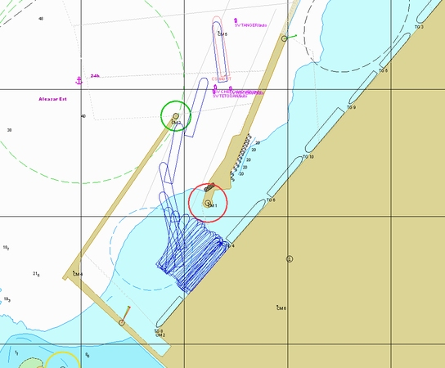

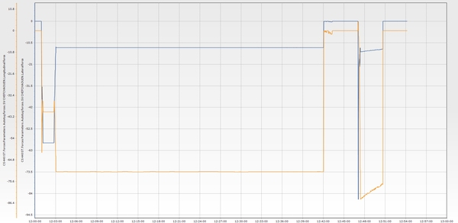

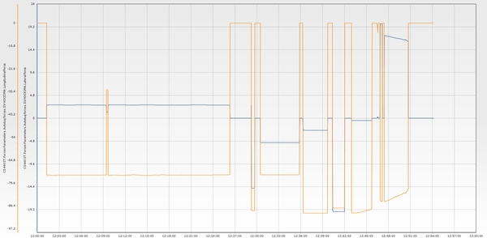

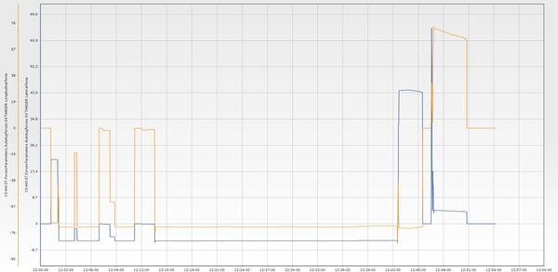

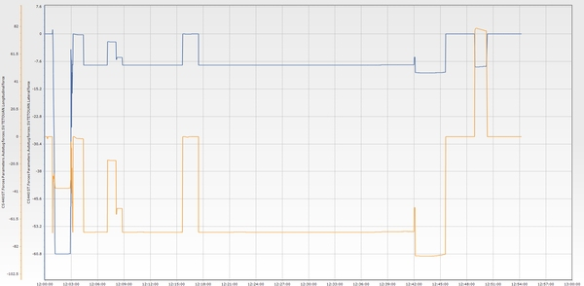

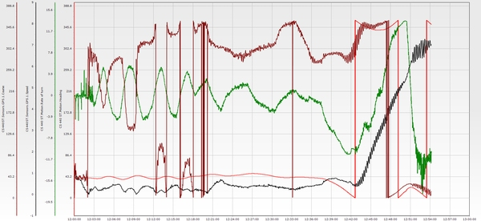

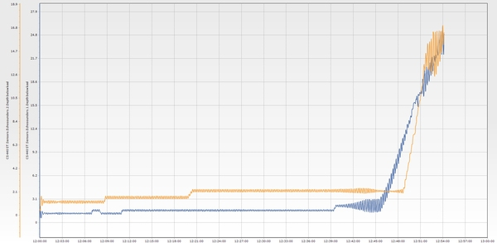

**Essai n° 10**

|  |  |  |  |  |  |  |  |  |  |  |  |  |
| --- | --- | --- | --- | --- | --- | --- | --- | --- | --- | --- | --- | --- |
| **Test n°** | **Condition** | **Wind** | **Wave** | **Current** | **Tide** | **Berth** | **Maneuver** | **Pilote** | **Side** | **Tugs** | **Entrance** | **Commentaire** |
| 10 | E1 | NE 25 knt | NE 2,5m 12s | 3 knt 60°/N | 0,6 m | P3 | Accostage P3 tribord | RAF/ Berjal | Tribord | 4 Remorqueurs | TM2 | Northeast wind conditions at 25 knots with an easterly current of 3 knots. The vessel's presentation was south of the planned passage for the TM2 entrance, requiring a full turn to port to align the vessel at the correct course over ground (COG). The entrance from TM2 was approached at a speed of 7 knots, passing all vessels alongside at a safe distance. Speed was reduced using the aft tug and the forward tug positioned at the center lead. After passing the TM3 red light, the berth vessel was close to port-side vessels. Swinging to starboard was not safe due to insufficient room at the port quarter. Safe berthing was achieved port side alongside. Four tugs were used. |

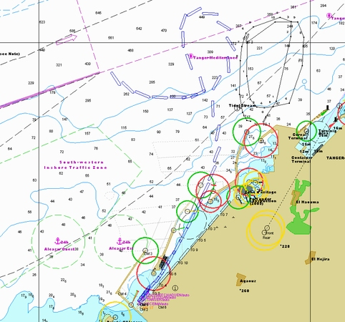

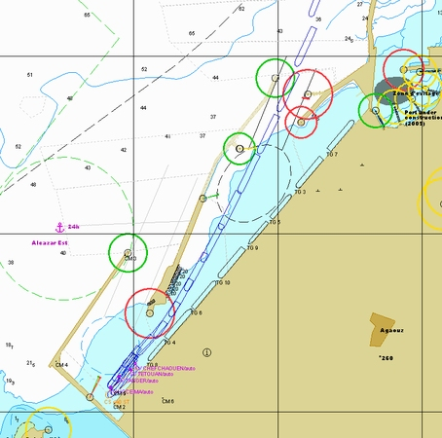

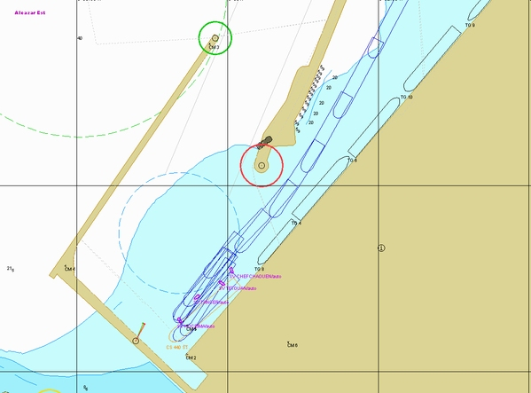

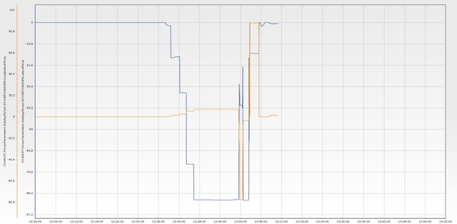

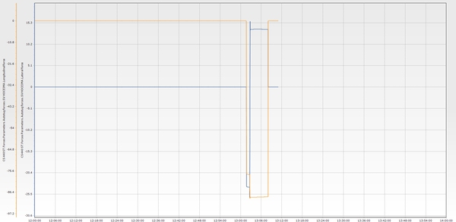

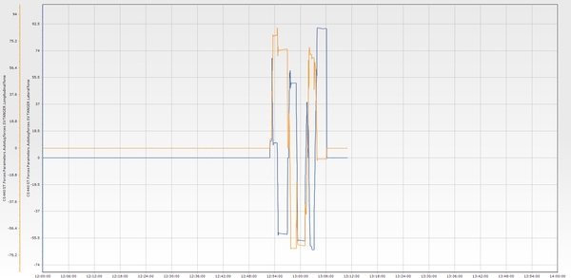

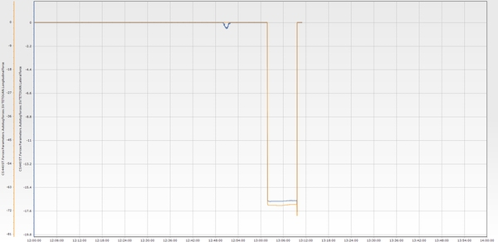

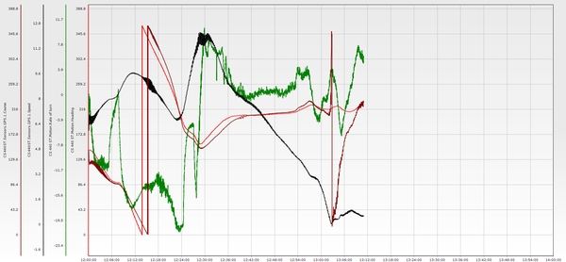

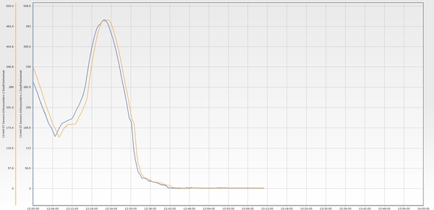

**Essai n° 11**

|  |  |  |  |  |  |  |  |  |  |  |  |  |
| --- | --- | --- | --- | --- | --- | --- | --- | --- | --- | --- | --- | --- |
| **Test n°** | **Condition** | **Wind** | **Wave** | **Current** | **Tide** | **Berth** | **Maneuver** | **Pilote** | **Side** | **Tugs** | **Entrance** | **Commentaire** |
| 11 | E3 | SW 25 knt | NW 3m 14s | 3 knt 60°/N | 0,6 m | P2 | Accostage P2 tribord | Soerensen / Dourasse | Tribord | 4 Remorqueurs | TM3 | The initial turn was too wide, resulting in an unfavorable position during the approach. It was difficult to initiate a port turn at the breakwater, even with four tugs, due to the wind conditions. Once inside, the vessel turned to port using three aft tugs to bring the stern up into the wind. |

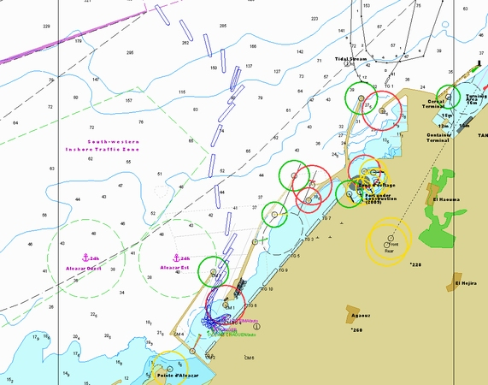

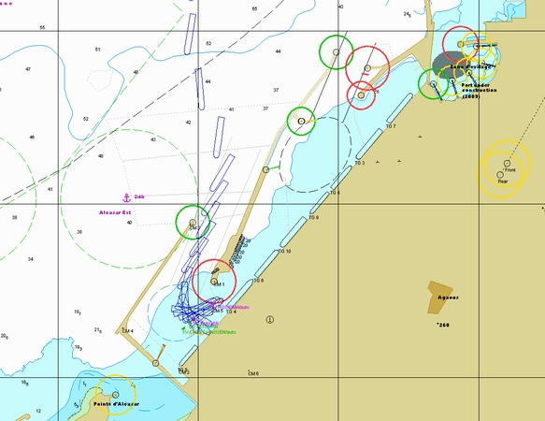

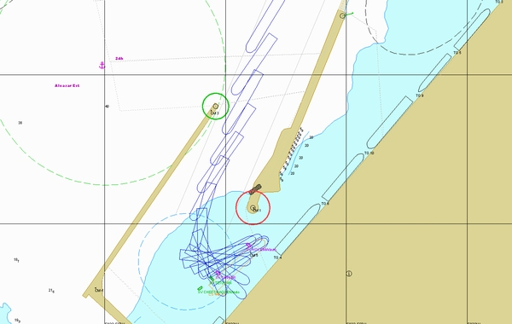

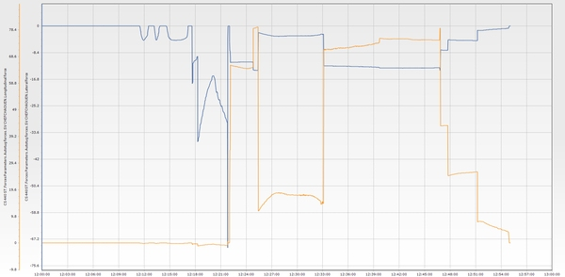

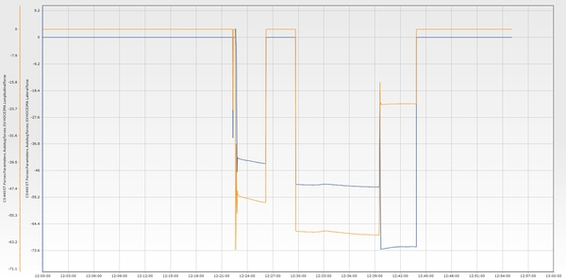

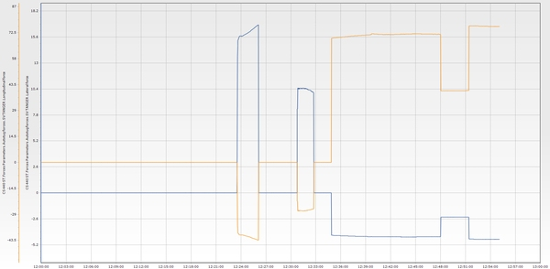

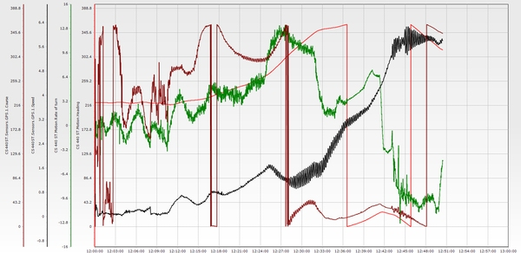

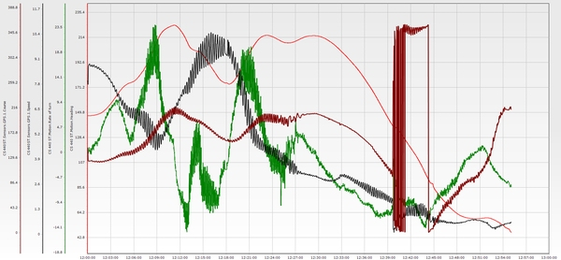

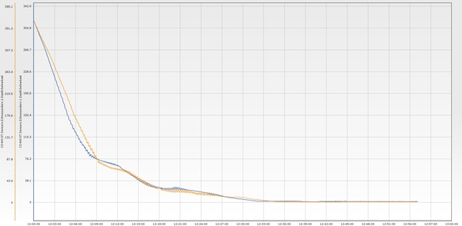

**Essai n° 12**

|  |  |  |  |  |  |  |  |  |  |  |  |  |
| --- | --- | --- | --- | --- | --- | --- | --- | --- | --- | --- | --- | --- |
| **Test n°** | **Condition** | **Wind** | **Wave** | **Current** | **Tide** | **Berth** | **Maneuver** | **Pilote** | **Side** | **Tugs** | **Entrance** | **Commentaire** |
| 12 | E2 | E 25 knt | NE 2,5m 12s | 1 knt 240°/N | 0,6 m | P3 | Accostage P3 tribord | REDA/ BERJAL | Tribord | 4 Remorqueurs | TM3 | Berthing with an easterly wind of 25 knots. The maneuver failed: the vessel was unable to turn to starboard and continued drifting toward the TM2 breakwater. Due to the vessel’s large windage and inertia, it is essential to maintain continuous control of the rate of turn. The rate of turning to port must not be allowed to increase excessively, as the vessel may no longer be able to regain a positive rate of turn — even with the engine at full ahead. |

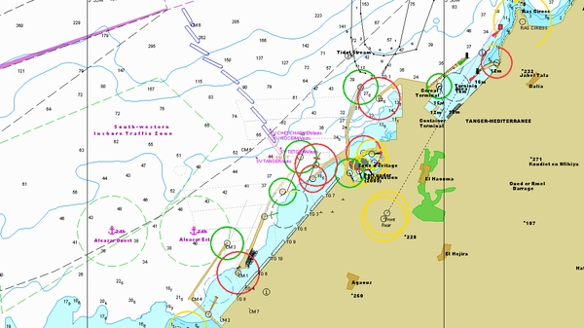

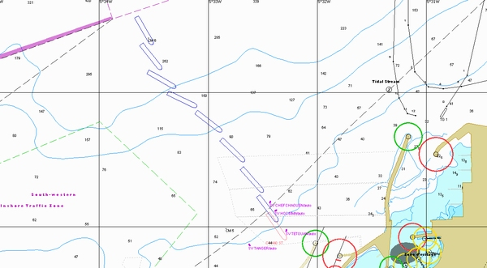

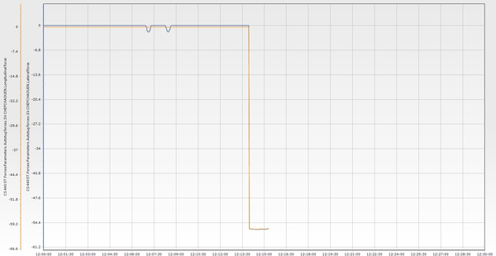

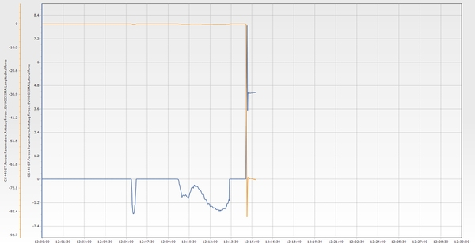

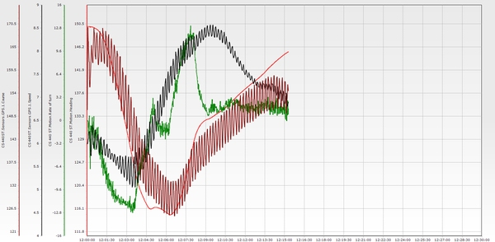

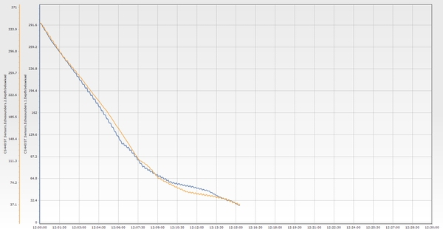

**Essai n° 12 BIS**

|  |  |  |  |  |  |  |  |  |  |  |  |  |
| --- | --- | --- | --- | --- | --- | --- | --- | --- | --- | --- | --- | --- |
| **Test n°** | **Condition** | **Wind** | **Wave** | **Current** | **Tide** | **Berth** | **Maneuver** | **Pilote** | **Side** | **Tugs** | **Entrance** | **Commentaire** |
| 12 BIS | E2 | E 25 knt | NE 2,5m 12s | 1 knt 240°/N | 0,6 m | P3 | Accostage P3 tribord | RAF/ REDA | Tribord | 4 Remorqueurs | TM3 | Failed maneuver. It is essential to keep the helm hard to starboard and maintain a positive rate of turn, as the vessel luffs significantly and it becomes difficult to recover a positive ROT. |

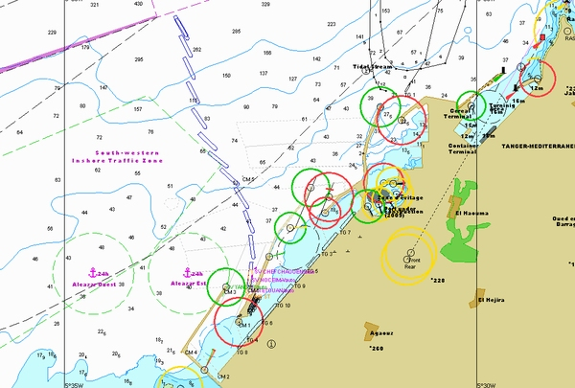

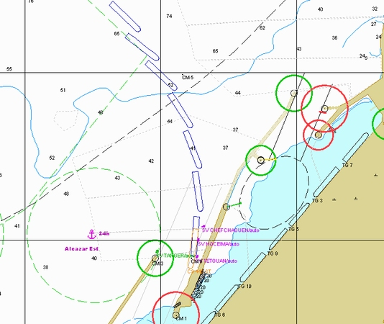

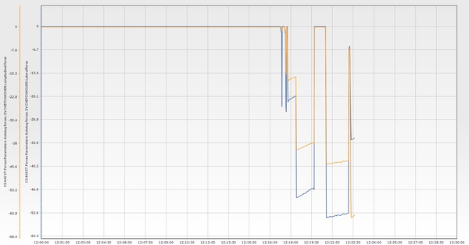

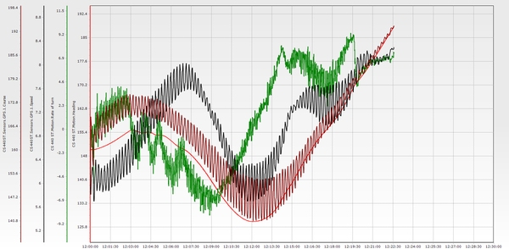

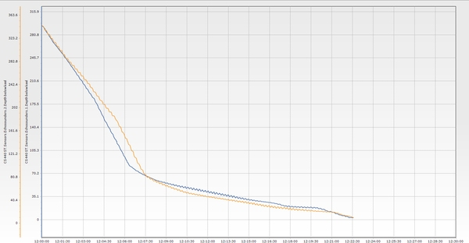

**Essai n° 13**

|  |  |  |  |  |  |  |  |  |  |  |  |  |
| --- | --- | --- | --- | --- | --- | --- | --- | --- | --- | --- | --- | --- |
| **Test n°** | **Condition** | **Wind** | **Wave** | **Current** | **Tide** | **Berth** | **Maneuver** | **Pilote** | **Side** | **Tugs** | **Entrance** | **Commentaire** |
| 13 | E4 | W 30 knt | W 3m 14s | 3 knt 60°/N | 0,6 m | P1 | Accostage P1 tribord | Rahoui/ BERJAL | Tribord | 4 Remorqueurs | TM3 | Strong drift to port due to a strong westerly wind and a 3-knot easterly current. Even with the engine at full ahead to increase speed and steer out of the entrance, it was difficult to control the port-side drift. The vessel entered too close to the secondary pier. |

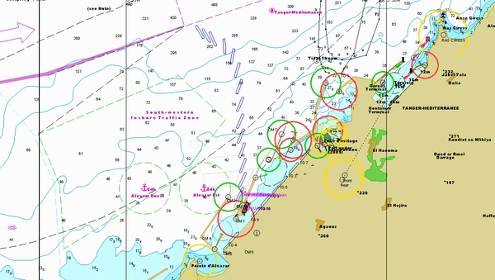

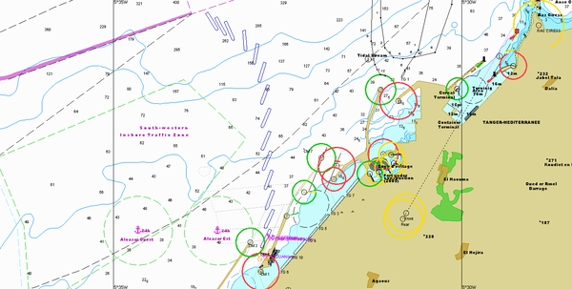

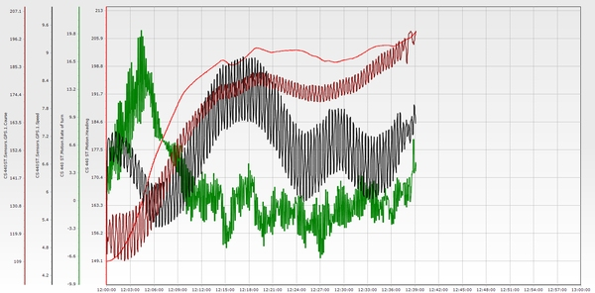

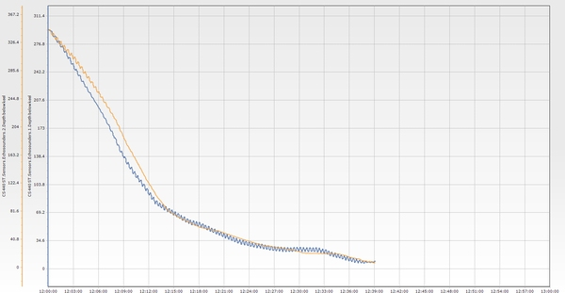

**Essai n° 13 Bis**

|  |  |  |  |  |  |  |  |  |  |  |  |  |
| --- | --- | --- | --- | --- | --- | --- | --- | --- | --- | --- | --- | --- |
| **Test n°** | **Condition** | **Wind** | **Wave** | **Current** | **Tide** | **Berth** | **Maneuver** | **Pilote** | **Side** | **Tugs** | **Entrance** | **Commentaire** |
| 13 Bis | E4 | W 30 knt | W 3m 14s | 3 knt 60°/N | 0,6 m | P1 | Accostage P1 tribord | Dourasse/ Berjal | Tribord | 4 Remorqueurs | TM3 | Proceed to the entrance with adequate speed and a clear strategy to manage the drift caused by the combined effect of westerly wind and current. The impact of a 30-knot wind on the beam near the green light is too strong and represents a limitation for vessels of this class. Even if the jetties are avoided, the challenge of swinging the vessel under such conditions remains a critical limitation. A 30-knot westerly wind has been identified as the operational limit, as two trial attempts failed under these conditions. Next step: attempt the maneuver with 25 knots. |

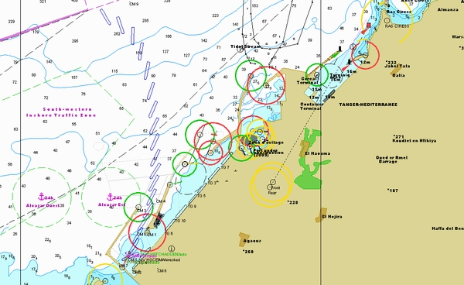

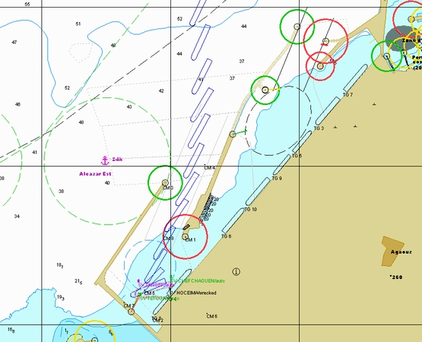

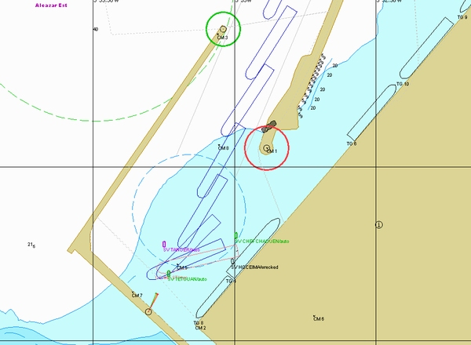

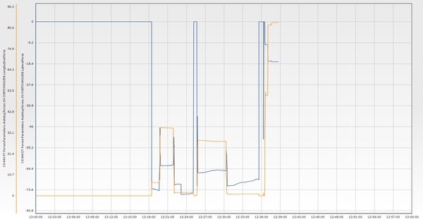

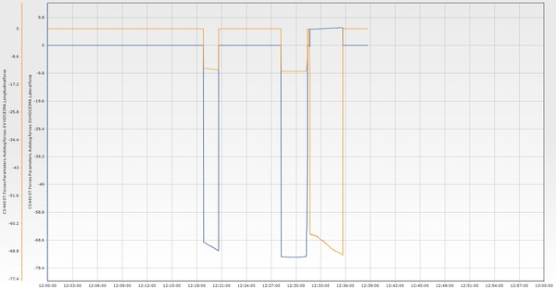

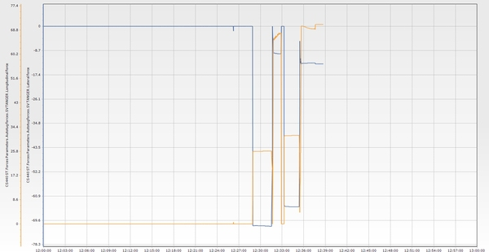

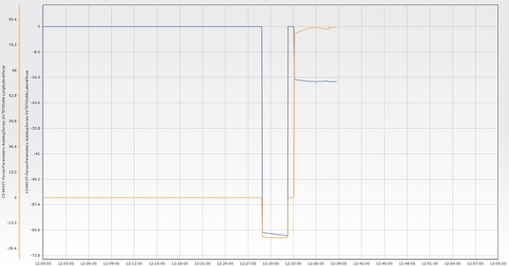

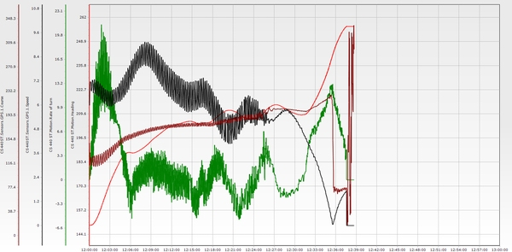

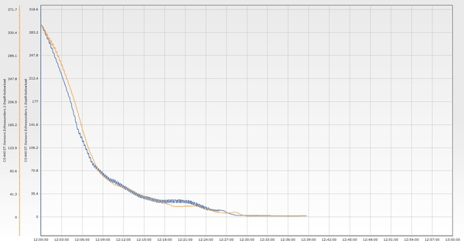

**Essai n° 13 Ter**

|  |  |  |  |  |  |  |  |  |  |  |  |  |
| --- | --- | --- | --- | --- | --- | --- | --- | --- | --- | --- | --- | --- |
| **Test n°** | **Condition** | **Wind** | **Wave** | **Current** | **Tide** | **Berth** | **Maneuver** | **Pilote** | **Side** | **Tugs** | **Entrance** | **Commentaire** |
| 13 Ter | E4 | W 25 knt | W 3m 14s | 3 knt 60°/N | 0,6 m | P1 | Accostage P1 tribord | Rahoui | Tribord | 4 Remorqueurs | TM3 | Presentation was satisfactory, with adjustments to heading and speed effectively counteracting the drift to starboard. Passage speed was manageable. The vessel was brought to a stop at the turning circle using the engine and three tugs. Starboard swing was successfully executed. |

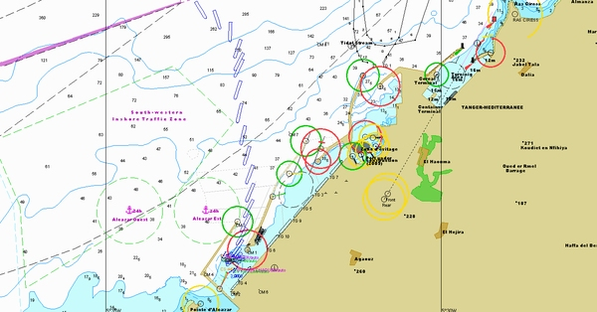

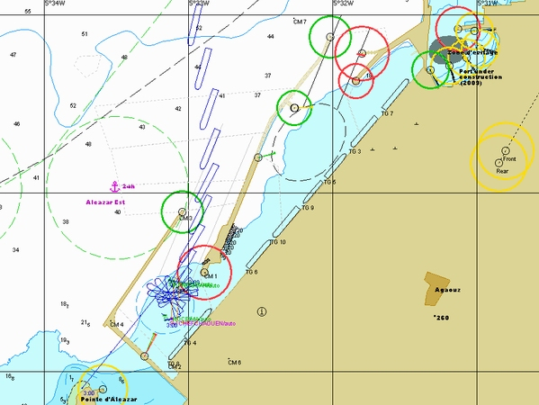

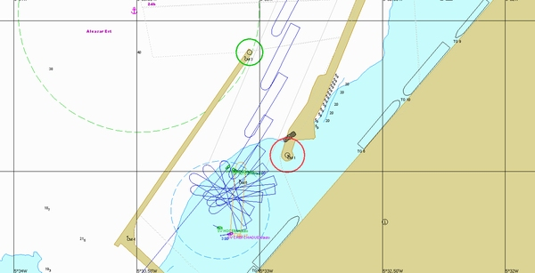

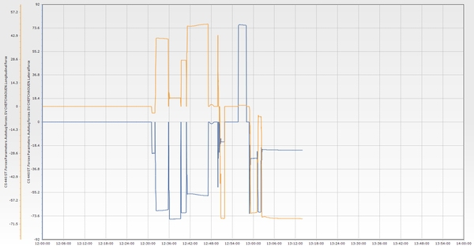

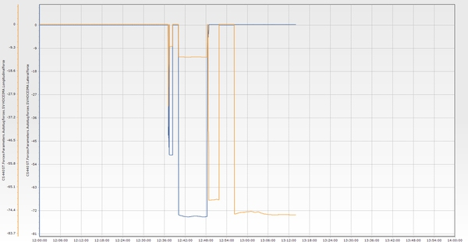

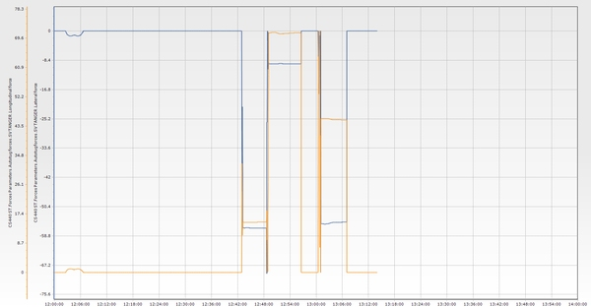

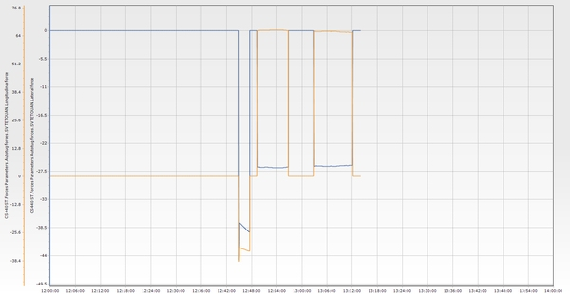

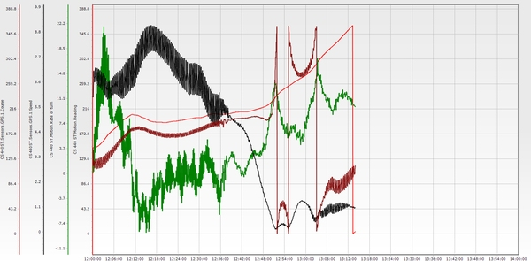

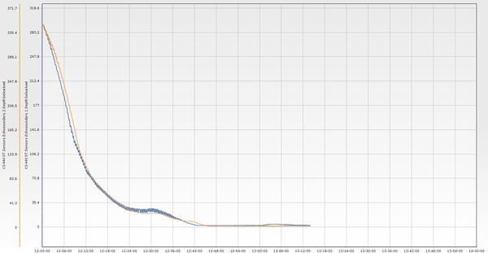

**Essai n° 14**

|  |  |  |  |  |  |  |  |  |  |  |  |  |
| --- | --- | --- | --- | --- | --- | --- | --- | --- | --- | --- | --- | --- |
| **Test n°** | **Condition** | **Wind** | **Wave** | **Current** | **Tide** | **Berth** | **Maneuver** | **Pilote** | **Side** | **Tugs** | **Entrance** | **Commentaire** |
| 14 | E2 | E 25 knt | NE 2,5m 12s | 1 knt 240°/N | 0,6 m | P1 | Accostage P1 tribord | RAF/MEFSIOUI | Tribord | 4 Remorqueurs | TM3 | Successful maneuver. The rate of turn (ROT) did not exceed 12 degrees. The passage plan must be followed to ensure the success of the maneuver. Tugboats were engaged at the port entrance, and berthing was well controlled. The bollard pull of the tugboats at TM3 must exceed 100 tons. |

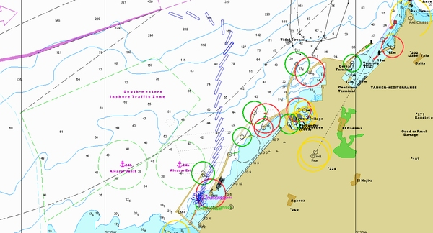

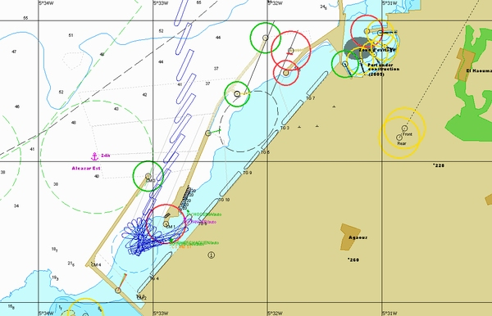

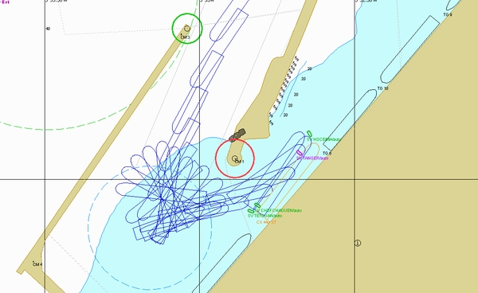

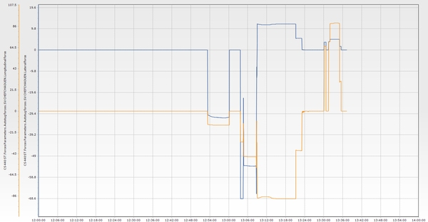

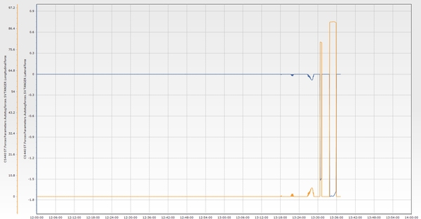

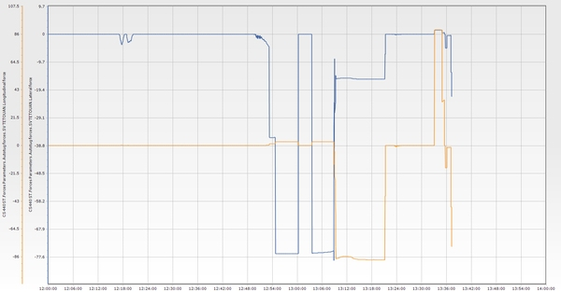

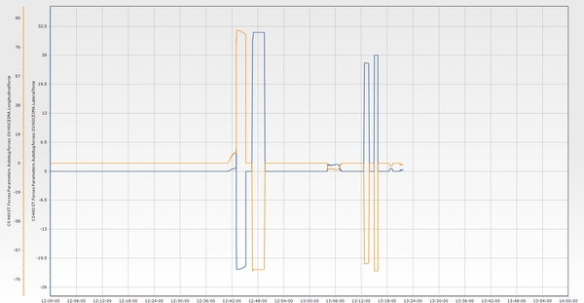

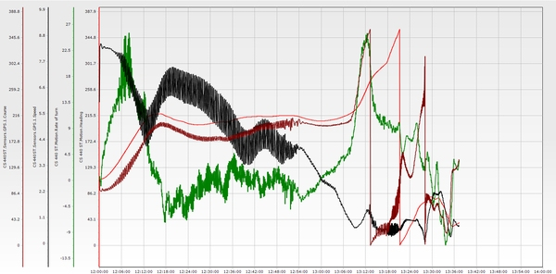

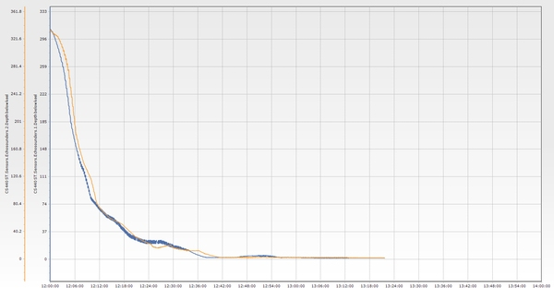

**Essai n° 15\***

|  |  |  |  |  |  |  |  |  |  |  |  |  |
| --- | --- | --- | --- | --- | --- | --- | --- | --- | --- | --- | --- | --- |
| **Test n°** | **Condition** | **Wind** | **Wave** | **Current** | **Tide** | **Berth** | **Maneuver** | **Pilote** | **Side** | **Tugs** | **Entrance** | **Commentaire** |
| 15* | E1 | NE 25 knt | NE 2,5m 12s | 3 knt 60°/N | 0,6 m | P1 | Appareillage P1 tribord | Dourasse/ Berjal | Tribord | 3 Remorqueurs | TM3 | Departure from the berth using two aft tugs and one forward tug. With the support of the onshore wind, efforts were made to control the vessel’s drift in order to reach the turning area in a good position to approach the entrance. It was important to anticipate the port turn to proceed to open sea while maintaining a safe distance from the TM2 main jetty. Special precautions are essential under easterly wind conditions. |

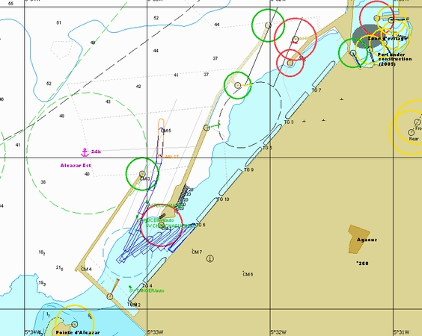

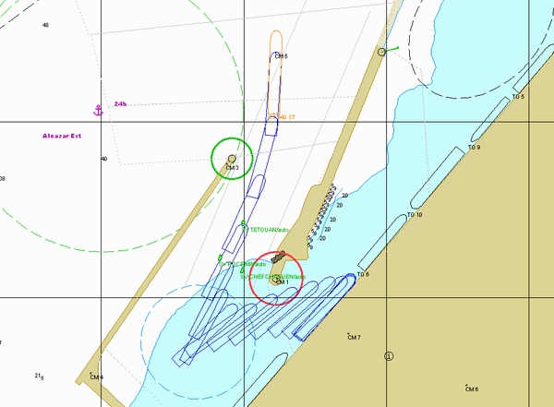

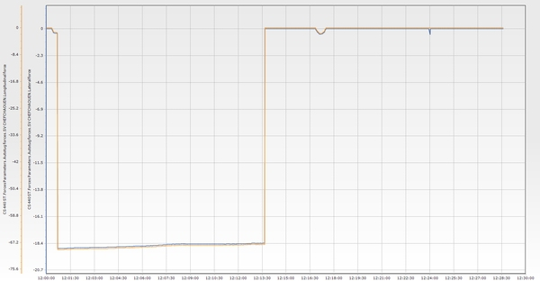

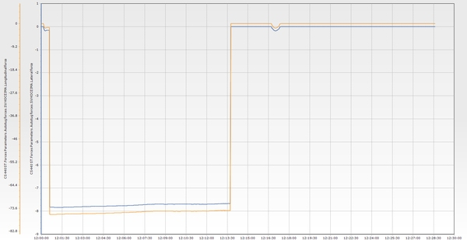

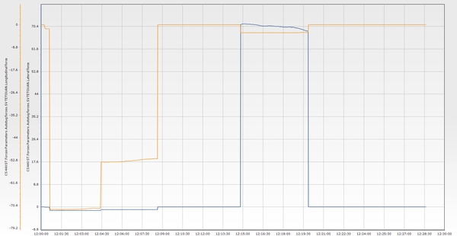

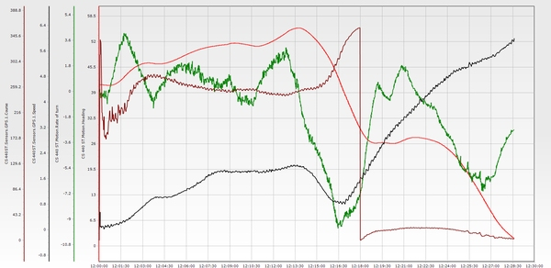

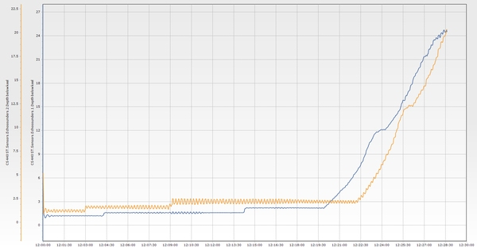

**Essai n° 16**

|  |  |  |  |  |  |  |  |  |  |  |  |  |
| --- | --- | --- | --- | --- | --- | --- | --- | --- | --- | --- | --- | --- |
| **Test n°** | **Condition** | **Wind** | **Wave** | **Current** | **Tide** | **Berth** | **Maneuver** | **Pilote** | **Side** | **Tugs** | **Entrance** | **Commentaire** |
| 16 | E5 | SE 25 knt | NE 3m 14s | 3 knt 60°/N | 0,6 m | P3 | Appareillage P3 bâbord | Dourasse/ Berjal | Bâbord | 4 Remorqueurs | TM3 | Once the vessel is clear of the berth, begin the starboard swing while keeping the wind head-on. Control the astern speed and stop the vessel in the turning area. Use four tugs to perform the swing and proceed toward the entrance, initiating the port turn early to prevent the vessel from sharing into the wind. This is a very important precaution under southeast (SE) wind conditions, even more so than under northeast (NE) conditions. |

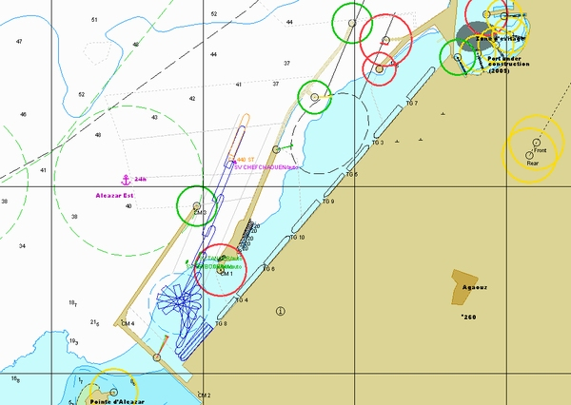

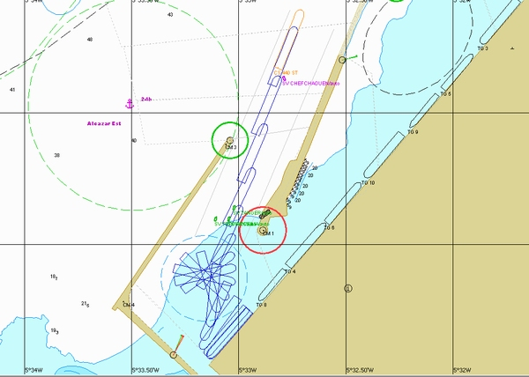

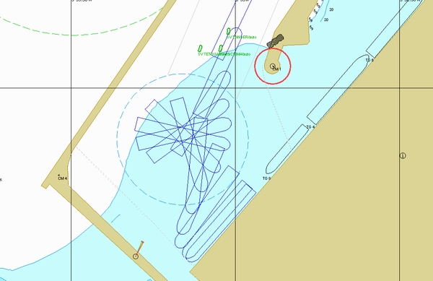

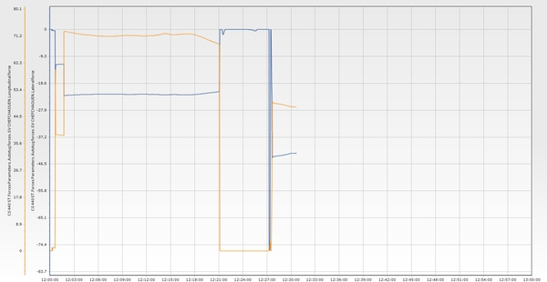

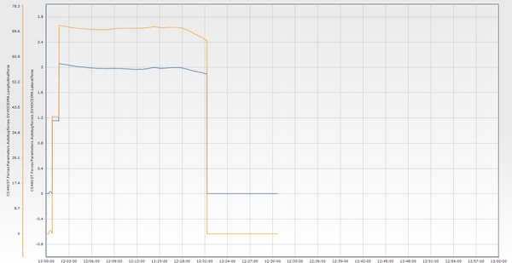

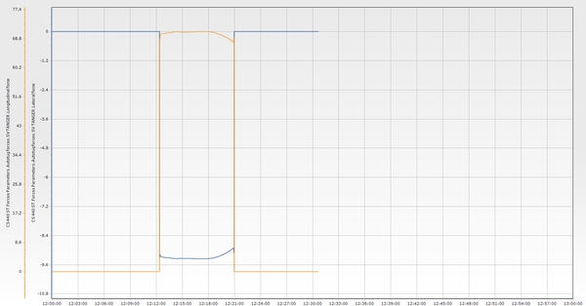

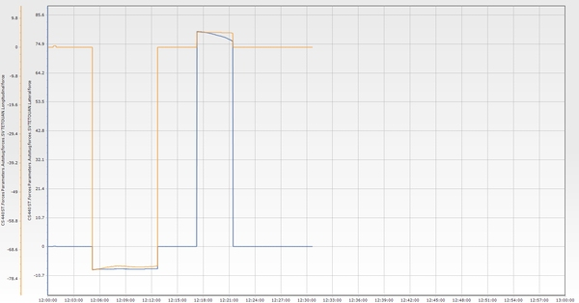

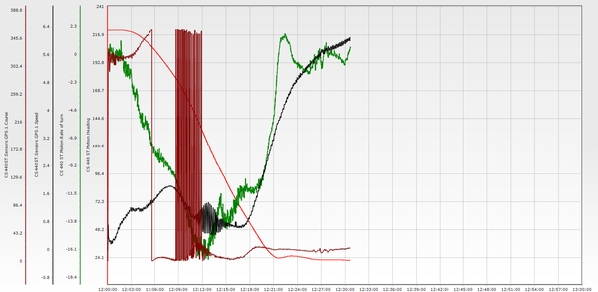

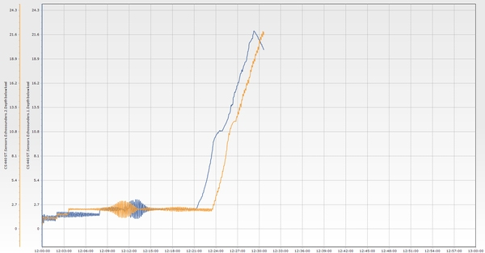

**Essai n° 17**

|  |  |  |  |  |  |  |  |  |  |  |  |  |
| --- | --- | --- | --- | --- | --- | --- | --- | --- | --- | --- | --- | --- |
| **Test n°** | **Condition** | **Wind** | **Wave** | **Current** | **Tide** | **Berth** | **Maneuver** | **Pilote** | **Side** | **Tugs** | **Entrance** | **Commentaire** |
| 17 | E2 | E 25 knt | NE 2,5m 12s | 1 knt 240°/N | 0,6 m | P3 | Appareillage P3 tribord | Rafouq/ Rachdi | Tribord | 3 Remorqueurs | TM3 | Departure starboard side alongside at P1. Wind: 25 knots from the east. Current: 3 knots easterly. The vessel’s bow was oriented toward the port entrance. Three tugs were used to control lateral drift and align the vessel with the entrance. It was necessary to quickly build up longitudinal speed to maintain control of the vessel’s trajectory toward the entrance. Maneuver successful. |

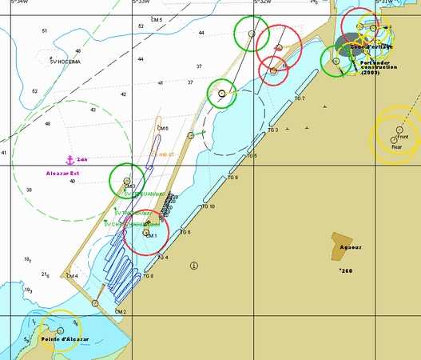

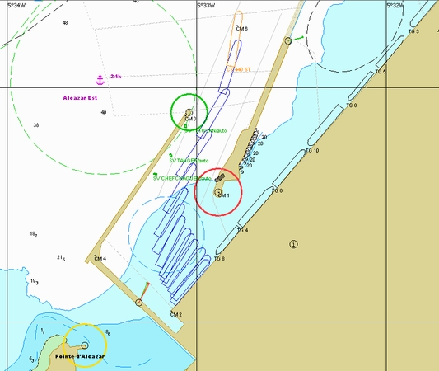

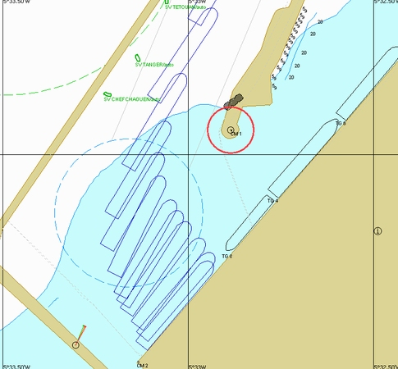

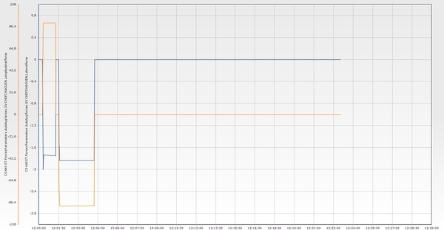

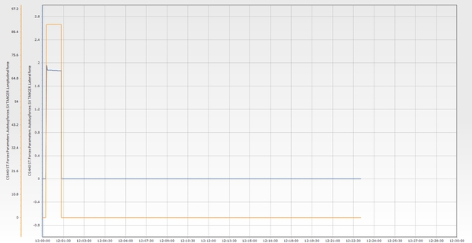

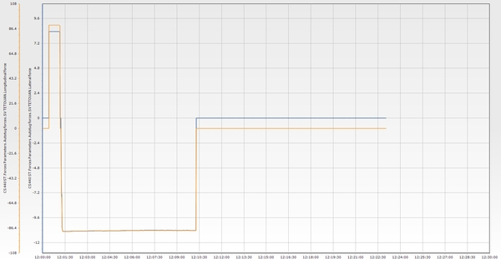

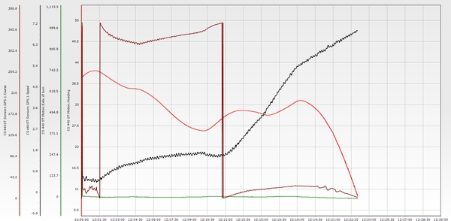

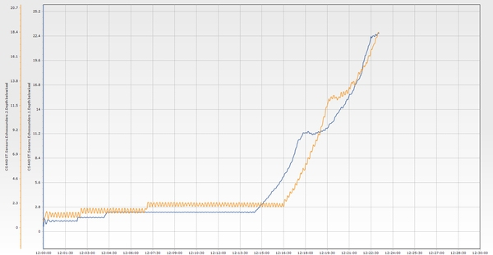

**Essai n° 18**

|  |  |  |  |  |  |  |  |  |  |  |  |  |
| --- | --- | --- | --- | --- | --- | --- | --- | --- | --- | --- | --- | --- |
| **Test n°** | **Condition** | **Wind** | **Wave** | **Current** | **Tide** | **Berth** | **Maneuver** | **Pilote** | **Side** | **Tugs** | **Entrance** | **Commentaire** |
| 18 | E5 | SE 25 knt | NE 3m 14s | 3 knt 60°/N | 0,6 m | P1 | Appareillage P1 bâbord | mefsioui | Bâbord | 4 Remorqueurs | TM3 | Departure with onshore wind. Two tugs pulling, with the bow positioned toward the center of the turning area. The vessel approaches the entrance by building speed with the engine half ahead. Crossing speed: 6 knots. |

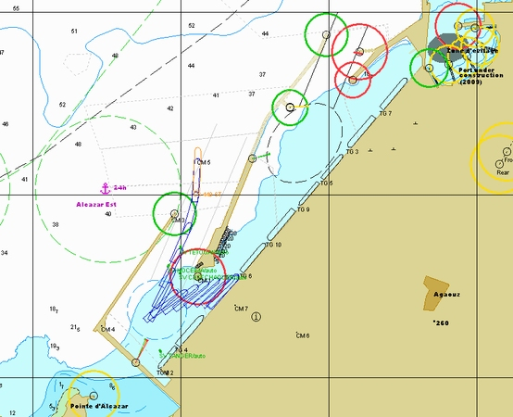

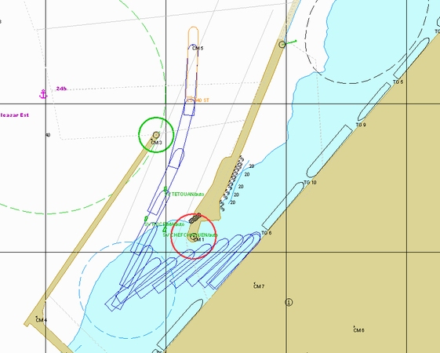

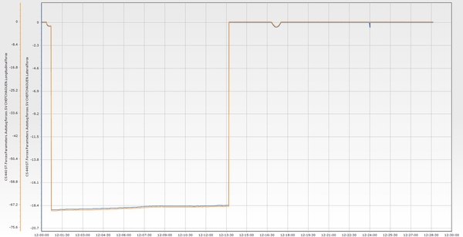

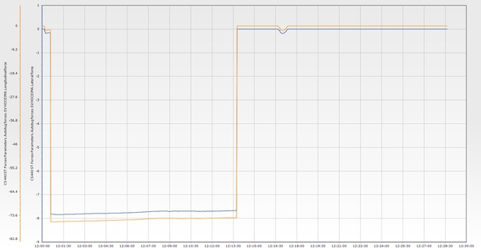

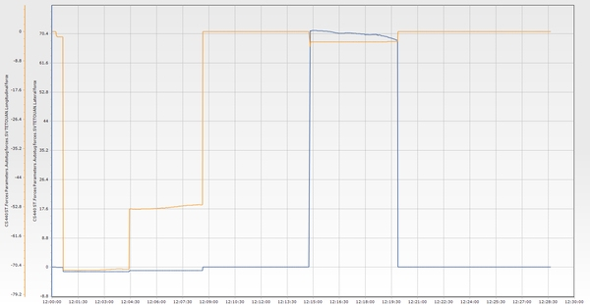

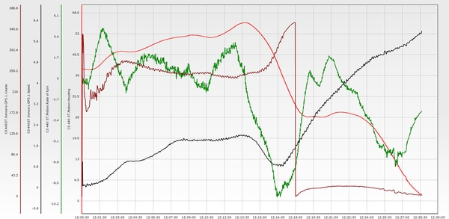

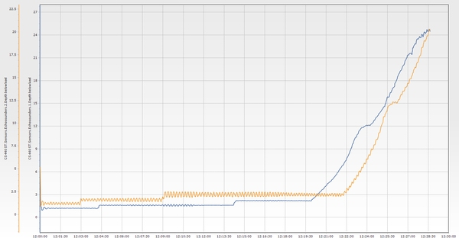

**Essai n° 19**

|  |  |  |  |  |  |  |  |  |  |  |  |  |
| --- | --- | --- | --- | --- | --- | --- | --- | --- | --- | --- | --- | --- |
| **Test n°** | **Condition** | **Wind** | **Wave** | **Current** | **Tide** | **Berth** | **Maneuver** | **Pilote** | **Side** | **Tugs** | **Entrance** | **Commentaire** |
| 19 | E1 | NE 25 knt | NE 2,5m 12s | 3 knt 60°/N | 0,6 m | P1 | Appareillage P1 bâbord | Reda/ Rachdi | Bâbord | 5 Remorqueurs | TM3 | Four tugs are required for departure. Drift was controlled throughout the entire maneuver. The rate of turn (ROT) was low while passing the main breakwater. It is preferable to keep the tug secured at the aft center and/or continue navigating until there is more space before turning to port. |

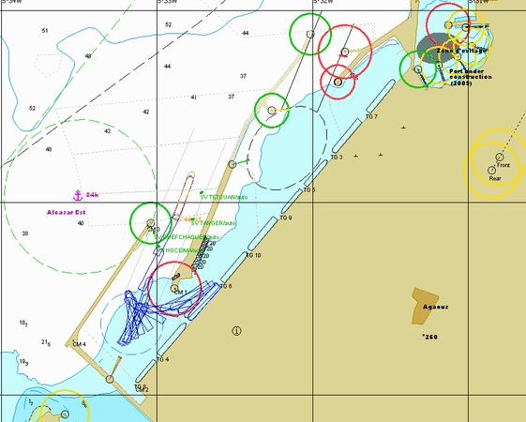

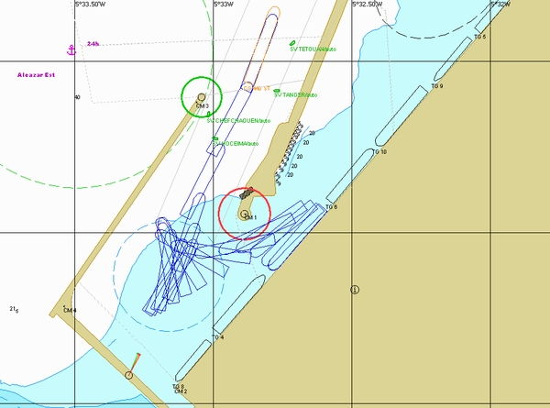

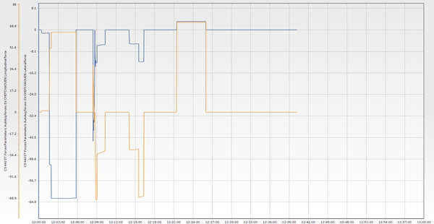

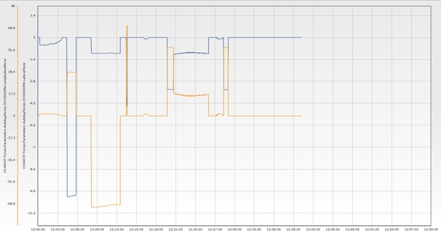

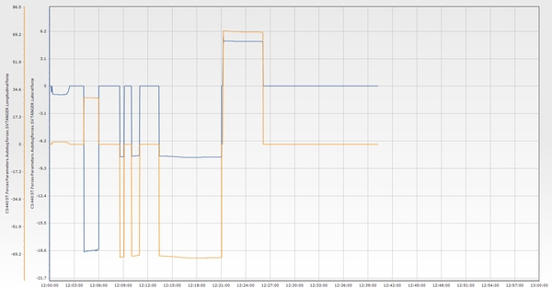

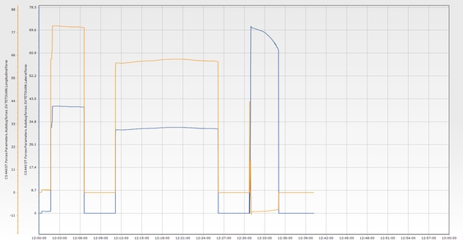

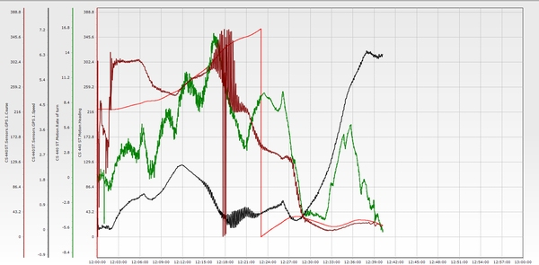

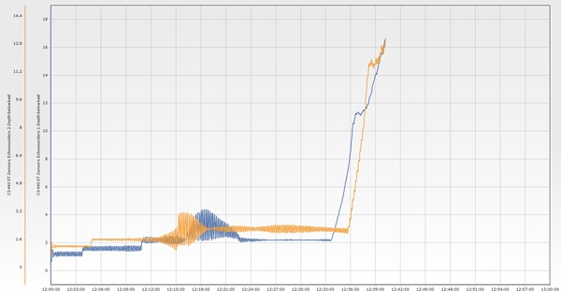

**Essai n° 20**

|  |  |  |  |  |  |  |  |  |  |  |  |  |
| --- | --- | --- | --- | --- | --- | --- | --- | --- | --- | --- | --- | --- |
| **Test n°** | **Condition** | **Wind** | **Wave** | **Current** | **Tide** | **Berth** | **Maneuver** | **Pilote** | **Side** | **Tugs** | **Entrance** | **Commentaire** |
| 20 | E1 | NE 25 knt | NE 2,5m 12s | 3 knt 60°/N | 0,6 m | P1 | Accostage P1 bâbord | BERJAL | Bâbord | 5 Remorqueurs | TM3 | During the approach, maintain control of the rate of turn and avoid excessive values. Use the engine half ahead to correct the vessel’s heading. Adjust the heading so that the current-induced drift brings the vessel to the center of the port entrance. The wind, coming almost from astern, has minimal effect on drift or steering. Keep the vessel’s speed under control to ensure it can be stopped safely. Berthing is carried out with four tugs. |

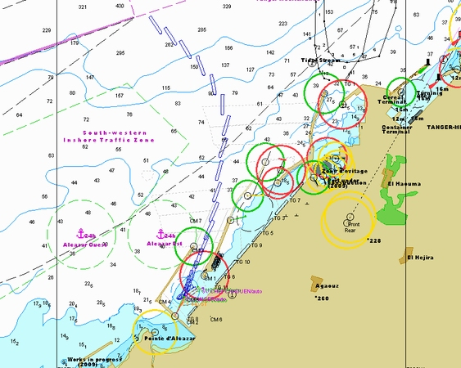

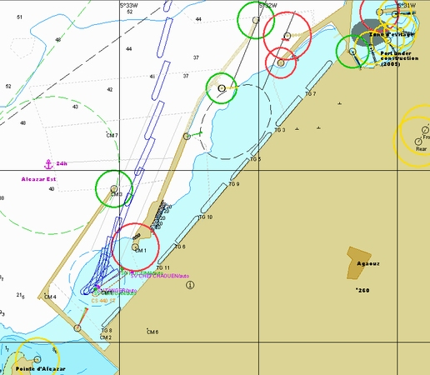

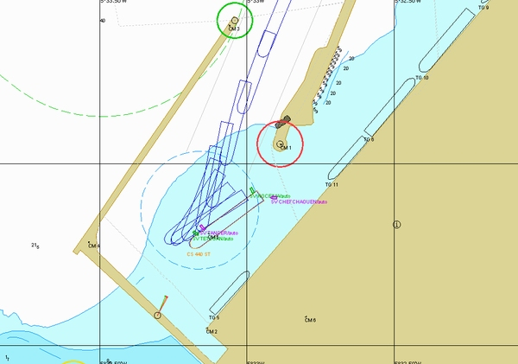

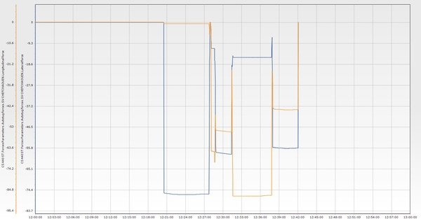

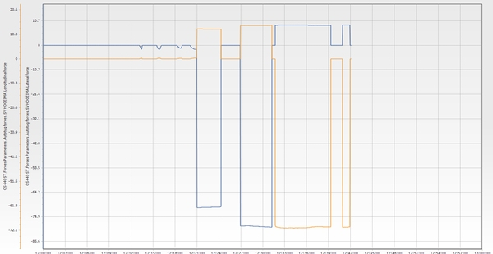

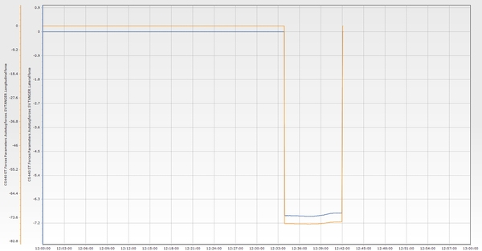

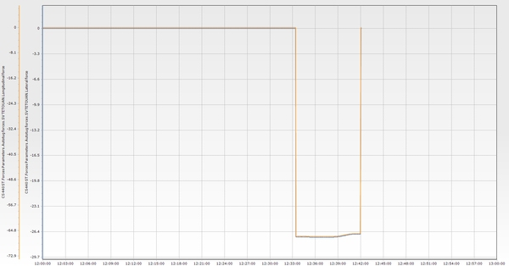

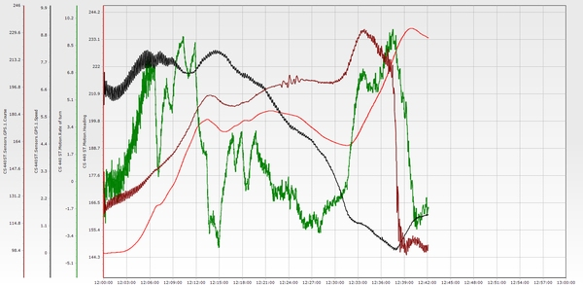

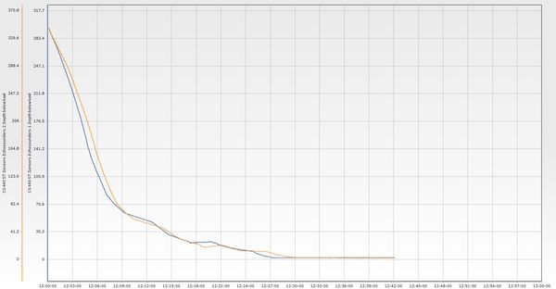

**Essai n° 21**

|  |  |  |  |  |  |  |  |  |  |  |  |  |
| --- | --- | --- | --- | --- | --- | --- | --- | --- | --- | --- | --- | --- |
| **Test n°** | **Condition** | **Wind** | **Wave** | **Current** | **Tide** | **Berth** | **Maneuver** | **Pilote** | **Side** | **Tugs** | **Entrance** | **Commentaire** |
| 21 | E5 | SE 25 knt | NE 3m 14s | 3 knt 60°/N | 0,6 m | P1 | Appareillage P1 bâbord | Reda / BERJAL | Bâbord | 5 Remorqueurs | TM3 | The channel was entered without issue. However, with a 3-knot current setting to the east, the vessel was unable to develop a rate of turn to port and continued on a straight course despite all actions taken to initiate a turn to port. |

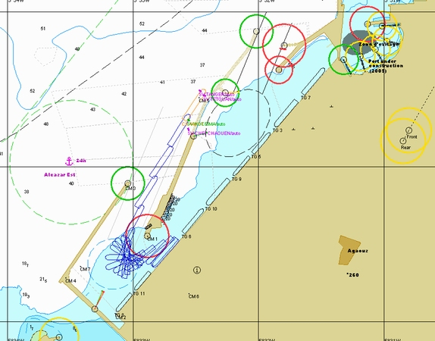

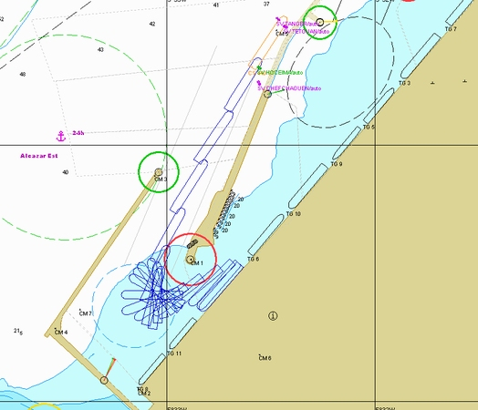

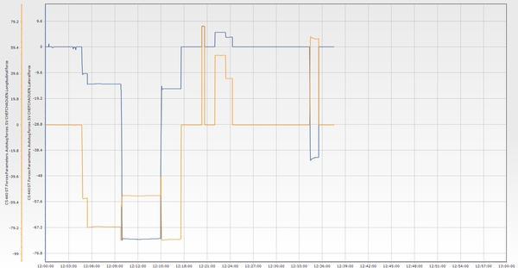

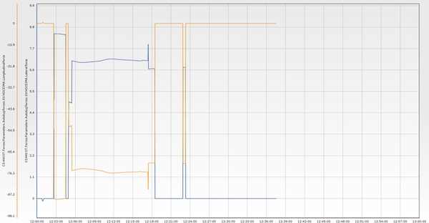

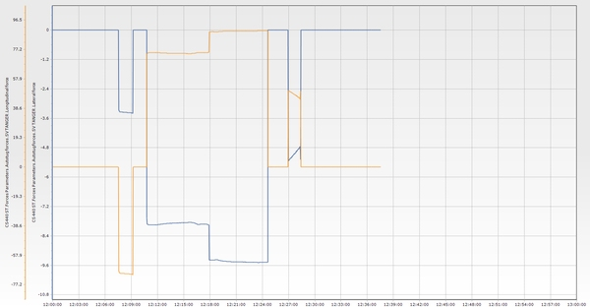

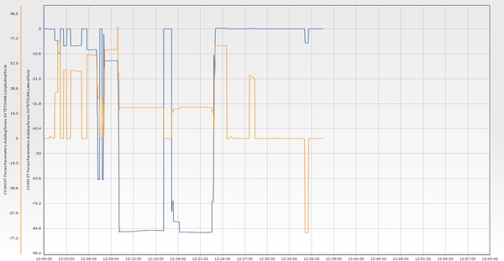

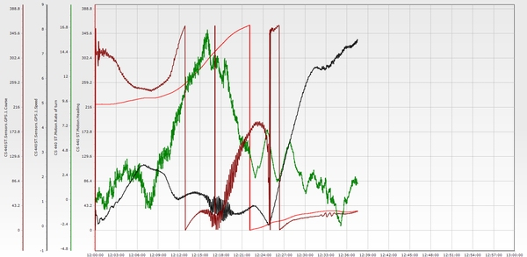

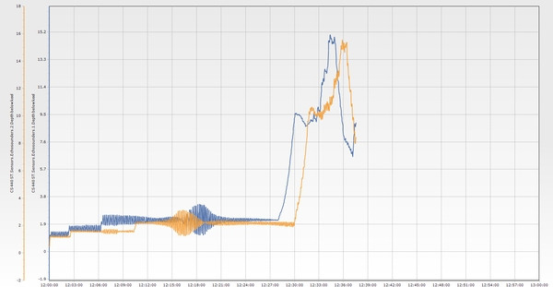

**Essai n° 22**

|  |  |  |  |  |  |  |  |  |  |  |  |  |
| --- | --- | --- | --- | --- | --- | --- | --- | --- | --- | --- | --- | --- |
| **Test n°** | **Condition** | **Wind** | **Wave** | **Current** | **Tide** | **Berth** | **Maneuver** | **Pilote** | **Side** | **Tugs** | **Entrance** | **Commentaire** |
| 22 | E4 | SW 25 knt | W 3m 14s | 3 knt 60°/N | 0,6 m | P1 | Accostage P1 tribord | RAFOUK/ MEFSIOUI | Tribord | 5 Remorqueurs | TM3 | Wind from the southwest at 25 knots, gusting up to 30 knots. Current at 3 knots. Four tugs in assistance. The Vessel presentation was satisfactory despite wind gusts and current limiting speed buildup. The port entrance was crossed at 4 knots with speed decreasing. Swinging in the basin to starboard using three tugs plus the ship’s thruster. Berthing at position P1 with four tugs, starboard thruster, and bow thruster. The wind consider for SW winds is 25 knots. |

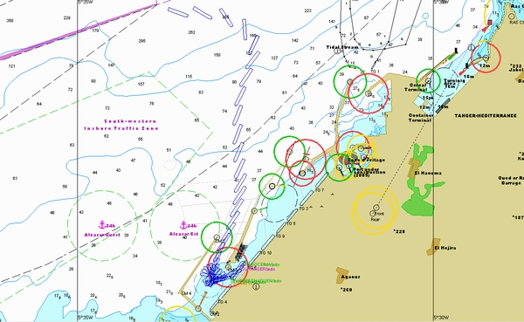

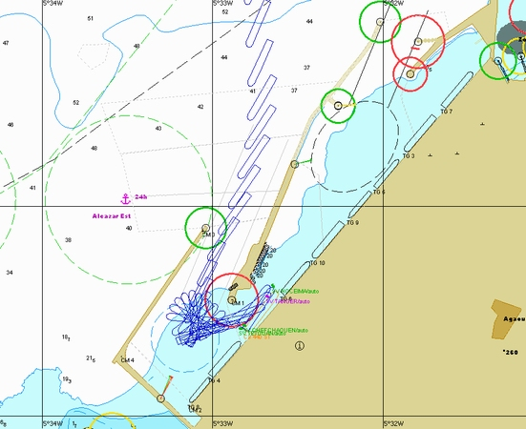

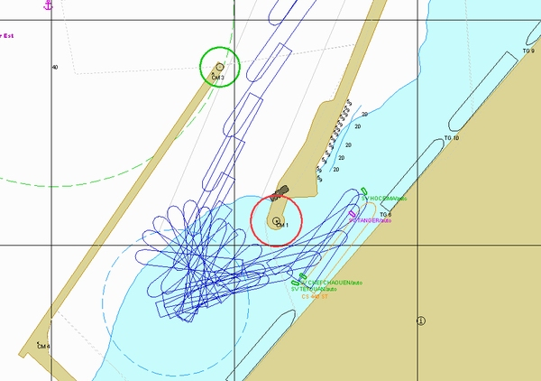

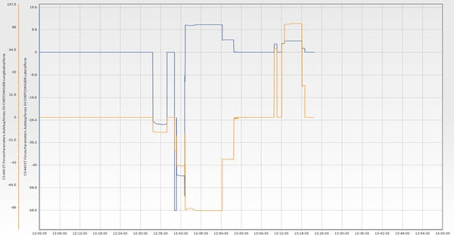

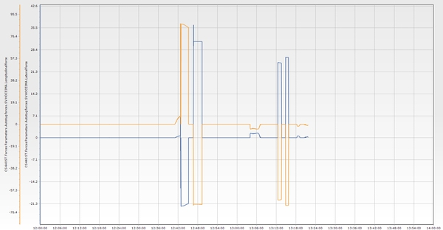

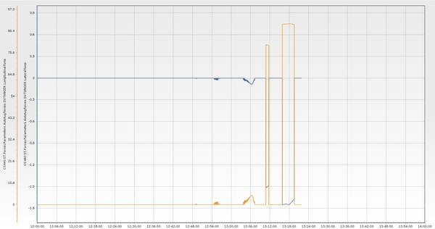

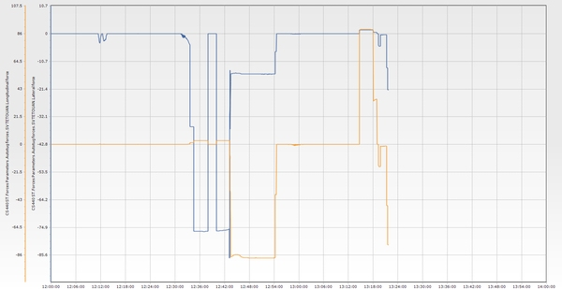

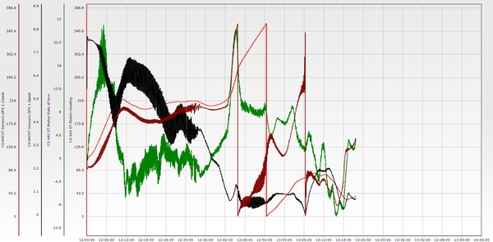

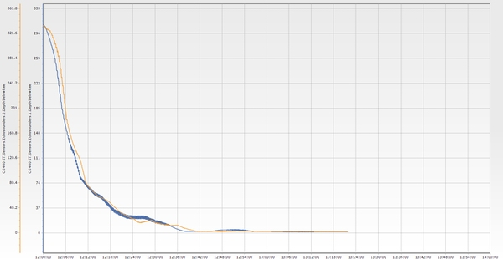

**Essai n° 23**

|  |  |  |  |  |  |  |  |  |  |  |  |  |
| --- | --- | --- | --- | --- | --- | --- | --- | --- | --- | --- | --- | --- |
| **Test n°** | **Condition** | **Wind** | **Wave** | **Current** | **Tide** | **Berth** | **Maneuver** | **Pilote** | **Side** | **Tugs** | **Entrance** | **Commentaire** |
| 23 | E5 | SE 25 knt | NE 3m 14s | 3 knt 60°/N | 0,6 m | P1 | Accostage P1 tribord | Rafouk | Tribord | 5 Remorqueurs | TM3 | Tug assistance was insufficient. Wind from the southeast at 25 knots. Current at 3 knots. Four tugs in use. Vessel presentation remained under control, balancing wind and current. Speed and course over ground were managed to cross the entrance at 7 knots, decreasing. Swinging in the basin was performed using four tugs, bow thruster (BT), and starboard thruster (ST). The issue arose when approaching berth P1: two tugs and full starboard bow thruster were not enough to hold the bow against the 25-knot beam wind. Recommended limit for safe operation in SE wind is 20 knots, with five tugs required to maintain a safety margin. |

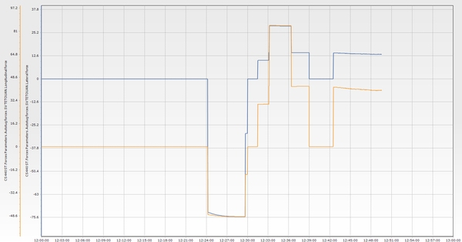

**Essai n° 23 BIS**

|  |  |  |  |  |  |  |  |  |  |  |  |  |
| --- | --- | --- | --- | --- | --- | --- | --- | --- | --- | --- | --- | --- |
| **Test n°** | **Condition** | **Wind** | **Wave** | **Current** | **Tide** | **Berth** | **Maneuver** | **Pilote** | **Side** | **Tugs** | **Entrance** | **Commentaire** |
| 23 BIS | E5 | SE 25 knt | NE 3m 14s | 3 knt 60°/N | 0,6 m | P1 | Accostage P1 tribord | Rahoui | Tribord | 5 Remorqueurs | TM3 | The vessel presentation to the port was satisfactory. Drift was controlled through appropriate heading and speed adjustments. The port entrance was crossed at a controlled speed. Once the current effect subsided, the vessel began drifting to starboard toward the main jetty. Swinging to port was initiated to bring the vessel head-on into the wind, which was successfully achieved. During the final approach to the berth, under the influence of crosswind, the use of four tugs operating at maximum pushing power was insufficient to fully counteract the wind effect. A fifth tug was called in to overcome the crosswind. Note: The bow thruster was out of service. |

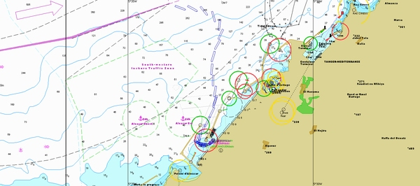

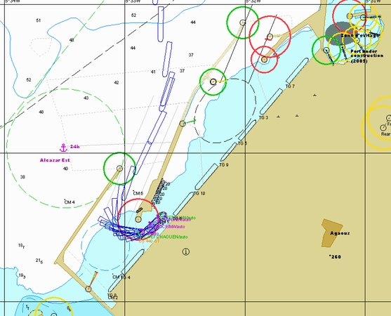

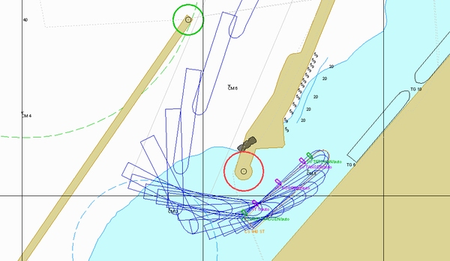

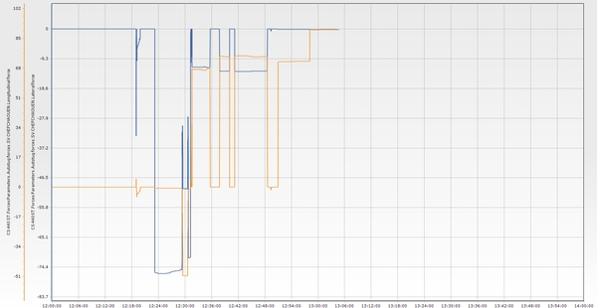

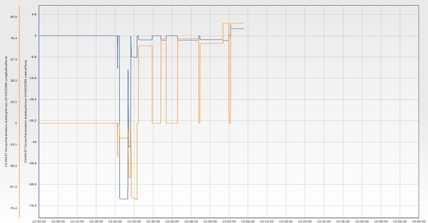

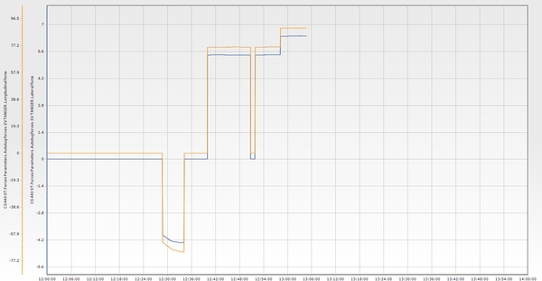

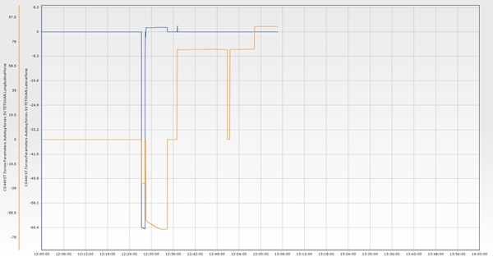

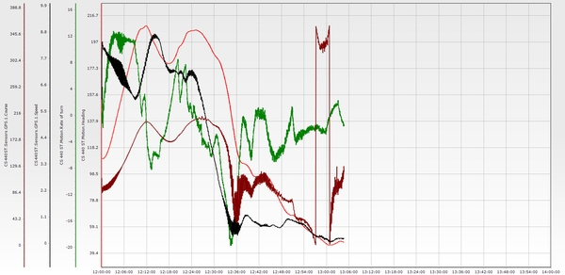

**Essai n° 24**

|  |  |  |  |  |  |  |  |  |  |  |  |  |
| --- | --- | --- | --- | --- | --- | --- | --- | --- | --- | --- | --- | --- |
| **Test n°** | **Condition** | **Wind** | **Wave** | **Current** | **Tide** | **Berth** | **Maneuver** | **Pilote** | **Side** | **Tugs** | **Entrance** | **Commentaire** |
| 24 | E4 | W 30 knt | W 3m 14s | 3 knt 60°/N | 0,6 m | P1 | Appareillage P1 tribord | Soerensen/ Rafouq | Tribord | 5 Remorqueurs | TM3 | Four tugs were used; no thrusters were available. Departure from the berth proceeded smoothly. The vessel came close to the opposite side but remained safe and under full control at all times.   While going astern, the maneuver was well executed with a controlled turn and effective use of centerline tugs. Minimum safe distance of 130 meters was maintained from the breakwater when passing the green light. |

**Essai n° 25**

|  |  |  |  |  |  |  |  |  |  |  |  |  |
| --- | --- | --- | --- | --- | --- | --- | --- | --- | --- | --- | --- | --- |
| **Test n°** | **Condition** | **Wind** | **Wave** | **Current** | **Tide** | **Berth** | **Maneuver** | **Pilote** | **Side** | **Tugs** | **Entrance** | **Commentaire** |
| 25 | E4 | SW 30 knt | W 3m 14s | 3 knt 60°/N | 0,6 m | P3 | Appareillage P3 bâbord | Rafouq/ Berjal | Bâbord | 5 Remorqueurs | TM3 | Departure from P1, port side alongside. Bow thruster not available. Wind from the southwest at 25 knots, current at 3 knots. The vessel’s bow was positioned in the enclosed corner of the berth. Four tugs were used to bring the vessel to the turning circle.   Heavy drift toward the main jetty was experienced, with a minimum distance of less than 30 meters between the bow and the breakwater. The maneuver required an extended duration. It was necessary to build up longitudinal speed quickly to maintain control of the vessel’s trajectory toward the entrance.   For improved safety and operational efficiency, the vessel should be berthed starboard side alongside P1. |

**Essai n° 26**

|  |  |  |  |  |  |  |  |  |  |  |  |  |
| --- | --- | --- | --- | --- | --- | --- | --- | --- | --- | --- | --- | --- |
| **Test n°** | **Condition** | **Wind** | **Wave** | **Current** | **Tide** | **Berth** | **Maneuver** | **Pilote** | **Side** | **Tugs** | **Entrance** | **Commentaire** |
| 26 | E4 | SW 30 knt | W 3m 14s | 3 knt 60°/N | 0,6 m | P1 | Accostage P1 tribord | nan | Tribord | 5 Remorqueurs | TM3 | Emergency scenario: engine failure.   The engine failed while the vessel was crossing the port entrance at a speed of 6.2 knots. The vessel was brought to a stop using four tugs operating at full power, without the use of anchors.   The vessel swung, and an attempt was made to berth. However, it was unsuccessful, as part of the available tug power—both forward and aft—was used to control longitudinal movement (ahead and astern), leaving insufficient force to bring the vessel alongside. |

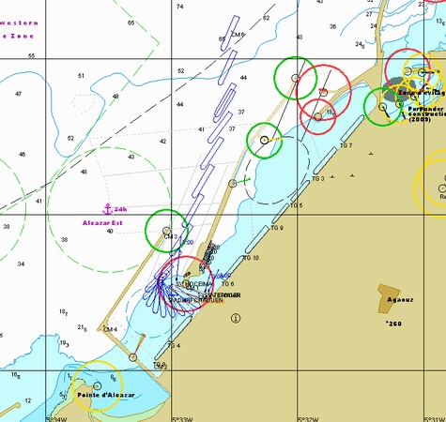

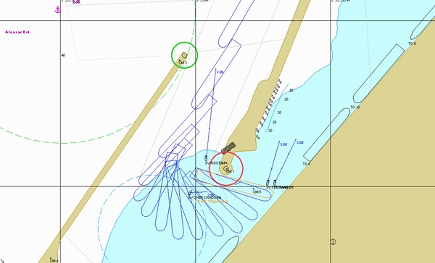

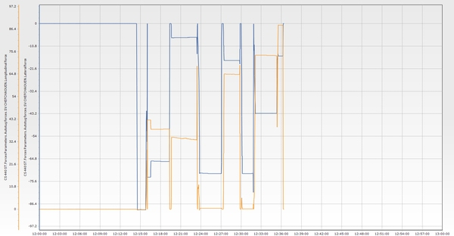

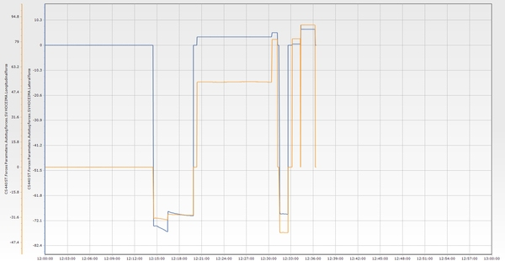

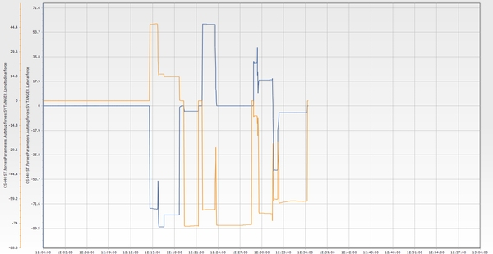

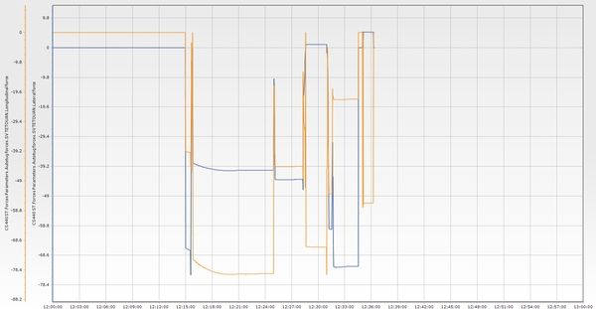

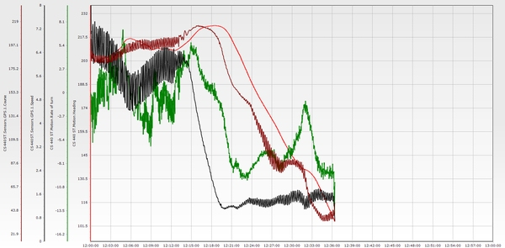

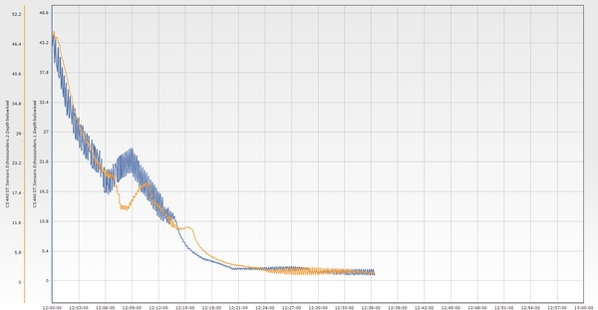

**Essai n° 26 BIS**

|  |  |  |  |  |  |  |  |  |  |  |  |  |
| --- | --- | --- | --- | --- | --- | --- | --- | --- | --- | --- | --- | --- |
| **Test n°** | **Condition** | **Wind** | **Wave** | **Current** | **Tide** | **Berth** | **Maneuver** | **Pilote** | **Side** | **Tugs** | **Entrance** | **Commentaire** |
| 26 BIS | E4 | SW 30 knt | W 3m 14s | 3 knt 60°/N | 0,6 m | P1 | Accostage P1 tribord | nan | Tribord | 5 Remorqueurs | TM3 | Engine failure occurred at the port entrance while the vessel was making 7.5 knots. The vessel was brought to a stop using tug assistance and emergency anchoring on both sides. An attempt was made to berth, but it was unsuccessful. |

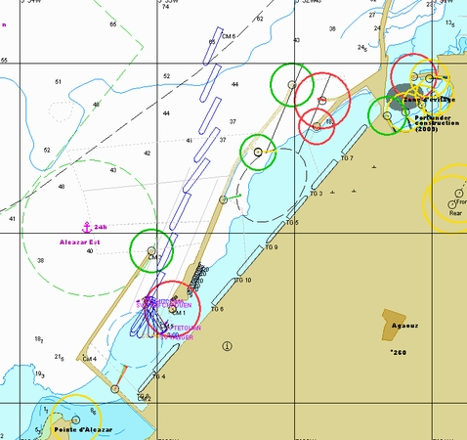

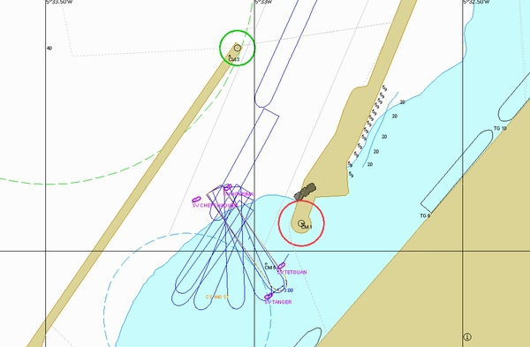

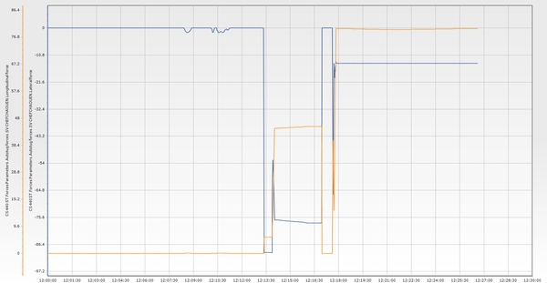

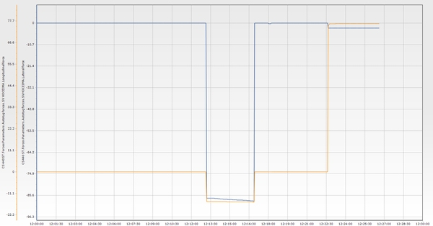

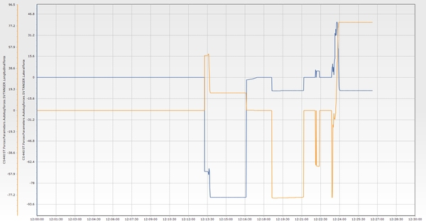

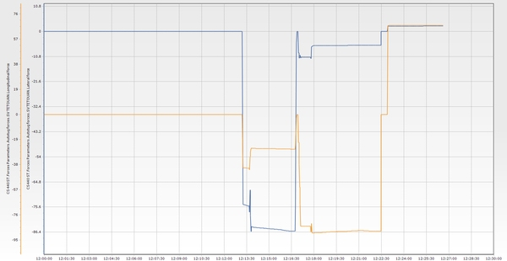

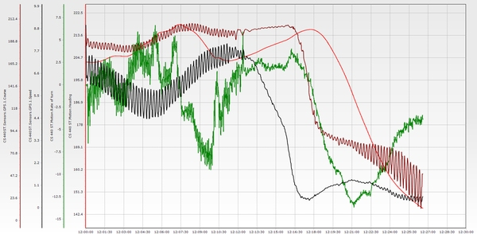

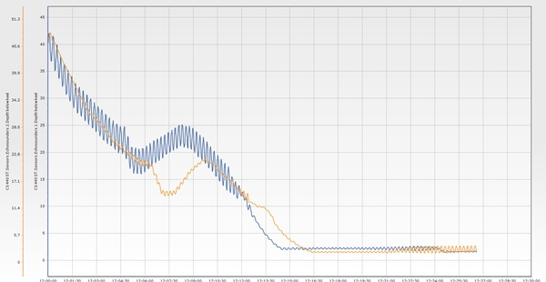

**Essai n° 26 TER**

|  |  |  |  |  |  |  |  |  |  |  |  |  |
| --- | --- | --- | --- | --- | --- | --- | --- | --- | --- | --- | --- | --- |
| **Test n°** | **Condition** | **Wind** | **Wave** | **Current** | **Tide** | **Berth** | **Maneuver** | **Pilote** | **Side** | **Tugs** | **Entrance** | **Commentaire** |
| 26 TER | E4 | SW 30 knt | W 3m 14s | 3 knt 60°/N | 0,6 m | P1 | Accostage P1 tribord | nan | Tribord | 4 Remorqueurs | TM3 | Engine failure occurred at the port entrance while the vessel was making 6.2 knots. The vessel was quickly stopped using tugs and anchors. It then swung and successfully berthed with the assistance of a fifth tug. |

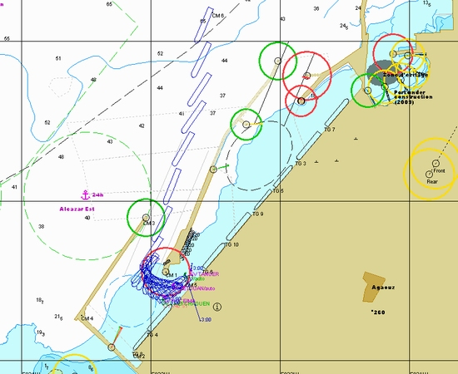

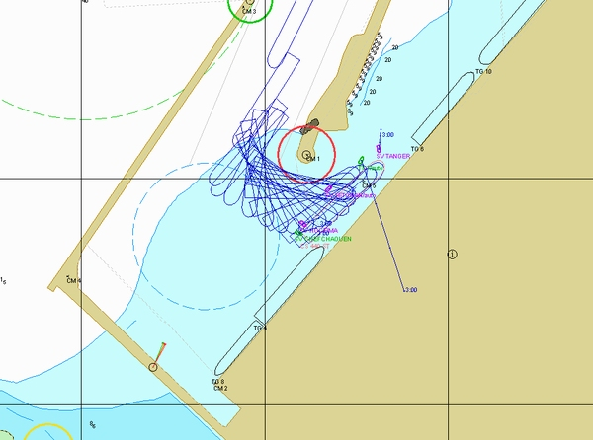

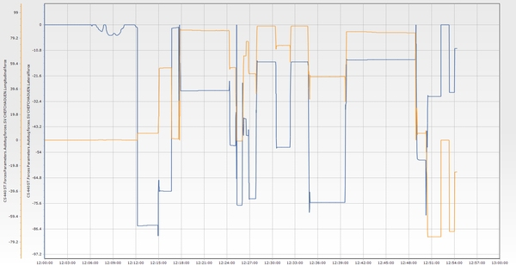

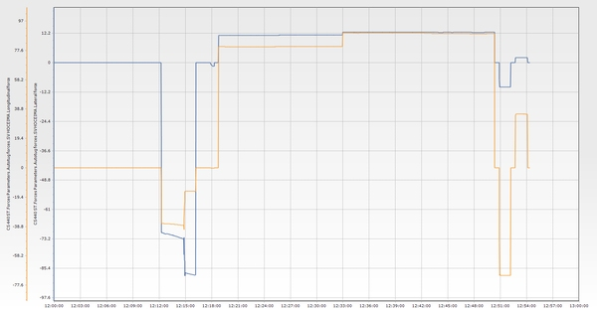

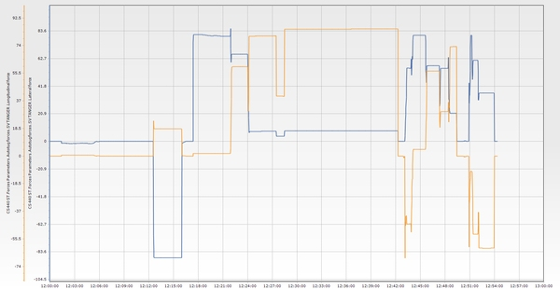

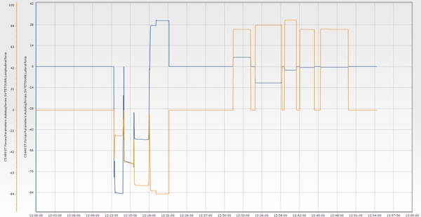

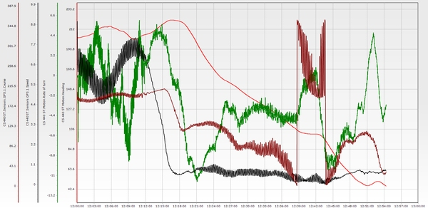

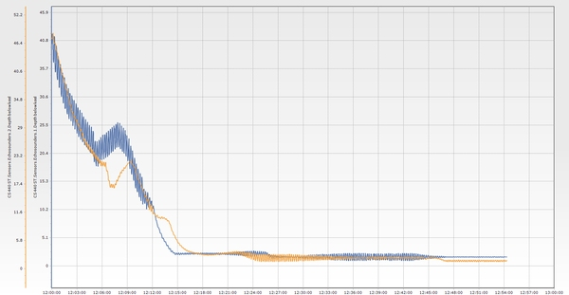

**Essai n° 27**

|  |  |  |  |  |  |  |  |  |  |  |  |  |
| --- | --- | --- | --- | --- | --- | --- | --- | --- | --- | --- | --- | --- |
| **Test n°** | **Condition** | **Wind** | **Wave** | **Current** | **Tide** | **Berth** | **Maneuver** | **Pilote** | **Side** | **Tugs** | **Entrance** | **Commentaire** |
| 27 | E3 | NW 25 knt | NW 3m 14s | 3 knt 60°/N | 0,6 m | P1 | Accostage P1 tribord | Rafouk/ Mefsioui | Tribord | 5 Remorqueurs | TM3 | The vessel presentation to the port was under control, and the entrance was crossed at a safe speed. The vessel stopped with the assistance of the tugs and began swinging clear. However, it was not possible to hold position with four tugs, and the vessel began drifting due to the wind. |

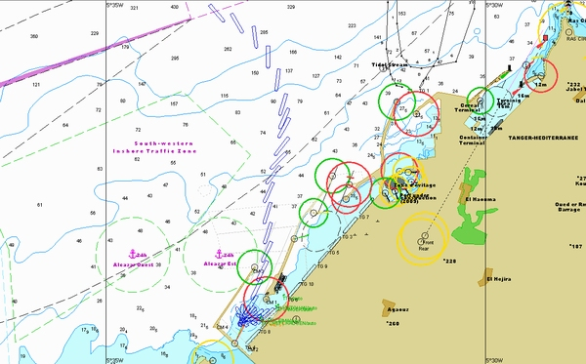

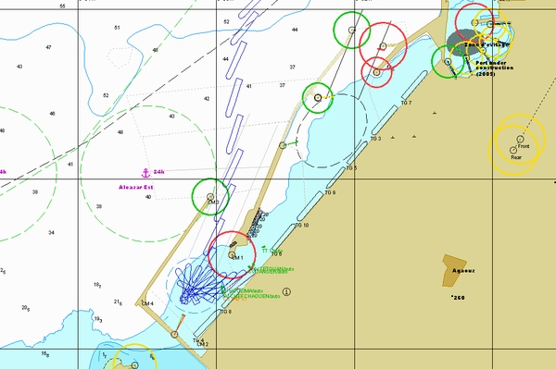

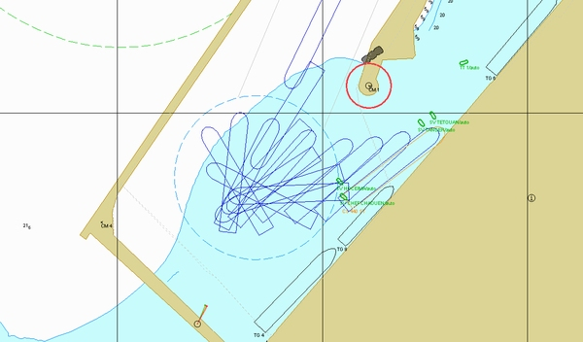

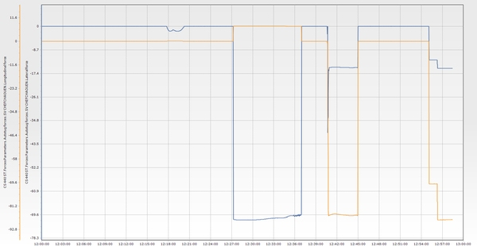

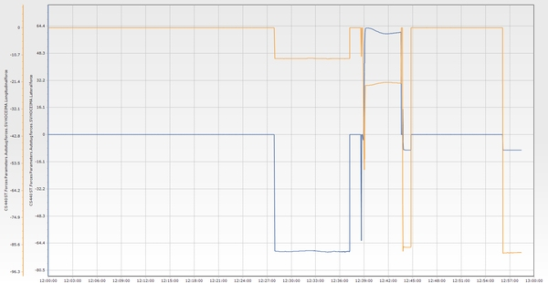

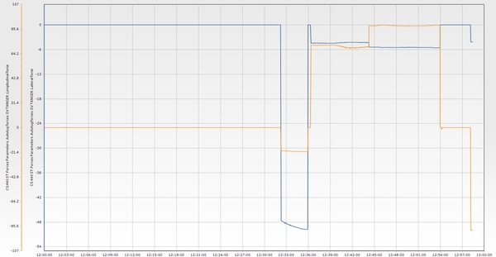

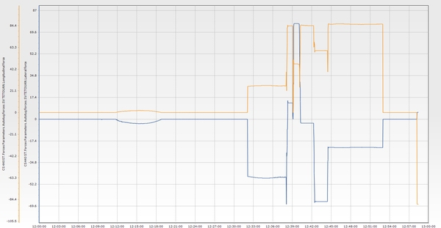

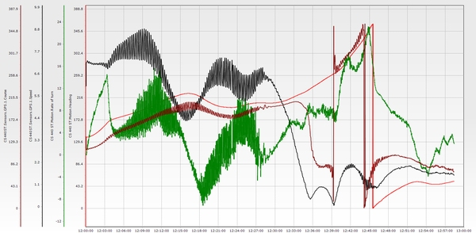

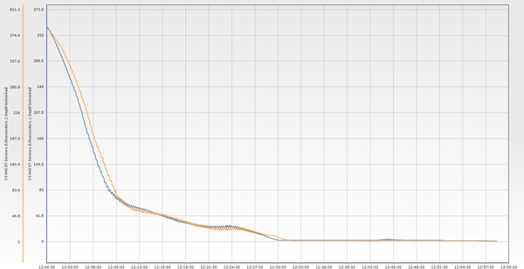

**Essai n° 27 BIS**

|  |  |  |  |  |  |  |  |  |  |  |  |  |
| --- | --- | --- | --- | --- | --- | --- | --- | --- | --- | --- | --- | --- |
| **Test n°** | **Condition** | **Wind** | **Wave** | **Current** | **Tide** | **Berth** | **Maneuver** | **Pilote** | **Side** | **Tugs** | **Entrance** | **Commentaire** |
| 27 BIS | E3 | NW 25 knt | NW 3m 14s | 3 knt 60°/N | 0,6 m | P1 | Accostage P1 tribord | Rahoui/ Mefsioui | Tribord | 5 Remorqueurs | TM3 | The presentation to the port was satisfactory. Drift was controlled through heading and speed adjustments. The vessel crossed the entrance at a controlled speed, but continued drifting to port due to wind effect. Drift was managed using the stern tug, forward tug, and rudder.   Swinging to starboard was initiated to bring the vessel head-on into the wind, and the swing was completed successfully. However, during the approach to the berth, four tugs were insufficient to counteract the crosswind effect. |

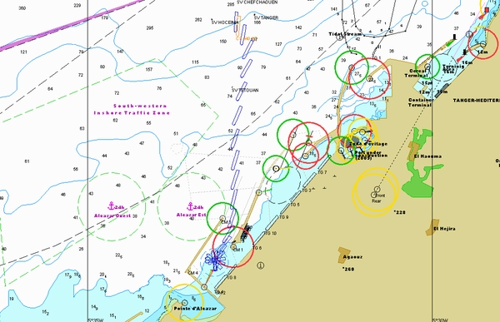

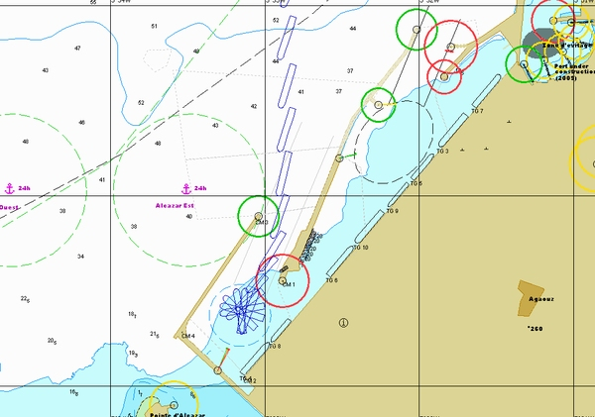

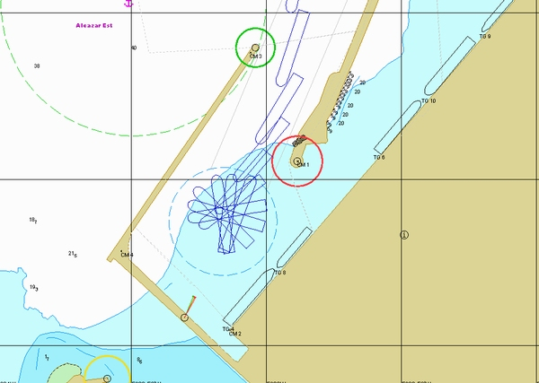

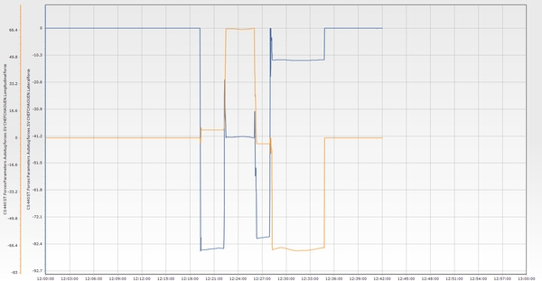

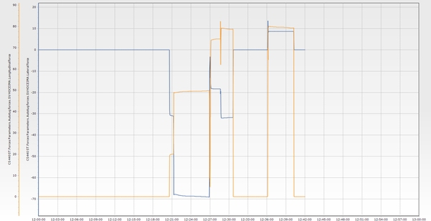

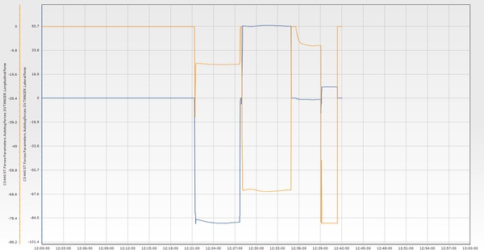

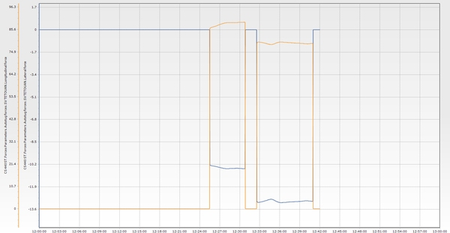

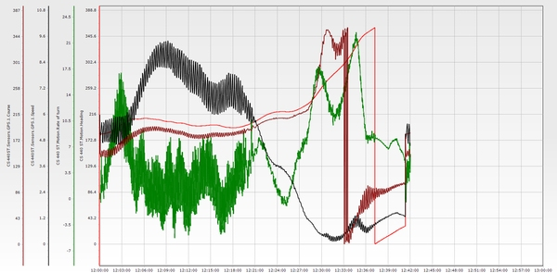

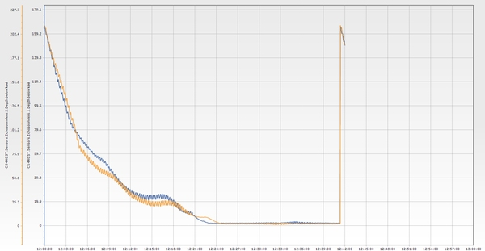

**Essai n° 28**

|  |  |  |  |  |  |  |  |  |  |  |  |  |
| --- | --- | --- | --- | --- | --- | --- | --- | --- | --- | --- | --- | --- |
| **Test n°** | **Condition** | **Wind** | **Wave** | **Current** | **Tide** | **Berth** | **Maneuver** | **Pilote** | **Side** | **Tugs** | **Entrance** | **Commentaire** |
| 28 | E5 | NW 25 knt | NW 3m 14s | 3 knt 60°/N | 0,6 m | P3 | Accostage P3 tribord | nan | Tribord | 5 Remorqueurs | TM3 | Berthing was carried out in southwesterly winds of 25 knots. The vessel should not be allowed to develop excessive port rate of turn due to its strong weather helm; otherwise, it may become difficult to bring it back to starboard.   The port entrance was crossed at just over 8 knots. The vessel swung to port, into the wind, and engine power was used to prevent drifting astern due to wind pressure.   Berthing was completed slowly, with four tugs pushing toward the quay and the bow thruster operating at full power. |

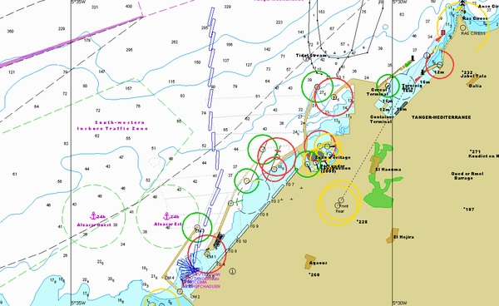

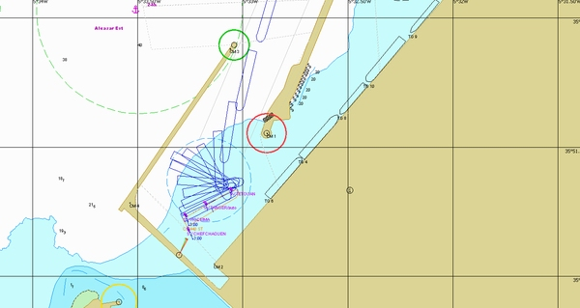

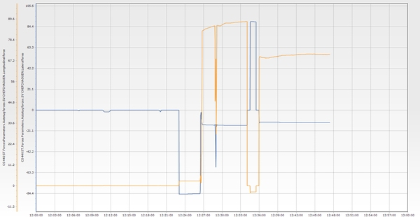

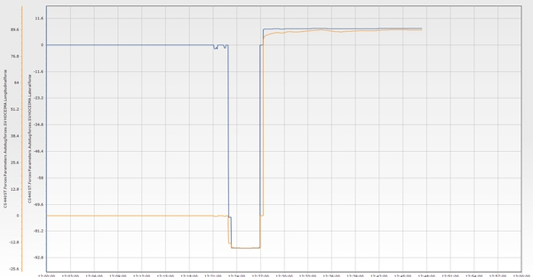

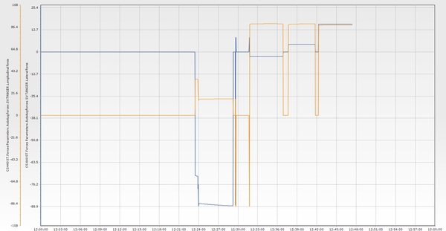

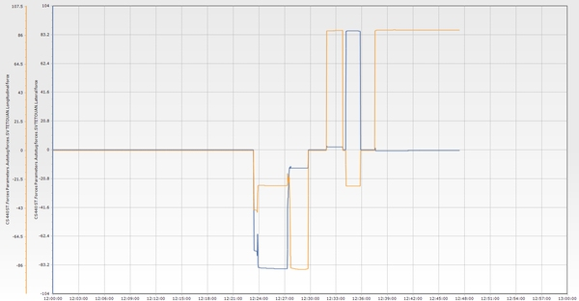

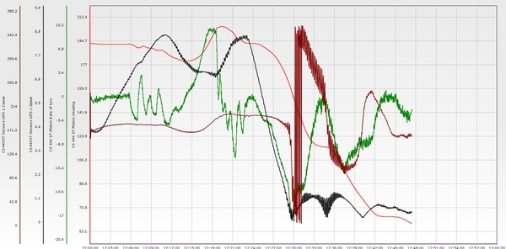

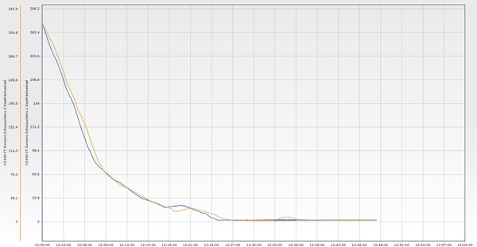

**Essai n° 29**

|  |  |  |  |  |  |  |  |  |  |  |  |  |
| --- | --- | --- | --- | --- | --- | --- | --- | --- | --- | --- | --- | --- |
| **Test n°** | **Condition** | **Wind** | **Wave** | **Current** | **Tide** | **Berth** | **Maneuver** | **Pilote** | **Side** | **Tugs** | **Entrance** | **Commentaire** |
| 29 | E2 | NW 25 knt | NW 3m 14s | 3 knt 60°/N | 0,6 m | P1 | Appareillage P1 tribord | mefsioui | Tribord | 5 Remorqueurs | TM3 | Departure maneuver assisted by four tugboats from berth P1 to exit the TM2 channel. The unberthing phase was well executed.   An emergency scenario involving an engine failure was simulated at the turning circle, with the vessel making 6 knots. The forward and aft centerline tugs were able to maintain control and steer the vessel, allowing it to safely exit the port. Once outside, the engine was successfully restarted. |

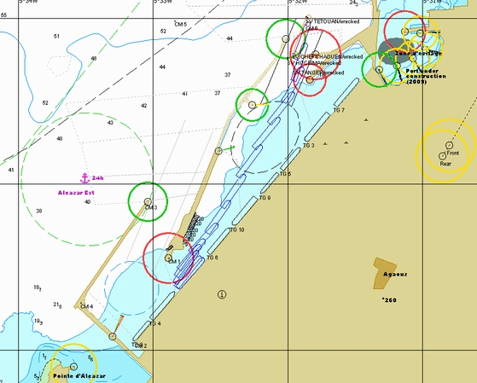

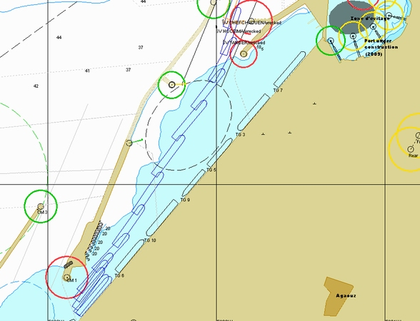

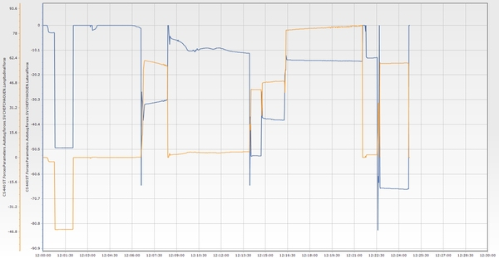

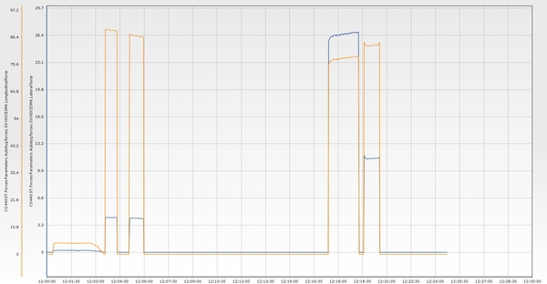

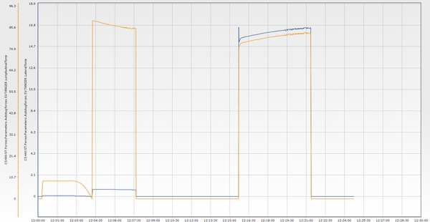

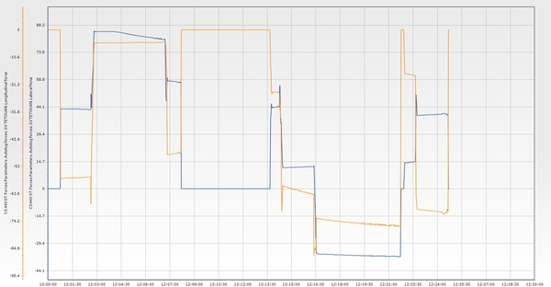

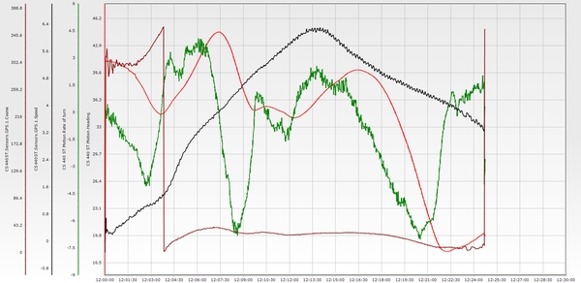

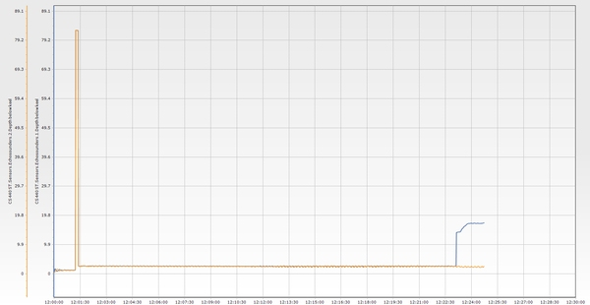

**Essai n° 30**

|  |  |  |  |  |  |  |  |  |  |  |  |  |
| --- | --- | --- | --- | --- | --- | --- | --- | --- | --- | --- | --- | --- |
| **Test n°** | **Condition** | **Wind** | **Wave** | **Current** | **Tide** | **Berth** | **Maneuver** | **Pilote** | **Side** | **Tugs** | **Entrance** | **Commentaire** |
| 30 | E2 | E 25 knt | NE 2,5m 12s | 1 knt 240°/N | 0,6 m | P3 | Accostage P3 tribord | Soerensen/ Rafouk | Tribord | 5 Remorqueurs | TM3 | The vessel came too close to the breakwater from Med 2. Only the aft tug was able to turn the vessel sufficiently. The vessel passed the green light at 7.7 knots but was successfully stopped using four tugs and the stern thruster, allowing for a controlled turn inside the basin.   After the turn, the maneuver proceeded smoothly, and the vessel was successfully docked using only three tugs, the bow thruster, and the main engine. |

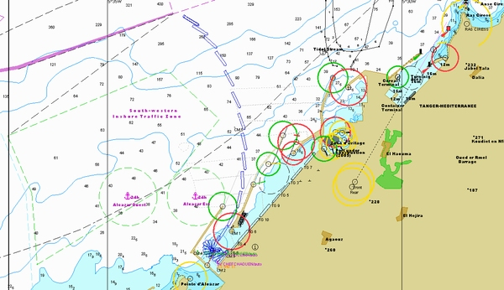

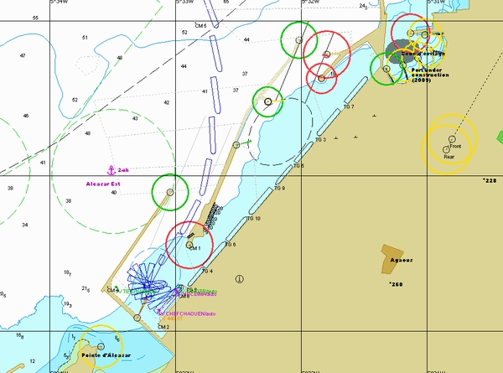

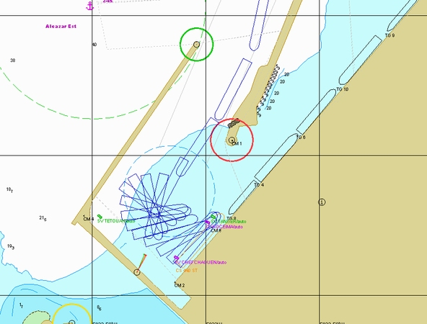

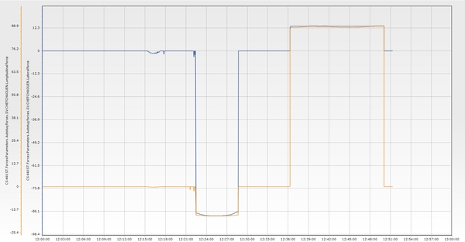

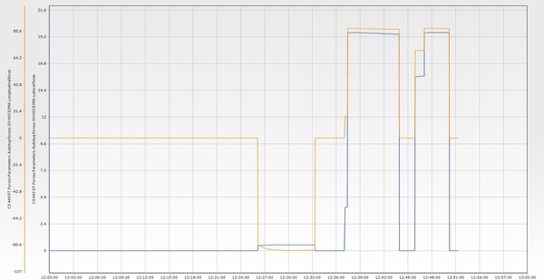

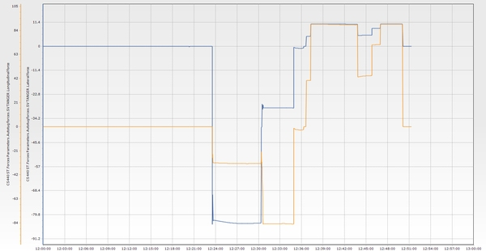

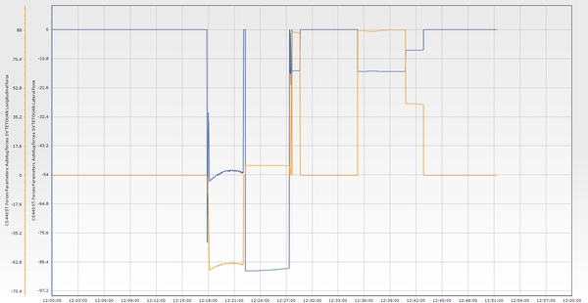

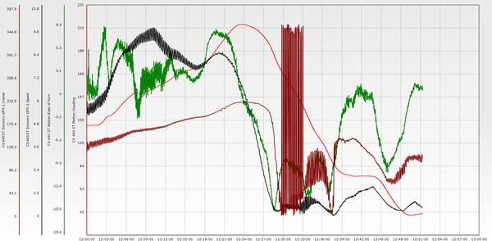

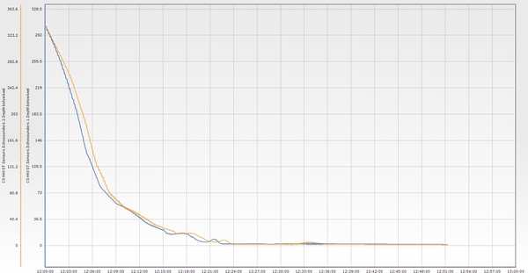

**Essai n° 31**

|  |  |  |  |  |  |  |  |  |  |  |  |  |
| --- | --- | --- | --- | --- | --- | --- | --- | --- | --- | --- | --- | --- |
| **Test n°** | **Condition** | **Wind** | **Wave** | **Current** | **Tide** | **Berth** | **Maneuver** | **Pilote** | **Side** | **Tugs** | **Entrance** | **Commentaire** |
| 31 | E3 | NW 25 knt | NW 3m 14s | 3 knt 60°/N | 0,6 m | P3 | Accostage P3 tribord | Dourasse | Tribord | 5 Remorqueurs | TM3 | Northwesterly wind at 25 knots with an easterly current of 3 knots. Attempting to line up earlier appears to be a more suitable and safer strategy, even in wind conditions exceeding 20 knots from the northwest.   This remains a very tricky and challenging situation, and should be avoided in real-life operations whenever possible. |

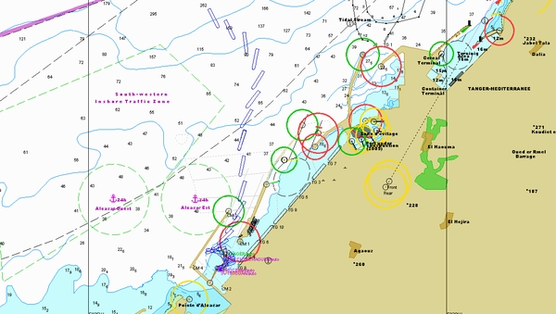

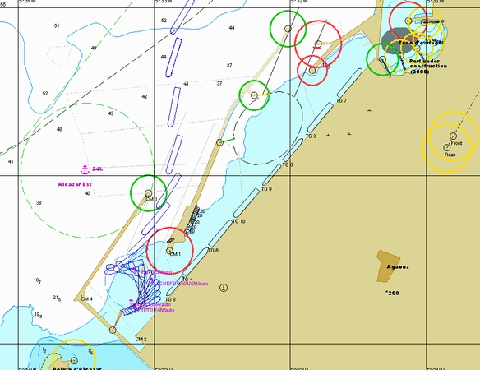

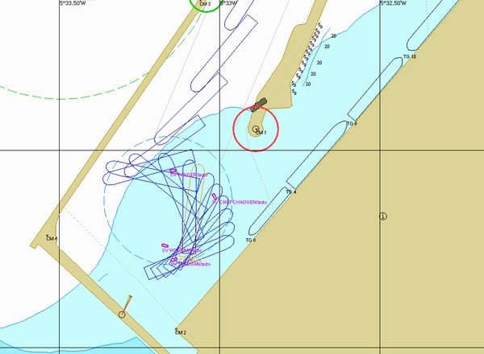

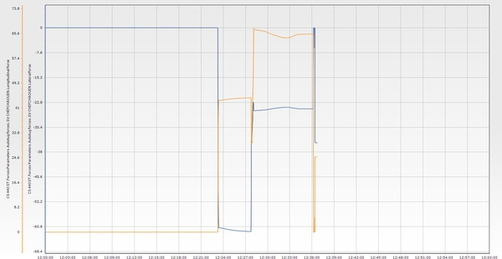

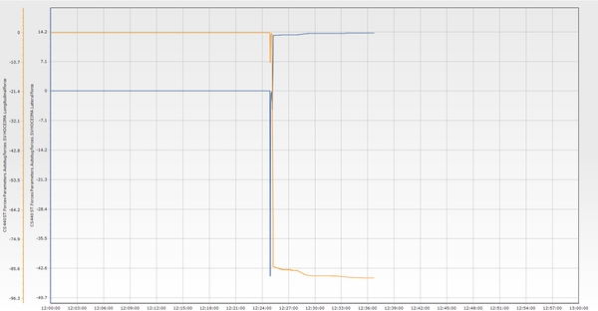

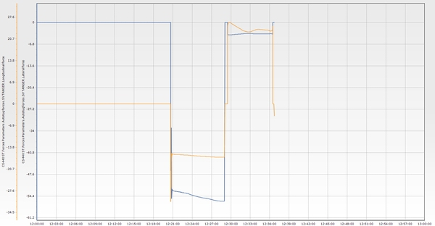

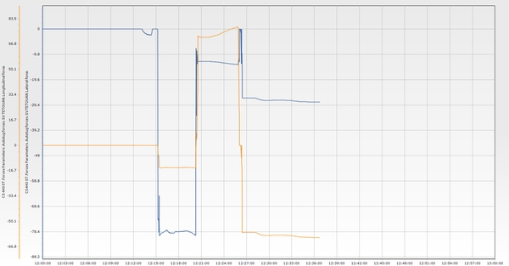

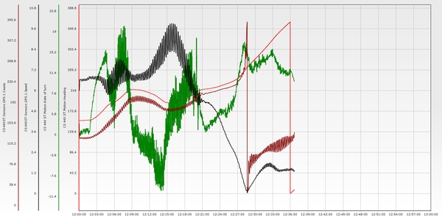

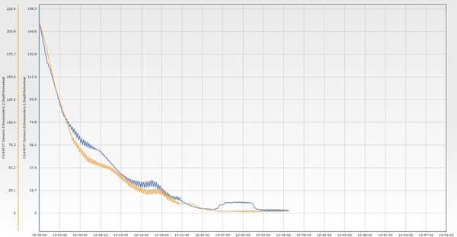

**Essai n° 33**

|  |  |  |  |  |  |  |  |  |  |  |  |  |
| --- | --- | --- | --- | --- | --- | --- | --- | --- | --- | --- | --- | --- |
| **Test n°** | **Condition** | **Wind** | **Wave** | **Current** | **Tide** | **Berth** | **Maneuver** | **Pilote** | **Side** | **Tugs** | **Entrance** | **Commentaire** |
| 33 | E5 | SE 25 knt | NE 3m 14s | 3 knt 60°/N | 0,6 m | P1 | Appareillage P1 tribord | Rachdi/ Berjal | Tribord | 5 Remorqueurs | TM2 | Unberthing maneuver carried out with four tugs: center lead forward and aft, port bow, and port quarter. The maneuver began with the intention to exit via TM2, initially moving the vessel sideways using the tugs while keeping the stern aligned with the wind.   A change of plan redirected the exit to TM3. The vessel was brought astern and began to slow down at 2 knots. However, the exit was then changed back to TM2, which resulted in excessive port drift.   Tugs were used at full power to counter the drift, while the main engine was brought to full ahead speed to quickly build up longitudinal speed. The vessel exited outbound through the channel.   It began to veer to port earlier than expected due to the 3-knot easterly current, which tends to push the vessel toward Pax Port. |

**Essai n° 33 (bis)**

|  |  |  |  |  |  |  |  |  |  |  |  |  |
| --- | --- | --- | --- | --- | --- | --- | --- | --- | --- | --- | --- | --- |
| **Test n°** | **Condition** | **Wind** | **Wave** | **Current** | **Tide** | **Berth** | **Maneuver** | **Pilote** | **Side** | **Tugs** | **Entrance** | **Commentaire** |
| 33 (bis) | E5 | SE 25 knt | NE 3m 14s | 3 knt 60°/N | 0,6 m | P1 | Appareillage P1 tribord | Rachdi/ Mefsioui | Tribord | 5 Remorqueurs | TM2 | Unberthing was carried out with four tugs, keeping the vessel close to the quay to counteract drift. The engine was kicked ahead while opening the bow and maintaining the stern into the wind. Speed was built up as quickly as possible to reach 7 to 8 knots, ensuring acceptable vessel behavior under the prevailing conditions. A port turn was initiated early to counter the effect of the current. |

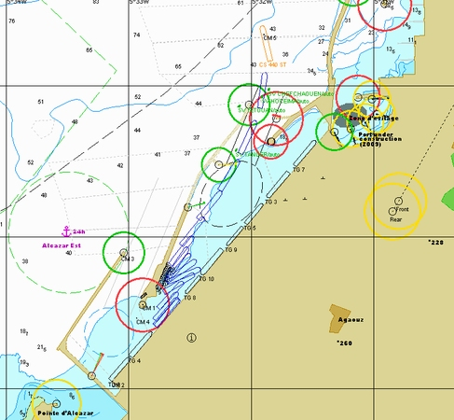

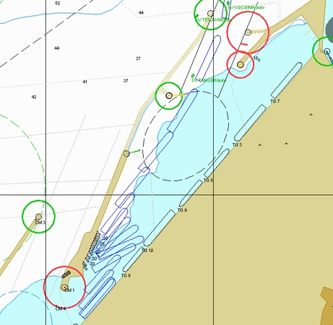

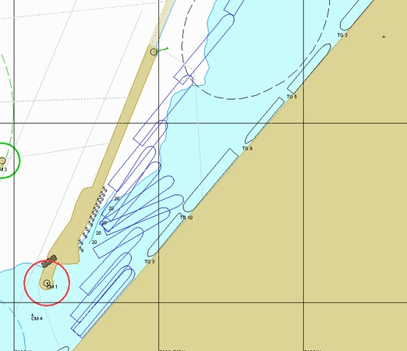

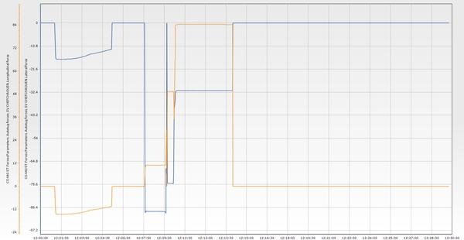

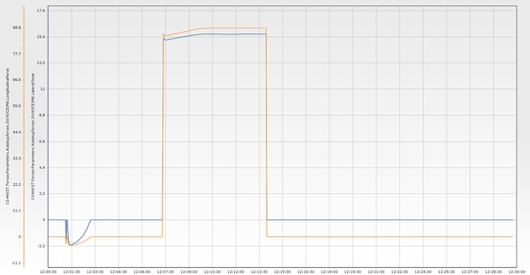

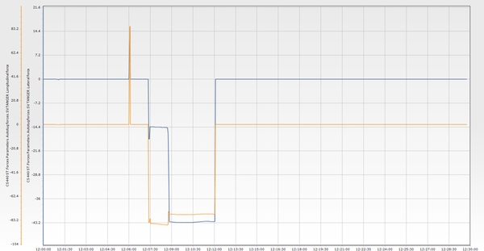

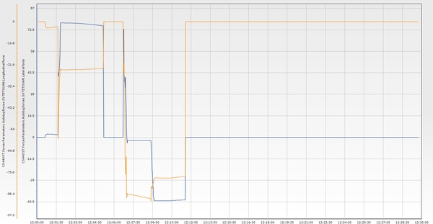

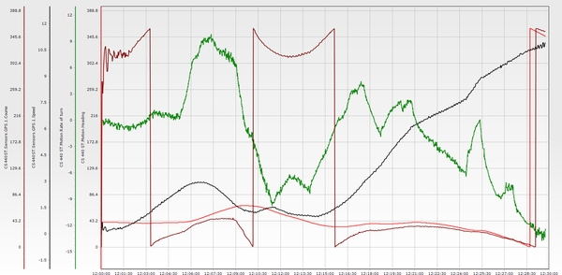

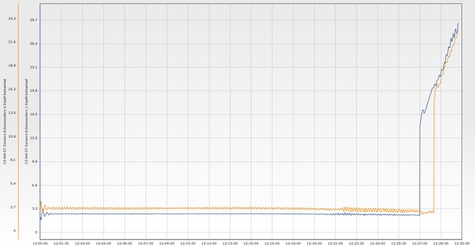

**Essai n° 34**

|  |  |  |  |  |  |  |  |  |  |  |  |  |
| --- | --- | --- | --- | --- | --- | --- | --- | --- | --- | --- | --- | --- |
| **Test n°** | **Condition** | **Wind** | **Wave** | **Current** | **Tide** | **Berth** | **Maneuver** | **Pilote** | **Side** | **Tugs** | **Entrance** | **Commentaire** |
| 34 | E1 | NE 25 knt | NE 2,5m 12s | 3 knt 60°/N | 0,6 m | P3 | Appareillage P3 tribord | nan | Tribord | 5 Remorqueurs | TM3 | For departure from P3 with strong northwesterly wind: - Push For departure from berth P3 in strong northwesterly wind conditions:   Push off while favoring the bow alignment with the departure heading, approximately 020°. Use engine power to build up speed as quickly as possible to prevent drifting toward the main jetty. Avoid staying too close to the red light; otherwise, the vessel may end up pressed against the TM2 jetty once outside, due to the effect of the current. Ensure a port side rate of turn when passing through the channel. favoring bow to align, with departure heading, approximately 020. - Use engine power to build up speed as quickly as possible to avoid drifting towards the main jetty - Do not stay too close to the red light , otherwise will end up pressed against TM2 jetty once outside, due to the effect of the current. - Ensure a port side rate of turn when passing the channel |

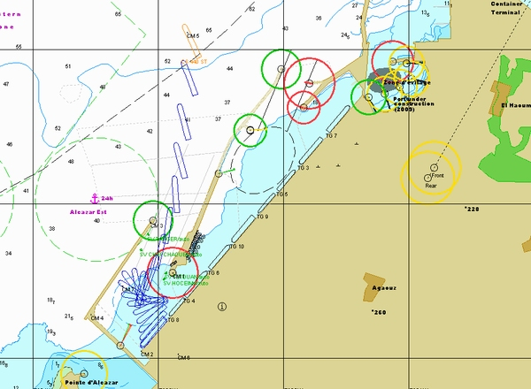

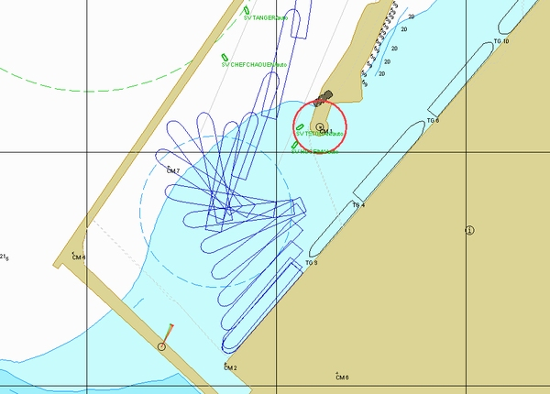

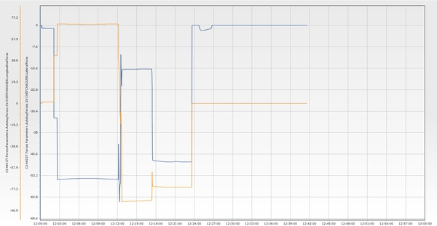

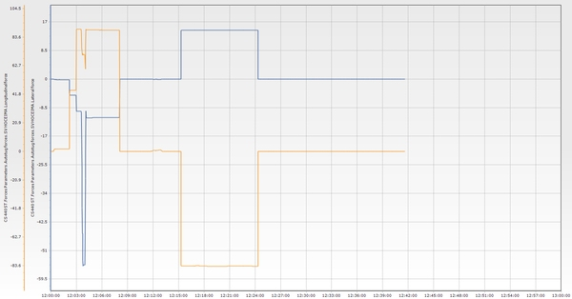

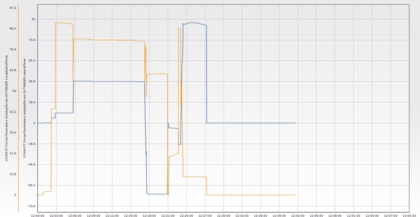

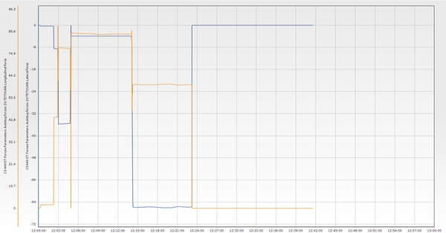

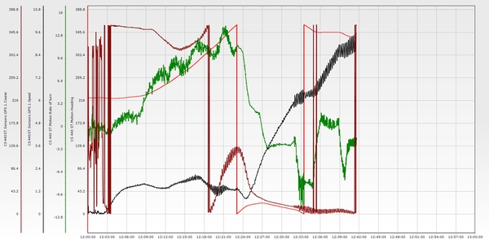

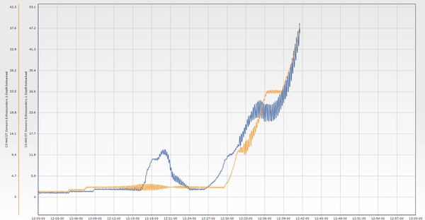

**Essai n° 35**

|  |  |  |  |  |  |  |  |  |  |  |  |  |
| --- | --- | --- | --- | --- | --- | --- | --- | --- | --- | --- | --- | --- |
| **Test n°** | **Condition** | **Wind** | **Wave** | **Current** | **Tide** | **Berth** | **Maneuver** | **Pilote** | **Side** | **Tugs** | **Entrance** | **Commentaire** |
| 35 | E3 | NW 25 knt | NW 3m 14s | 3 knt 60°/N | 0,6 m | P3 | Appareillage P3 bâbord | nan | Bâbord | 5 Remorqueurs | TM3 | Departure was carried out in northwesterly winds of 25 knots. An initial attempt to sail with three tugs and the bow thruster proved insufficient, and a fourth tug was called in.   The vessel turned to starboard, and engine power was applied ahead to prevent wind-induced drift and avoid being pushed backward toward the quay.   The vessel exited with a heading close to the green light to compensate for wind drift and gained sufficient speed at the entrance to avoid being blown toward the TM2 breakwater. |

